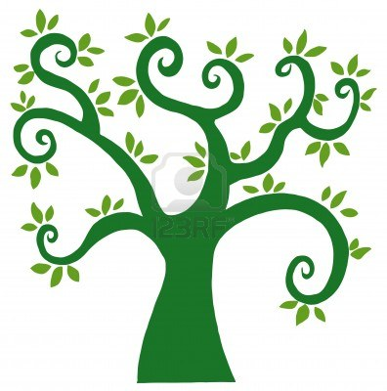

**Numeracy:**

- Investigate the importance of mathematics in the world

- Explore whole numbers, place, value, make calculations, estimate and round.

- Understand that the number line extends below 0

- Interpret and draw conclusions from a range of data, analyse ways of presenting this and create ways of data collection.

**Literacy:**

- Learn to distinguish between fact and opinion, use this to express own opinion. Explore issues and clarify points to persuade others.

-Identify features of non- fiction texts; use these to organise own writing appropriately.

**Science:**

-Show how plants have benefitted society.

-Investigate characteristics and behaviours of living things

***Grow Through Learning***

**Expressive Arts:**

-Sing and play music of different styles

-Observe and record from sources

**Social Studies:**

- Discuss the environmental impact of human activities

-Compare and contrast similarities and differences between people in different societies

- Consider approaches to living in a more environmentally friendly way.

**Health and Wellbeing/RME:**

-Work with others to achieve a common goal, identify and apply techniques to play a range of team games successfully.

- Keeping safe, substance misuse (P6)/ Emotional wellbeing (P7)

- Understand own and others' beliefs. Explore barriers and how people have overcome these.