

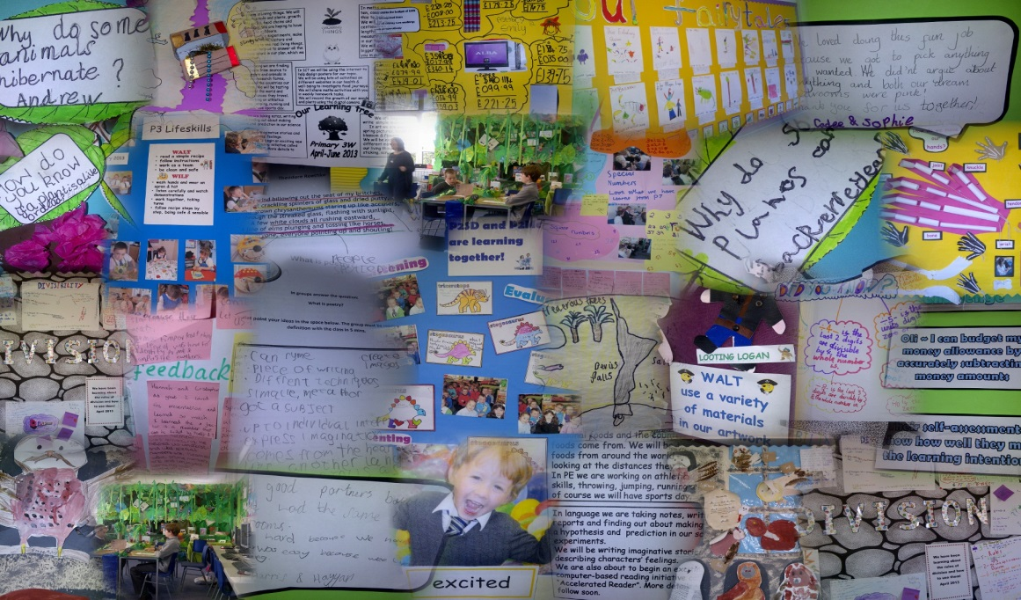



***Grow Through Learning…***



|  |  |  |
| --- | --- | --- |
| **Values**  The totality of learning experienced by all our children enables them to develop the knowledge, skills and attributes to be lifelong successful learners, confident individuals, responsible citizens and effective contributors in a global society.  Children, families, staff, partners and our community effectively work together to provide a rich, inclusive, relevant and motivating learning environment for all.  Each child is actively involved in planning and assessing their own learning and next steps and their achievements are recognised and celebrated. | **Totality of the Curriculum**  There is a considered blend of discrete subject development and interdisciplinary learning designed around contexts which are relevant and meaningful to our children. This includes whole school and community events and vertical learning where appropriate.  Opportunities are planned for all children to develop and achieve their potential as individuals. Their achievements within and out with school are valued and celebrated by our school community. | **Learning and Teaching**  All staff have a shared understanding of effective learning and teaching approaches which are embedded in practice consistently across the school. A variety of high quality strategies and tools are employed appropriately and effectively to ensure that each child is engaged, challenged and enjoying their learning. These include Cooperative Learning, active learning, outdoor learning and use of appropriate technologies. |
| **Experiences and Outcomes**  All the Experiences and Outcomes are used to plan relevant meaningful learning experiences for every child. This ensures consistent, progressive development of their knowledge, skills and attributes. | p13 circle | **Entitlements**  Each child experiences a broad, coherent, relevant curriculum which meets their needs. All children have appropriate opportunities to develop the skills for learning, life and work, including the skills and attributes of the four capacities, and can talk about their progress in this area. |
| **Support**  All learners will be supported and challenged in their learning. There will be a clear focus on the individual learner, their development and progress. | **Principles**  The seven principles and four contexts underpin the curriculum designed for all learners.  They are used as an integral part of the quality assurance process within the school. | **Assessment**  The continuous cycle of learning, teaching and assessment is built on a sound foundation underpinned by the principles of Assessment for Learning. School, LMG, PKC and national moderation processes enable us to make sound judgements about each learner's progress which is supported by a bank of good quality evidence demonstrating breadth, challenge and application of knowledge, skills and attributes. |

**Viewlands Primary School Strategic Plan 2013 / 2014 / 2015**

**Grow Through Learning …**

**Viewlands Primary School 2014-2015**

**High Level Strategic Outcomes**

|  |  |
| --- | --- |
| **Outcomes and measures of impact**  What are the outcomes that you plan to achieve for your children, young people and families for this session? | |
| **Key Outcomes:**  (The focus here is on what is going to be different for your children, young people, families and communities) | **What and how will you measure?**  (The focus here is on how much and how well. Some carefully planned approaches may gather information about a number of key outcomes) |
| * All children are clear about their intended learning, know what they need to do to be successful and can identify their next steps. | **What?**   * The extent to which children are clear about their intended learning and their ability to articulate this through the learning activities and experiences they engage in.children’s own learning reflections to check for understanding of their progress and areas for development. * Children’s learning with a focus on the progression made against their identified next steps.   **How?**   * SLT and peer observations, including learning walks and monitoring, ensure consistency in AfL approaches. * Scrutinise children’s work which will include jotters, wall displays, profiles and tracking information. * Planned and informal learning discussions with children with a focus on an increased understanding and use of the language of learning. * Focus groups |
| * All children will increase their competency in their core skills of mental maths (four operations, mental agility) and spelling | **What?**   * Children’s progress in mental maths and spelling * Children’s levels of engagement in mental maths and spelling * Children’s ability to transfer these skills into open ended and rich tasks   **How?**   * Use assessment information to predict progress and plan next steps in learning for all children. Regular and planned assessment, including open ended and rich tasks, in their core skills of mental maths (four operations, mental agility) and spelling * SLT and peer observations, including learning walks and monitoring, ensure consistency in the teaching of the core skills * Scrutiny of tracking and collection of assessment data * Parental survey first and last terms. Focus on children’s learning of core skills and parental understanding of their role in supporting Evaluate responses. |
| * All children will enjoy positive and positive relationships and contribute to the life and ethos of their school and their community | **What?**   * Levels of concern re playground behaviour * Children’s engagement and levels of enjoyment in weekly vertical groups * Staff, pupil and parent questionnaires on opportunities for all to engage in activities around life and ethos of the school * Children’s own learning reflections to ascertain the impact of the weekly vertical groups * Levels of participation from children, staff and parents * Impact of the opportunities on Eco, Health Promoting School, Bounce Back and awareness raising of children’s rights and responsibilities.   **How?**   * Scrutinise and categorise data re concerning behaviour and action plan * SLT and peer observations focussing on levels of engagement, participation and challenge and enjoyment * Issue questionnaires first and last term and evaluate responses * Scrutinise children’s activity log/ thinking floor book which will contain evidence of the process of the learning and children’s own reflections on their engagement with the different activities * Planned and informal learning discussions with children with a focus on their engagement in and their understanding of their role in contributing to the life and ethos of the school * Evaluate progress of Eco, Health Promoting School and Bounce Back using relevant documentation from these sources |