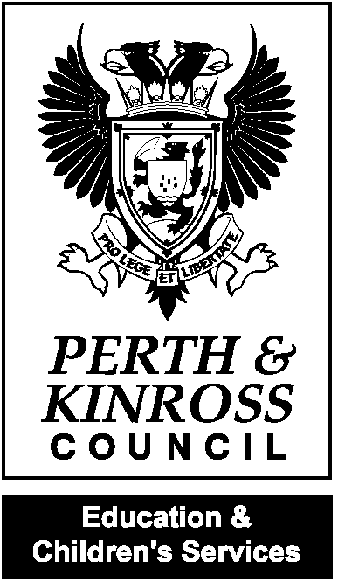
Perth and Kinross Council

Education and Children’s Services

Extended Learning and Achievement Visit

Portmoak Primary School

16 and 17 May 2012

BACKGROUND

To support the school in the process of self-evaluation, a team of one quality improvement officer and two education development officers visited Portmoak Primary School in May 2012. The themes for the review were achievement, learning and leadership. These themes were subject to scrutiny through core quality indicators from How Good is Our School? (3).

The school Standards and Quality Report for 2010-2011, the School Improvement Plan for 2011-2012 and the school’s own self evaluation pro-forma formed the core documentation for the visit.

During the extended learning and achievement visit, the team carried out discussions with the headteacher and other staff, observed learning and teaching in classrooms, reviewed documentation, and met with groups of children and parents.

The strengths and areas for development identified as a result of this visit and the school’s self-evaluation process are recorded below under the three main themes of Achievement, Learning and Leadership.

ACHIEVEMENT

Strengths
- Across Portmoak Primary School attainment for children is at an appropriate level and children are making good progress in their learning.
- As the result of a collaborative process, the school have developed a clearly articulated vision, based on values and aims which accurately represent the ethos of the school.
- Children in Portmoak impress as happy, polite, articulate and very well behaved. Pupils consulted are very clear that they are well cared for, are known and understood by all adults in the school and know where to go if they need help.
- Throughout the school, very high expectations in regard to pupil attitudes and behaviour are evident.
- All children access a range of opportunities to achieve success in sporting, community and social activities. The significant regular involvement of parents and community members in engaging with learners and delivering activities and experiences is a particular strength.
- Skilfully planned learning experiences - including each class’s Sharing Assemblies, whole school vertical committee groups, enterprise and citizenship activities linked to community projects - contribute to the development of Portmoak children as successful learners, confident individuals, responsible citizens and effective contributors.
- The recently enhanced transition processes from Nursery to P1 address the need to cater equally well for children from all feeder nurseries. Transition from P7 to S1 is supported by the Local Management Group (LMG) residential activity week and strong links with Kinross High School. In particular, the school has provided enhanced transition experiences for those children for whom a particular need makes them vulnerable at times of change.
- Parents consulted identified very effective transition of information between classes at the end of the year, and between staff on an ongoing basis, as key strengths of the school.
- All parents, staff, learning partners and community members consulted reported that, in their view, Portmoak is regarded as a very good school where continued improvement in performance is planned for and expected.

Areas for development
- Review the on-going organisation and management of committees to maximise the potential for planned progress in learning.
- Continue with plans in place to engage in professional dialogue around the Perth and Kinross Standards for literacy and numeracy to support evaluation of progress and pace in learning.
- Further develop the use of Glow in tracking children’s learning and achievements.

LEARNING

Strengths
- Portmoak’s classrooms and shared display areas present as a stimulating environment where children’s learning is valued.
- All children in Portmoak access a range of active, motivating and engaging learning experiences. Very good use is made of the outdoor environment - in the school grounds and the wider local community. The school pond area is managed both as an aesthetic experience and an environment for learning which promotes biodiversity. Rich learning experiences are evident, for example, in the ongoing projects involving RSPB Loch Leven, Kinnesswood in Bloom, The Woodland Trust and the Scotlandwell Wash House project.
- Lessons observed were carefully planned, effectively structured and well resourced. Overall, the pace of lessons was adjusted to take account of learners’ needs and very positive teacher-pupil interactions were observed. A positive climate for learning is evident across the school.
- Learning Intentions were planned for, displayed and referred to in most lessons observed.
- Across the school, children were confident in using appropriate vocabulary in maths and English language and used success criteria to evaluate their learning.
- The team of staff who support learning at Portmoak contribute very effectively to the school’s evident commitment to meeting the needs of all learners. For children with identified Additional Support Needs clear systems are in place for communicating relevant information to staff and parents.

Areas for development
- Review and revise the current process for teachers’ forward planning of learning to reduce duplication and encourage innovation and flexibility at the point of delivery.
- Further develop current good practice to achieve consistency across the school. This should include the use of learning intentions and success criteria to:
  - direct the focus on learning
  - encourage reflection
  - extend differentiation
  - support target setting
- Extend the range of planned opportunities to develop pupil voice and increase pupil responsibility and decision making; further develop Learning Chats and agree planned learning outcomes for the school committees system.

LEADERSHIP

Strengths
- The very strong leadership of the headteacher in promoting learning and teaching as the core business of the school, and in establishing very positive partnerships with parents and a wide range of community groups, has resulted in a demonstrable climate of achievement and continuous improvement in Portmoak Primary.
- The principal teacher models good practice in effective learning and teaching; she demonstrates high expectations for her pupils.
- All class teachers take on leadership responsibilities within committees and within the school’s plan for improvement.
- All staff, parents and children are involved in the school’s self evaluation process. Parents’ views are sought regularly by the school, in a range of ways, and their views then impact on practice. Communications between school and home are seen to be very good.
- A group of community representatives consulted during the course of this visit spoke of the school being central to the community. Parent helpers and community members support the learning in school on a weekly basis and report that they feel valued. In a culture of mutual regard and respect, the school and the community share the benefit of joint working.

Areas for development
- Further develop learners’ involvement in the self evaluation process to impact on planning for improvement.
- In continuing to take account of parents’ views, plan for opportunities to share with parents more detail on key aspects of the maths and language curriculum.

Portmoak Primary School occupies an enviable location. It is a highly regarded school at the very heart of its local community. Parents support the school and highly value the individual care each child receives. The positive partnerships between the school and the Parent Council and the Events and Fundraising Committee are effective in promoting school improvement. Very strong partnerships across the community are employed by the school to enhance children’s learning experiences. Portmoak Primary School benefits from a cohesive and effective staff team who value and involve visiting specialists, parent helpers and community members. Children in Portmoak are articulate, thoughtful and ready to learn. The school has high expectations for its learners. Working together, the headteacher, principal teacher and class teachers are well placed to lead the school’s development in line with its recently refreshed vision ‘Being the best I can be in Portmoak’ focusing on Learning, Inclusion, Friendship and the Environment.

The school should now address the areas for development identified in this report, including them in the school’s improvement plan for session 2012-2013.

HMI Report

Responsible Officer: Anne Dalziel
Email: adalziel@pkc.gov.uk
Telephone no: 01738 476376

