Moncreiffe Primary School
Standards & Quality Report
Session 2012-13
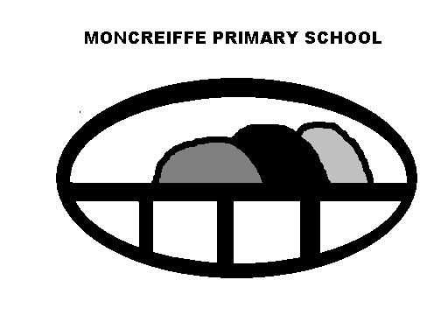

Standards & Quality Report
This is our annual Standards & Quality Report which reflects some of the key developments and achievement for the school session 2012-13. More detailed information about the work of the school can be found in newsletters which you can find on the school website. If you would like to discuss any aspect of this report, please contact me.
Barbara Boyd
Head Teacher

School Aims
- To encourage each child to work to the best of his/her ability, thus reaching his/her fullest potential.

- Through effective planning, to provide a broad and balanced curriculum that ensures continuity and progression for all pupils.

- To provide a variety of learning and teaching approaches, which take account of the individual pupil needs, resulting in motivated, independent learners.

- To assess pupils regularly in order to inform the next steps in learning and provide high quality, regular communications with parents.

- To meet the emotional, physical and social needs of each child and support his/her learning through effective deployment of staff and resources, thus enabling the child to develop positive attitudes towards themselves and others.

- To create a happy, stimulating environment, a sense of identity and pride in the school through the co-operation of pupils, staff, parents and the wider community.

- To provide a sufficient range of effectively organised resources, both human and material, by the efficient use of financial budgets and appropriate deployment of staff.

- To ensure continuous improvement in the quality of provision for our pupils through systematic self-evaluation and school improvement planning in consultation with all stakeholders

Attainment
We were pleased with the general levels of attainment achieved by our pupils. The majority of pupils at P4 (Curriculum for Excellence - first level) and P7 (Curriculum for Excellence- second level) were secure in the appropriate level in reading, writing and mathematics in line with National Standards in June 2013. Most pupils at P4 (Curriculum for Excellence- first level) and P7 (Curriculum for Excellence -second level) were secure in the appropriate level in listening and talking in line with National Standards in June 2013. Almost all children were working within the CFE level appropriate for their stage. Pupils at all stages, who experienced some difficulty, were given good support and consequently most of these pupils made gains in their attainment.
Attendance
2012-13 | Attendance | All absence | Authorised Absence | Unauthorised Absence
Moncreiffe PS | 96.12% | 3.88% | 2.83 | 1.03

Achievements
Pupils were given many excellent opportunities to develop personal achievement through a wide range of activities, individually, collaboratively, within and outwith school. Achievements were regularly celebrated with the school community. The Pupil Council proved again a great way for most pupils to take responsibility for their learning, develop leadership skills and making valuable contributions to both the school and community through activities and enterprising events.
Learning
Last session we had a Learning & Achievement visit by members of Perth & Kinross, Education & Children’s Services. The findings of the review confirmed our own assessments, of the very good quality of learning experiences the pupils received in the school. Pupils were motivated and actively involved in their own learning and development. Pupils were increasingly more involved in planning the learning activities along with the teachers. Almost all staff were trained in the Co-operative Learning techniques and pupils were given more opportunities to work in a collaborative way. The pupils in the early years experienced a curriculum which was increasingly based on an active learning approach. There was a dedicated support team providing direct support to pupils and a well-managed system for identifying and reviewing needs of individual pupils. Parents were fully involved in this process and the level of engagement from outside professionals was very good.
Leadership
Last session saw the introduction of Mrs Boyd our new Headteacher at the start of the session and the retirement of Mr Oliphant the Depute Headteacher at the end of the session. Mr Oliphant’s post was replaced by Mrs Murray in a Principal Teacher role. Staff were fully committed to evaluating and monitoring the work of the school to ensure continuous improvement. Pupils and staff had been given many opportunities to develop their leadership skills. Staff undertook key leadership roles within the school to develop aspects of the curriculum and ethos, life and work of the school.

Partnership with Parents
There continued to be a positive working partnership between the school and the Parent Council and FRoM (Friends of Moncreiffe). The continued support of both of these parent groups continued to be a strength of the school. Communication with parents was enhanced through; regular newsletters, text messages, meetings, curriculum events and the web site. Parents were given termly information about what their child was learning through the sharing of the Learning Trees. Parents were also encouraged to support and encourage their child to contribute to their e- portfolios on GLOW.
Progress on Priorities 2012-13
- Curriculum for excellence audit - All the teachers were involved in carrying out an extensive evaluation of the school’s progress to date in the implementation of Curriculum for Excellence. This allowed us to make strategic plans for the future developments and set key priorities for the next three years.
- Health & Wellbeing- Staff worked collaboratively to plan for the implementation of a whole school Food Project which will form a key part of our Health & Wellbeing curriculum.
- E- Portfolios & Profiles – Staff undertook development work to enable them to further develop pupil’s skills in reflective writing. Pupils were then able to apply this skill in creating their e- portfolios (P4, P6 & P7), the P7 Pupil Profile and their class Blogs. Work was also done by staff to improve the way pupil attainment was recorded and tracked through the use of the school’s Information Management System.
- Nursery - At the Nursery we improved parental engagement through the introduction of the successful parent and child cooking sessions. We also audited parents on their views and the findings will help shape the nursery improvements we will make this session. Giving pupils a say (Pupil Voice) was also developed through the range of specific activities that the staff planned. Children shared their learning with parents and others through the development of a learning wall. Children’s Next Steps in Learning sheets were introduced to give parents more information about their child’s learning. The staff audited and reviewed practice to ensure that Health & Safety practices in the nursery were in line with PKC policy and procedure guidance.
Consultation
In forming this self -evaluation we took on board the views of staff and pupils. We also canvased views of parents through the Parent Council.

Improvement Priorities for Session 2013-14
The key areas for development will be:
- Developing and implementing a science programme with our Perth High School Cluster colleagues.
- Developing strategies to ensure that skills for life, work and learning are planned, taught and assessed with specific reference to Health & Wellbeing).
- Further developing strategies to ensure that children reflect on their learning, identify their strengths and next steps and know what they need to do to achieve this (specific reference to literacy).

