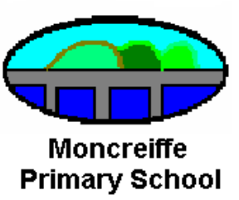
Session 2014-2015

Information sheet 3

Parent Contact

Parent Contact events are an important part of the school’s work and provide an opportunity for you to discuss your child’s individual achievements, progress and next steps.

The last few years have seen quite a change take place as schools in Scotland have introduced a new curriculum, ‘Curriculum for Excellence’. This change in curriculum has introduced different ways of working and brings a new terminology. The purpose of this leaflet is to provide you with some information to help you can get the best from the discussion with your child’s teacher.

About Curriculum for Excellence
‘Curriculum’ is the word used to describe all the experiences which are planned for children and young people through their education. These experiences are grouped into four categories.

- Curriculum areas and subjects
The curriculum areas are the organisers for setting out the experiences and outcomes.
- Interdisciplinary learning
The curriculum includes space for learning beyond subject boundaries – at Moncreiffe we have been trying to ‘join up’ the children’s learning into particular contexts. Remember the ‘Art Gallery’ and ‘Room to Read’ we featured last term.
- Ethos and life of the school
The starting point for learning is a positive ethos and climate of respect and trust based upon shared values across the school community. There are many opportunities for children to learn as part of this. e.g tasks like being in a School Council, monitors etc.
- Opportunities for personal achievement
Pupils need opportunities for achievements both in the classroom and beyond, giving them a sense of satisfaction and helping to build motivation, resilience and confidence.

The eight curriculum areas ensure that learning takes place across a broad range of contexts and subjects.

Expressive arts | Religious and moral education
Health and wellbeing | Sciences
Languages | Social studies
Mathematics | Technologies

Each curriculum area has a set of experiences and outcomes that describe the expectations for learning. The title ‘experiences and outcomes’ recognises the importance of the quality and nature of the learning experience in developing attributes and capabilities and in achieving active engagement, motivation and depth of learning. An outcome represents what is to be achieved.

At Moncreiffe …
Your child’s teacher plans a range of learning opportunities with the class across the curriculum areas. The teacher then identifies particular experiences and outcomes as the focus for the learning in each planning block. Block 1 was Aug – Oct, Block 2 Oct – Dec etc.

For example – here is one of the outcomes that deals with technical skills in writing.
I can write independently, use appropriate punctuation and order and link my sentences in a way that makes sense.

Clearly ‘appropriate punctuation’ would need to be taught over quite a number of lessons…actually quite a lot!

As part of the teacher’s block planning s/he would decide what specific piece of learning would be addressed within that outcome – what pupils should be able to know, think and do by the end of that block of learning. This is called the learning intention.

In our example this might be …
When writing independently, I can use capital letters and full stops. I can use the joining words ‘and’ and ‘but’.

As the children undertake their daily tasks the teachers give them clear success criteria so that they understand what will make that piece of work successful.


In our example this might be…

In my writing today
- I have written 3 sentences
- I have used capital letters
- I have used full stops

The next set of learning experiences might focus on joining words.

In my writing today I have
- written at least 4 sentences
- used capital letters and full stops
- used a joining word

Even our youngest children are showing that they are able to assess their own work by looking at what they have done and checking it against the success criteria.
The teacher gathers all the information about the children’s successes and challenges (discussed with child) and assesses their progress against the original learning intention.

I hope this goes some way to illustrate how the learning is built up – it’s a very thorough process. Our example here would be a small part of the learning experience over a block of learning. In writing alone, the teacher would also be addressing spelling, writing style etc.

This process will be replicated many times over – there are 8 curriculum areas!

Children are not pre-programmed robots and they all progress at different rates. Individual learning journeys
take varying turns and have ups and downs. It’s important
that you understand that our aim is to meet each individual child’s learning need – to offer the right amount of support
and the right amount of challenge so that every child progresses at the rate that is appropriate to them.

At parents’ night I’m sure you will want to find out things like

- how well your child is progressing
- what they have achieved
- what they may have found difficult
- their ‘next steps’
- how your child presents at school – happy, anxious, confident?

The teacher will talk about your child’s progress in terms of how well they have achieved across the learning intentions that have been covered. We hope that this will be a two way conversation. It’s so helpful for us to get parent/carer’s perspective on the children’s progress.

In days gone by, progress in learning was often described in terms of ‘achieving levels’. One of the criticisms of the 5-14 curriculum was that the six levels were perceived as being hoops that children jumped through at certain points.

We know from educational leaders that children do not learn in ‘straight lines’. We are being encouraged to scaffold their learning so that they can build on prior learning in meaningful ways and make connections across the areas of the curriculum.
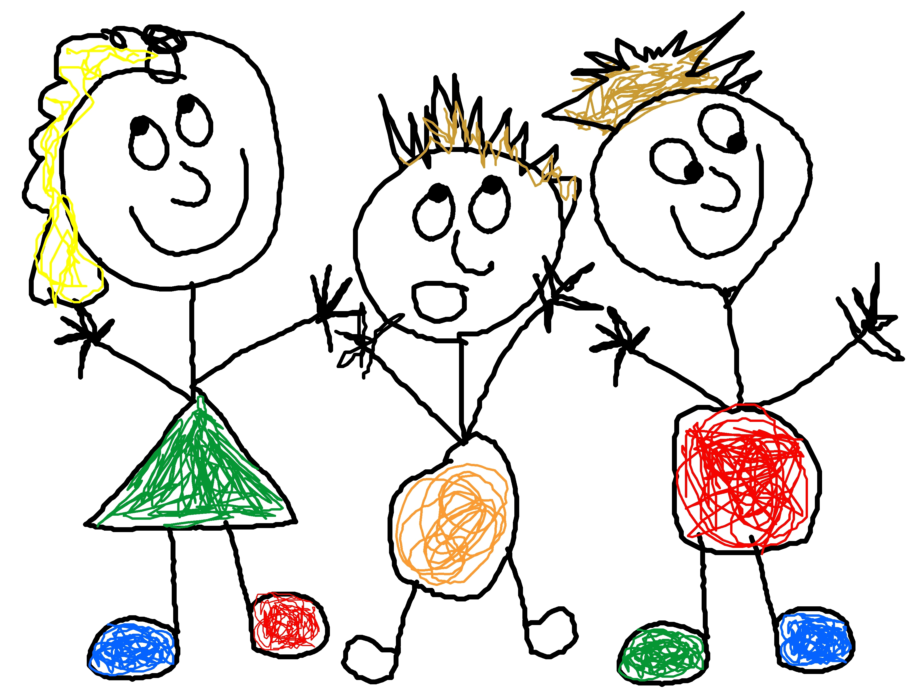
The new curriculum has three levels relevant to primary

Early level – pre-school years - p1, or later for some
First level – children in P2 –P4, earlier or later for some
Second level – children P5 -7, earlier or later for some

What you will see In days gone by you might have looked at worksheets or pages and pages of jotter writing. However now because your child is accessing lots of active learning approaches other methods, for example displays, photographs and comments from teacher’s observations may be used to demonstrate learning.

It would not be possible to convey the full curriculum story to you in one small leaflet but I hope this information goes someway to support you as you attend the parent contact events.

Karen Young Moncreiffe Primary School Nov 2010

