Glow
- Log in to glow using your username (begins with gw) and your password (remember the space!)
- You will be prompted to change your password. Passwords can include numbers and letters, be any length but must include a space.
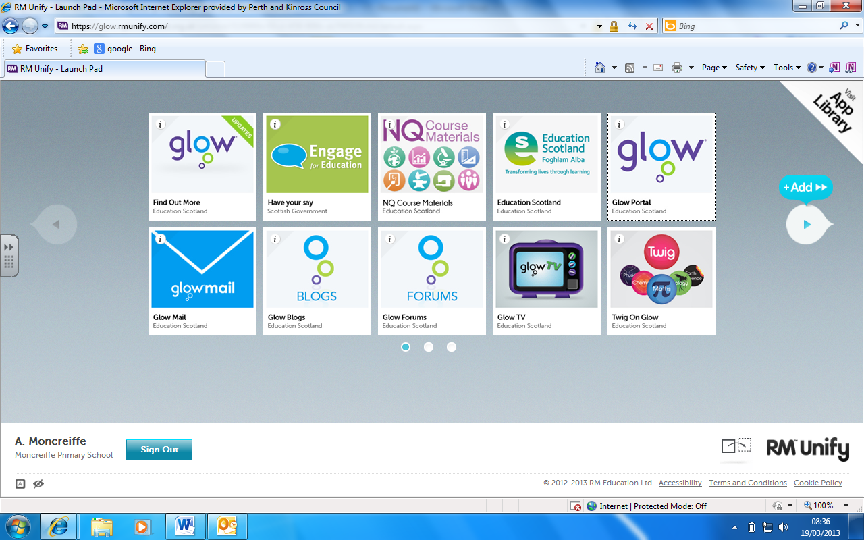
- Once you have logged into glow and changed your password you will be taken to the screen below. Click Glow Portal to access Glow.

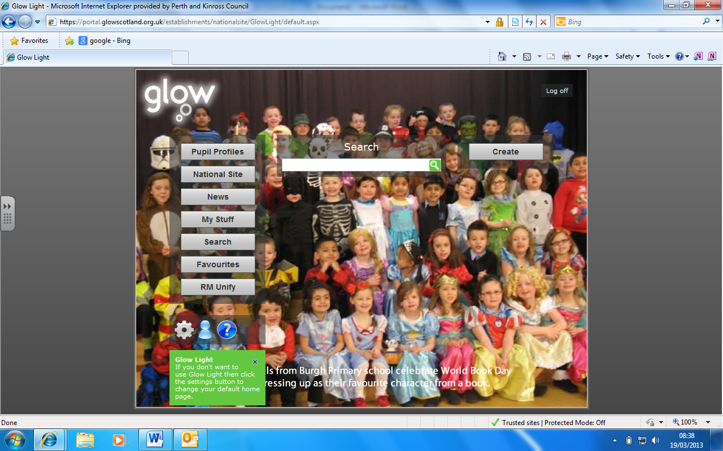
- You will then be taken to the screen below which we call Glow Light. Please click on My Stuff and then My Glow

- In my Glow you can change your password and set challenge questions in case you forget your password. Click Change Profile which will open a new window with all your details. Then click edit to change any of this information. You can also add in an alternative email address.
Accessing your child’s profile (Primary 2, 3 and 5)
- Whilst in My Glow there is a tool bar down the left hand side. Click Moncreiffe Primary School on this tool bar.
- Along the task bar at the top click Pupil Profiles and then choose your child’s Year of Entry.
Accessing your child’s E-portfolio (Primary 4, 6 & 7)
- Whilst in My Glow there is a tool bar down the left hand side. Click Moncreiffe Primary School on this tool bar.
- Along the task bar at the top click E-portfolios and then choose your child’s class.
(Please note, your child will have to allow you access to their E-Portfolio: see below)

How to Allow Parents Access to E-Portfolio
- Ask your child to log in to Glow as themselves. They must then access their E-portfolio through My Glow. They should have a similar screen as below but with their own name.
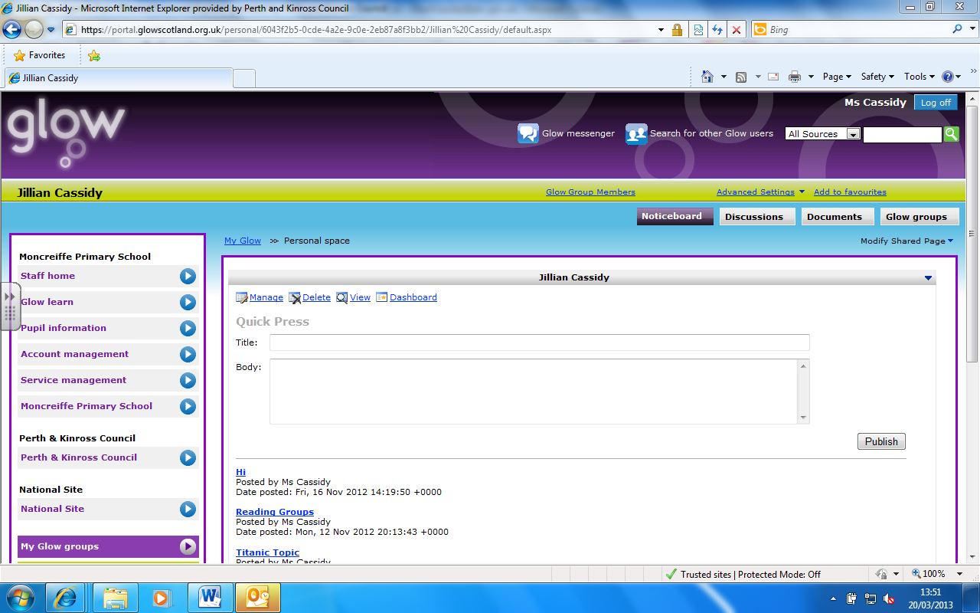

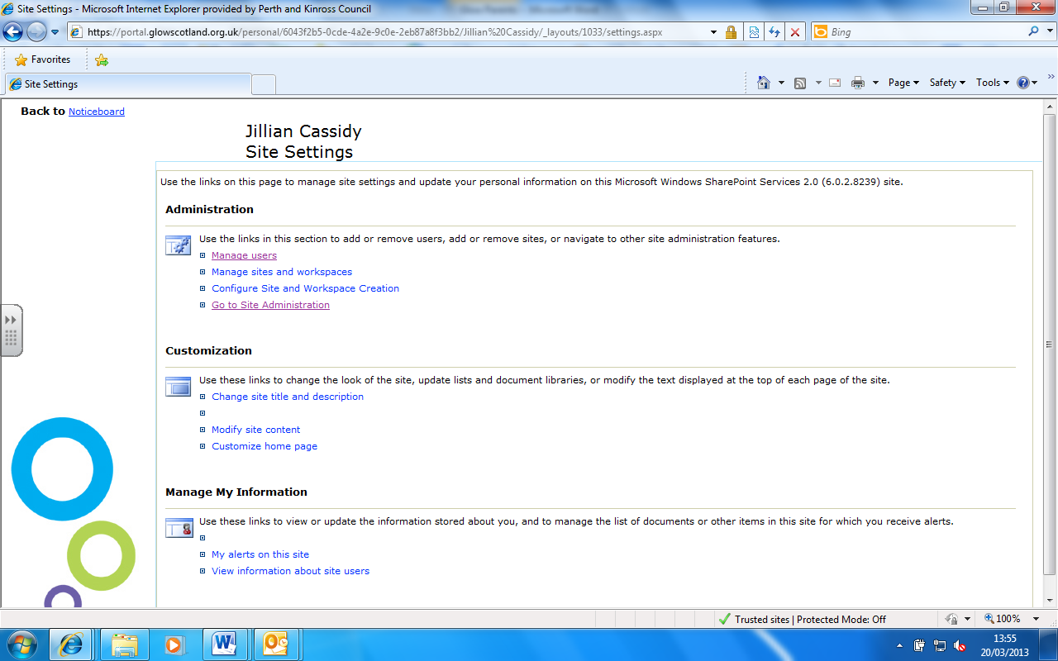
- Click on Advanced Settings and then Site Settings. You will be taken to the screen below.

- Click Go to Site Administration then Manage Users. You then need to Add Users.
- You’ll arrive on the page below. In the large white box(1) enter the your (Parent’s) Glow username. Then tick the box that says Reader with Discussions(2) followed by next and then finish.
You should now be able to log in on your Parent account and access your child’s E-Portfolio using the instructions above.
Accessing Class Blogs
- Visit https://blogs.glowscotland.org.uk/pk/MoncreiffePrimarySchool2/
- Click on Our Classes then choose your child’s class.
- You will have to enter your Glow username and password.

Should you have any problems with Glow, please fill out the slip below and return it to school with your child. Someone will contact you to resolve the issue.
Please state the problem you are having:
____________________________________________________________________________________________________________________________________________________________________________________________________________
Date of issue: _________________________
Name____________________________________
Child’s Name__________________________ Class_______

