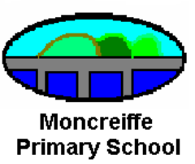

Session 2014 – 2015

Information sheet 4

Active Spelling

Background Information

During session 2009-2010 we developed and changed our approach to teaching spelling to keep teaching and learning real and relevant in line with Curriculum for Excellence. In the past, Spelling was taught using the Nelson Spelling Programme and was mainly a textbook and jotter exercise perhaps similar to how you may remember yourself being taught.

We now know however from research, that this is not the most effective way to learn. Research shows that a more effective way for all children to learn to spell, including those with barriers to learning, is through using a multi-sensory, active learning approach.

Why Multi-sensory?

- Often spelling rules are taught and learned, but then not put into use when learners read or write. However multi-sensory teaching helps learners store these rules efficiently in their long term memory so when needed, they will be retrieved and used across learning.

- When children are familiar with spelling rules, their reading and writing are strengthened. Spelling is an essential and interconnected complement to reading.

- Multi-sensory instruction is a powerful tool in reinforcing our language teaching in three important ways:
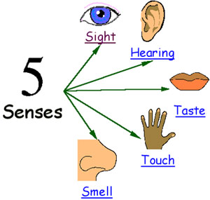
- It helps get the information across

- It helps the learner process the information

- It helps learners retrieve information already learned



‘Have a go’
We have learned that there are real benefits in encouraging children to ‘have a go’ at something and learning from their mistakes, within a supportive environment. At Moncreiffe Primary we use the ‘have a go’ strategy. Simply by training learners to say
HOW do you spell…?
IS THIS how you spell…?
rather than

… we are teaching them to use the spelling strategies that they have learned e.g. sounds like another word, breaking it into syllables or sounding it out.

Through this, children are also learning the skill of ‘does it look right?’ This is the strategy that most adults use before they reach for a dictionary. We need to teach children this skill and also help them to understand that a dictionary is not the first port of call. Children regularly use a whiteboard to have a go or simply a piece of scrap paper before a word is transferred to the actual copy.

‘Have a go’ is a particularly useful skill with younger children as they may seek help with almost every word they write in their enthusiasm to ‘get it right’. By immediately asking the teacher for help, the writing process is slowed considerably for pupils. We need to help them build up their confidence in their own ability to use the knowledge they have already. Please support this by valuing fluency as well as accuracy!
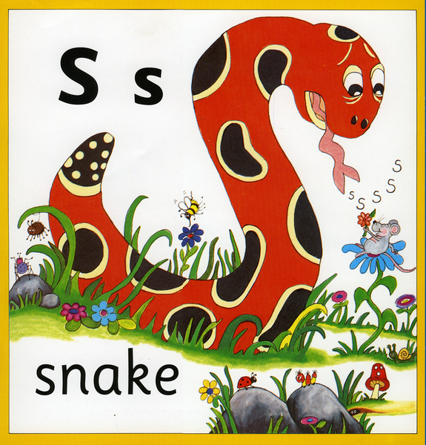
Learning to Spell
To become successful spellers, pupils are taught
in a fun, motivating and active way using a wide
variety of resources and multi-sensory activities.
Pupils in the early years also learn to spell through
a phonic approach which in itself is very active.

The practice of giving lists of words solely to learn as homework has proven to be less than successful. The teaching part of spelling is mostly done in school but most of the active, multi-sensory activities we do can also be done at home to reinforce the learning.
(examples on page 4)
The teaching of spelling can be broken down into the following three main areas:

Systematic Approach
Learners, throughout the whole school, are taught to spell using a systematic approach. So, teachers at Moncreiffe Primary consult the Nelson Spelling programme and Jolly Phonics programme to see where to go next and how to progress with learning. However the children no longer sit with textbooks; learning is active and multi-sensory, in other words, the rules and strategies suggested in the programmes are brought to life! Spelling is differentiated in both difficulty and also through the number of words learned, to enable pupils to work at their own pace and level of learning.

Common Words (High Frequency)
The teaching and learning of common words is given a high priority in all classes as they make up a significant percentage of all written work across learning. The progression is mainly in the amount of words that are introduced at each stage. Children are assessed at key points throughout the session to see what words they are confident with and which ones they need to practise.

Writing / Spelling connection
Learners are given opportunities to learn the words that they have misspelled in their own writing. The teacher may choose to highlight a few of these words for the pupils to look up in a dictionary and these can then be learned. This then becomes a tailor made, individual learning task which is matched exactly to their needs. However it is still possible and beneficial to use collaborative activities to support this learning e.g. pupils could work in twos to help each other to practise and learn their words.

After a writing lesson, the class teacher may note any key words which are appearing as misspelled words from more than one pupil. These words may be the focus of a direct teaching session during the following week.

As we still want to encourage pupils to write freely, it is recommended that the writing and spelling connection is made regularly but not through every piece of writing.

How can you help at home?
It has been found that children learn to spell better, quicker and more easily if they are given short but fun activities on a daily basis. Research has proven that tasks that are active are much more effective than textbooks/worksheets and will lead to pupils becoming more independent and focused learners.

Below are some suggestions for spelling strategies that you could encourage your child to use at home when they are learning to spell.
Spelling Strategies

Rhyme – if they can spell mouse, they should be able to spell house
Write the word with different coloured pens to break it into sections.
This will help your child to learn to spell in ‘chunks’ rather than ‘letter by letter’.
Use different coloured post- its, one for each word. This will help your child visualise the word when they are trying to recall it.
Write the word in sand, finger paint, shaving foam! – helps form memory hooks.
Use big paper and big felt pens.
Chant the syllables e.g. Wed-nes-day, emphasising the tricky bit. Use actions for each syllable.
Draw a picture to help with a word e.g. big
elephants can always understand small elephants = because.
Make the word into a picture e.g. bed could be drawn to look like a bed

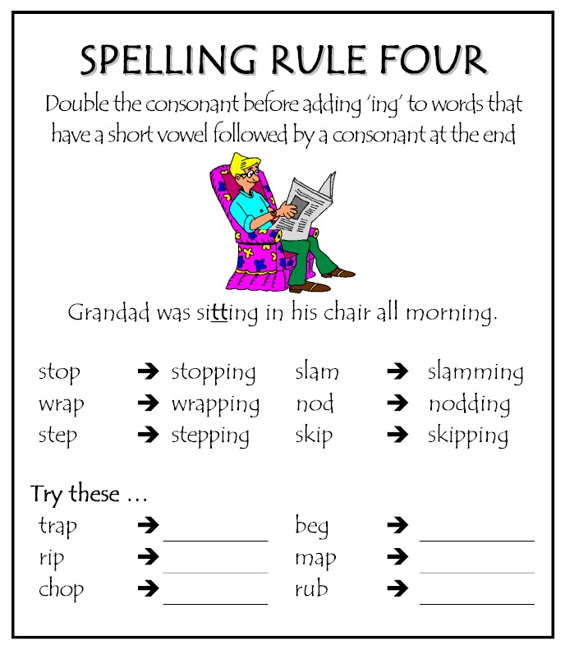

If you would like any further information on Active Spelling please contact the school.

We are always very grateful to receive feedback from you.

F Campbell Dec 2010

