Fairview School
Nursery
2023-2024

.

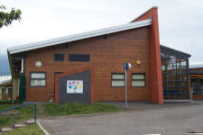

All about us

Dear Parent/Carer,

Welcome to Fairview nursery. Our aim is to provide your child with a happy, secure, and supportive learning environment. We encourage children to be active and successful learners, able to make choices and to be as independent as possible. We aim for children to be confident and responsible members of the nursery when and wherever possible. It is important to us for parents and Nursery staff to work together as a team.

Parents as Partners
We are always looking for ways in which we can improve our service to you and your child. Parents are always welcome to share opinions and suggest improvements through discussions, questionnaires and parent meetings which provide formal and informal opportunities to be involved in improving the service. We are also currently exploring ways of involving parents in on-going nursery activities.

Parents have the right to ask questions and make suggestions or complaints about any aspect of nursery life. Please do contact us through the home school diary or directly by phone. We love to hear from parents!

During your child’s time here at the nursery we aim to encourage a two way flow of information. Home /school teamwork is essential in creating a partnership which is fully supportive of your child.

We are always looking for good ideas and ways to engage with your children. If you have any skills/hobbies that you could share with our children we would love to hear from you.

Should you wish to discuss any matter privately with a member of staff please do not hesitate to make an appointment. Likewise, if you should wish to speak with the Head Teacher, Depute Head Teacher or Principal teacher for the nursery please make an appointment by telephone or calling into the school office in person.

So how will we pass on and exchange information with you?
- Face to face and by telephone – please be aware that during nursery hours we may not be able to speak to you and so will contact as soon as we can.
- Our Handbook
- Our Website
- Seesaw / Home diary
- Yearly report
- My Learning Journals which have individualised targets for your child. You will be given opportunities to discuss these with Debbie Spiers and to give any advice or contribution.
- Yearly Child’s Plan meetings. These are meetings where all the professionals who are involved with your child meet up to ensure that specific needs are being appropriately met and to agree next steps and priorities. You will be invited to these meetings and your input is valuable and essential!
- Parent/carer evenings.
- Invitations to whole school events eg Summer Fayre, concert, Sports day, Book bug sessions and Stay and play opportunities
- Home achievement information sent in to school
- Stay and Play sessions
- Open events within nursery

Debbie Speirs  Early Years Practitioner  I am the main point of contact within the nursery. | 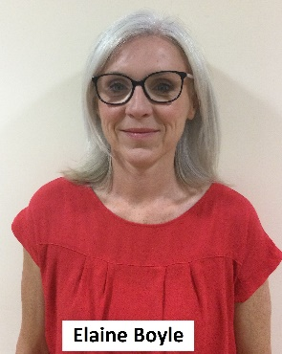  Elaine Boyle  Pupil Support Assistant  Supports pupils within the nursery.  Works Mon/Tue and Thur/Fri. | 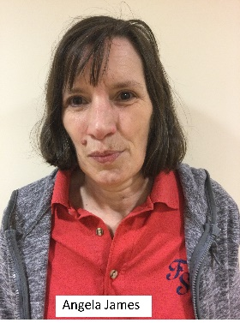  Angela James  Pupil Support Assistant  Supports pupils with the nursery.  Works Wednesday.
Nancy Colville  Play Assistant  Supports pupils within the nursery for half a day, every day. | Katrina Blair  Early Years Family Learning Practitioner  Works with families both within and out with the nursery with courses, activities, etc. | Julia Dixon  Early Years Support Teacher  Supports learning within the nursery and helps staff keep up to date with the latest early years initiatives and standards
Susie Crawford  Health Care Assistant  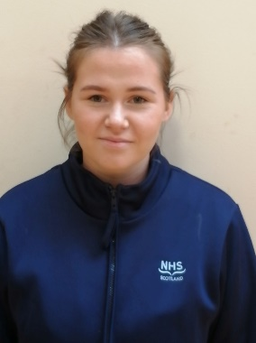  Supports a pupil medically but also helps all pupils in the nursery. | Claire Beatson  Early Years Principal Teacher  You will see me chairing in Child’s Plan meetings and links in with Debbie. | Leigh Verdot  Head Teacher  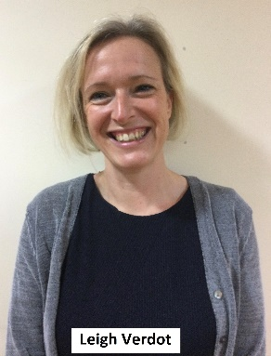  Oversees Fairview school and nursery and links in with Claire

Staff
Other staff that come into the nursery:
- Trudie Carstairs – Depute Head Teacher – supports Leigh Verdot across the whole school.
- Lynn Drysdale – Senior Social Care Officer – helps us with transport among many, many other things.
- Lindsay Harris – Community Link Worker – supports within the nursery with a session in touch and communication through using our senses.
- Carl Downham – School Swimming Pool
- Mrs Karen Borland – Art specialist
- Medical Team – Sarah Lowe is the Lead Nurse at Fairview and is supported by a team to deliver medication and to support the medical needs of pupils across the school.

Nursery Links within the Allied Health Professionals:

- Physiotherapy – Fiona Fummey
- Speech and Language – Joanna Ford and Heather Payne
- Occupational Therapy – Katharine Hodgkinson and Jasmine Ashcroft

Hearing Impairment Teachers – Lesley McGuigan and Audrey Clarke

Visual Impairment Teachers – Kirstie O’Shea and Claire Wilkie.

Nursery Day

Session 9.00am – 3pm

Snack am approximately 10am/10.15am

Lunch 12pm
Snack pm approximately 2pm

Curriculum

Educational experiences in the early years are developed through play. We use guidance from the Birth to Three and Realising the Ambition documents, along with Curriculum for Excellence where appropriate, and the Equals Curriculum to provide a wide range of opportunities for your child to develop their skills and abilities.

We focus on the development of independence, supporting all developmental targets that are appropriate and targeted on an individual basis.

Children are given the opportunity to access the pool in Fairview, library, soft play and a sensory room which Nursery use on a regular basis.

We aim to keep you informed of current learning through home-nursery diaries through Seesaw as well as our regular school newsletters.

Each Nursery child has a Learning Journal which tracks the experiences and achievements that have been made through the year. We take lots of photos and videos and these are displayed as part of their journal. This can be accessed using the parent Seesaw app. Permissions must be signed before accessing this. Parents can look at, like and comment on posts made by nursery staff at a time that is convenient to them and are

Families can also opt to have hard copies of documents sent home if they choose not to access the Seesaw app.

You will be invited into the Nursery to discuss your child’s progress at different points throughout the year including through parent contact meetings, child’s plan meetings with planning partners invited, phone call discussions about setting targets and through other discussions with planning partners as and when required.

However please feel free to contact school if you wish to speak to Nursery staff or to discuss anything that you are unsure of or are worried about and we will contact you when we can.

Visitors to Nursery

The Nursery staff work closely with outside agencies who will visit regularly to discuss the progress of individual children.

Visitors to the Nursery may include:
Health Visitors/medical staff Educational Psychologist
Social Workers Art and PE specialists
Dentists & Dental Nurses Peer tutors from local schools
Staff from other nurseries College Students

The Clown Doctors

The Clown Doctors have been visiting Fairview for a few years and support with the engagement of learners. Referrals are made by room staff for a block of direct work but all staff have participated in a workshop to support our skills as practitioners to work with and engage in our learners in a way that supports all of the different communication styles we see at Fairview.

“The Clown Doctors guarantee laughter, distraction and joy in visits tailored for each child, delivered in person or virtually in hospitals, hospice care and special educational schools. With their distinctive yellow doctor coats and red noses they use interactive creative play, song and storytelling to engage children.”

For more information please visit:
https://www.heartsminds.org.uk/

Snack

A snack is provided for children each morning. We aim to provide a wide selection of healthy snacks and we aim to take part in cooking activities regularly. There is always water, milk and fruit on offer. We aim to involve the children in choosing snack if possible. We also aim for the children to be as independent as possible when eating and drinking and we will promote as much independence as possible. We sit down to snack together and make it a social time as well as an important learning experience.
Snack for the day will be written in the daily diary on seesaw.
Afternoon snacks will be provided by families and can be stored in our Nursery Kitchen.

IT IS IMPORTANT THAT STAFF ARE INFORMED, IN WRITING, OF ANY FOOD ALLERGIES OR DIETARY REQUIREMENTS.
Sometimes parents will choose to provide snack because of allergy or different dietary requirements e.g. Gluten/dairy free. Snack from home must be sent in an insulated picnic bag.
No meat products please.

Morning snacks are funded by Early Years and will be free of charge to families. We do sit down for a drink in the afternoon and parents can provide afternoon snacks for their child if they wish to do so.

Special events
Please let us know about special events in your child’s life. These are so that you can share special moments with Nursery e.g horse-riding for the first time/swimming certificate/bus for the first time/went on a train/went to the fair/ slept through the night!

We love to celebrate all the steps that your child makes, big and little so please share these! We will stick them onto our new Home Achievement Wall and share with the group.

Tooth brushing
All children are invited to take part in the Child Smile Teeth Brushing Programme. This is to supplement tooth brushing at home. All children have their own brushes and clean their teeth at the end of each day. If you do not wish your child to take part please tell the nursery staff.

Outings

It is nursery policy to extend our children’s knowledge by visiting local places of interest. You will be asked to sign a consent form for these outings when your child starts nursery.
We try to have regular community visits in the school minibus or on public transport. If you r child has a bus pass then please let the nursery staff know. This can be kept in their bags. Equally, if they do not yet have a bus pass then we can provide you with information about how to apply for one.
Parents have often met up with us on these trips out. If you would like to do this please let Nursery know.

Absences and appointments

Please contact the school phone number to let the office know of any absences before 9.30am at the latest. However the earlier you can let us know then the better we can plan our day.

A message to Debbie via Seesaw might not be picked up so please call the school office on 01738 473050.

Clothing

When dressing your child for nursery please remember that your child should:
- feel comfortable in order to enjoy and take part in nursery activities by wearing suitable clothing and footwear.
- be able to push up his/her sleeves easily in order to wash hands, take part in water, sand and paint play.
- be able to go to the toilet independently if they are able to do so.

- All clothing should have your child’s name on. A spare set (including socks, top and trousers) can be kept in your child’s nursery bag or kept in school.

- Please make sure that your child has a warm, waterproof jacket/coat suitable for outdoor play and activities. Outdoor play/walks are a daily routine! (with name in!)

- Please ensure that children bring in clean bibs for lunch and snack daily,

- A spare fleece of cardigan to be brought into Nursery daily for the colder days,

- Children are able to use the pool once a week when at Nursery, they will need a swimming costume, towel and swimming nappy as appropriate. These will be brought into school weekly and sent home again. Swimming nappies can be found at www.splashabout.com

- Parents will receive protocols for swimming/personal care at the start of the nursery session. We will ask parents to agree and sign these. These will be reviewed again whenever necessary.

SUN AWARE
During warmer weather (!) please ensure that your child is protected from the sun. It will help to protect your child from the sun if you:
- Use sunscreen and please apply before your child comes to nursery-SPF 30 or above.
- Sunscreen should be unopened when it first comes into nursery so we can ensure it is in date according to the manufacturer’s instructions. This should be clearly labelled with your child’s name.
- Choose clothes that protect and keep cool. Ideally clothing made of cotton, with collars to protect the neck, longer sleeves on tops, longer shorts and dresses.
- Provide a hat to be worn outside- with a neck protecting flap, a wide brim or a cap with a front shade.

EMERGENCY CONTACT

Should your child become ill or have an accident while at nursery it is most important that we have an address and telephone number of someone other than yourself. In all circumstances we would try to contact you first but another contact is essential should you be unavailable. Please let us know about any changes of address and contact numbers for all emergency contacts.

Health

Please inform us of any change in your child’s health and of any infectious/contagious conditions.

Please do not send your child to nursery if he/she is unwell, this includes diarrhoea, vomiting, a high temperature (38 degrees or above is considered to be a fever with 37.7 being in the higher range of normal). We must consider the wellbeing of all of our pupils and staff and ensure that we maintain high levels of infection control.

If your child has sickness/ diarrhoea, they MUST NOT come to Nursery for 48 hours after illness has stopped.

If you are unsure please phone and chat to Debbie Spiers

HOLIDAYS AND IN SERVICE DATES

Holiday dates can be found on the Perth and Kinross council website and will be highlighted in school and nursery newsletter.

SCHOOL ADDRESS AND PHONE NUMBER
Fairview school
Oakbank Crescent Telephone: (01738 473050)
PERTH
PH1 1DF

NURSERY COMPLAINTS PROCEDURE
If a problem arises you should raise this in the first instance with the Nursery staff.
If for any reason this is not possible then your complaint should be addressed to the Head Teacher. All complaints will be recorded, acknowledged and dealt with in a confidential and sensitive manner. Please refer to Fairview School Complaints Procedures for further information. These are available in the school handbook or on the school website https://blogs.glowscotland.org.uk/pk/FairviewSchool/

If the problem is not resolved, the complaint should be put in writing to Perth and Kinross Council who will investigate the matter further. Further information is available in the Information Sheet on Resolving Disagreements available on the Council’s website: www.pkc.gov.uk or by contacting Tel No: 01738 476790.
More information on the Council’s Complaints Handling Procedure is available on the Council’s website: http://www.pkc.gov.uk/complaints
The work of the Nursery is inspected independently on a biennial basis by the Care Inspectorate. Anyone can also seek further advice by contacting them at Compass House, 11 Riverside Drive, Dundee, DD1 4NY.
Telephone number 0845 6009527 or at enquires@careinspectorate.com
Please ask for further information or refer to the booklet: ‘How to use the Care Inspectorate Complaints Procedure’. This can be downloaded from the Care Inspectorate website.

We hope that we are approachable and that any worries or problems can be resolved before an official complaint needs to be raised. Please feel free to contact us to discuss things or arrange a meeting at any time.
Once again, welcome to Fairview nursery! We look forward to working with you and getting to know you and your child.

