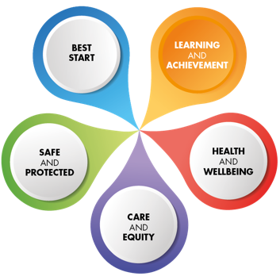`­

**Quality Improvement Plan**

**2023-2024**

**SCHOOL: Fairview School SEED: 5340047**

**Please insert your Curriculum Rationale here:**

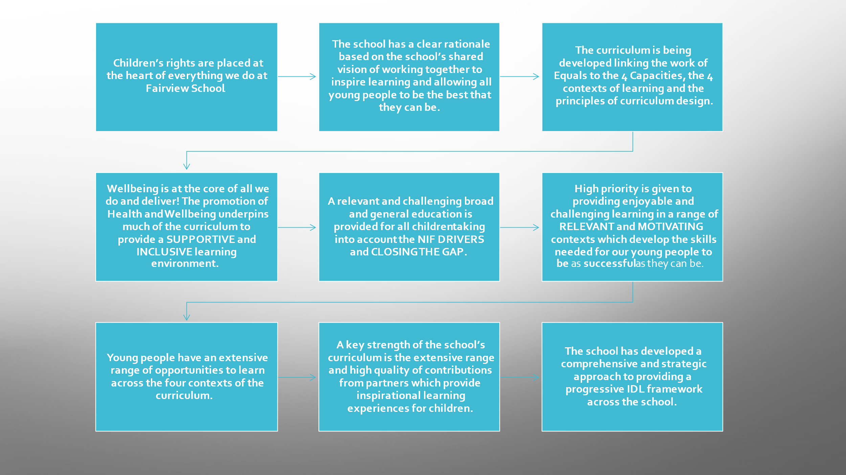

|  |  |
| --- | --- |
| **Three Year Overview of Key School Priorities 2023-2026** | |
| 2023-2024 | **To have an effective tool that shows progression and allows staff to build on prior learning.**  **To refresh the school’s vision, values linking in with the curriculum rationale.**  **Implement robust processes to ensure quality learning and teaching and improvement** |
| 2024-2025 | * For staff to develop in confidence using the tracking tool and in their professional judgements, add in additional areas as required * Revisit the curriculum framework and associated assessment procedures * Consider how best to enhance the use of observations to progress learning |
| 2025-2026 | * To see progression across all curricular and skills area using the tracking tool – add in additional areas as required * Ensure assessment information is streamlined and relevant and enhances progression * Enhance teacher confidence through moderation including with other schools in Scotland which have a similar profile |
| LMG Priorities for 2023-2024  Fairview School will link in with LMG priorities where relevant. | |
|
|
|  | |

|  |  |  |  |  |  |  |  |  |
| --- | --- | --- | --- | --- | --- | --- | --- | --- |
| **Quality Improvement Plan** - **Priorities and Outcomes**  What are the outcomes that you plan to achieve for your children, young people and families for this session? | | | | | | | | |
| **Key Priority One: To have an effective tool that shows progression and allows staff to build on prior learning.**  **Rationale: As the curriculum has been adapted to meet pupil needs it has meant that the current tracking system is not fit for purpose for the majority of pupils and does not track the skills which pupils are developing, thus making it difficult to build on prior learning.** | | | | | | | | |
| **Overall Aim: By June 2024, all pupils will have been baselined against relevant tracking systems depending on which curriculum they are following.** | | | | | | | | |
| **NIF Priority(***Highlight)***:**   * *Placing the human rights and needs of every child & young person at the centre of education* * *Improvement in children & young people's health & wellbeing* * *Closing the attainment gap between the most & least disadvantaged children & young people* * *Improvement in skills & sustained, positive school-leaver destinations for all young people* * *Improvement in attainment, particularly in literacy & numeracy* | | | **NIF Drivers** *(Highlight)***:**   * *School & ELC leadership* * *Teacher & Practitioner professionalism* * *Parent/carer involvement & engagement* * *Curriculum and assessment* * *School & ELC improvement* * *Performance information* | | **HGIOS4 QIs**(*Highlight*) **:** | | | |
| * 1. *Self-evaluation for self-improvement*   2. *Leadership of learning*   3. *Leadership of change*   4. *Leadership & management of staff*   5. *Management of resources to promote equity* | | * 1. *Safeguarding & child*   *Protection*   * 1. *Curriculum*   2. *Learning, teaching & assessment*   3. *Personalised support*   4. *Family learning*   5. *Transitions*   6. *Partnerships* | *3.1 Ensuring wellbeing,*  *Equality & inclusion*  *3.2 Raising attainment*  *3.3 Increasing creativity*  *& employability* |
| **Objective**  ***What will change? When, who, what, by how much?*** | **Intended Outcomes**  ***What will happen as a result of the objective?*** | **Key Improvement Activity**  ***What approaches or interventions will be in place? (May be Universal or Targeted)*** | | **Measures**  ***How will you measure the intended outcomes?*** | | **Key Personnel** | **Monitoring**  ***Is the activity happening as planned?*** | **Progress and Impact** |
| **By June 2024, there will be trackers in place for each pupils covering a range of relevant skills areas based on the Equals Curriculum Frameworks**  **By June 2024, Learning activities will build on prior learning for all pupils.**  **By June 2024, the Fairview Tracker will be linked to CfE** | **Education staff will be able to see where young people are currently sitting in a range of skill areas and be able to plan to build on prior learning**  **Attainment of skills will increase and learning outcomes will be more relevant and challenging.**  **All staff will understand that the new trackers link to CfE** | **Teaching staff will be given time to benchmark each of their pupils and discuss this with their link SMT.**  **As above and through discussions with teams and families.**  **PTs and DHT will work on tracker and TLC groups to relate back to CfE, work will be shared with all staff and families as required.** | | **Through observation of the trackers and discussions within teams and with class teachers.**  **As above**  **Through staff, team meetings and surveys for staff and through discussions with families at CYPP meetings** | | **SMT, PTs, Class teachers**  **All staff**  **Parents**  **As above**  **As above** |  |  |

|  |  |  |  |  |  |  |  |  |
| --- | --- | --- | --- | --- | --- | --- | --- | --- |
| **Quality Improvement Plan** - **Priorities and Outcomes**  What are the outcomes that you plan to achieve for your children, young people and families for this session? | | | | | | | | |
| **Key Priority Two: To refresh the school’s vision, values and curriculum rationale.**  **Rationale: As the school has developed it’s new curriculum, it has become apparent that there is huge importance needing to be placed on the culture, stemming from the vision and values and tying this to the curriculum rationale. For all stakeholders to have ownership of this would be beneficial to the confidence of staff and families.** | | | | | | | | |
| **Overall Aim: By June 2024, the school will have a refreshed vision, values and curriculum rationale which will have involved input from all stakeholders. All stakeholders will feel they have had a say in these and will feel confident that they are being implemented.** | | | | | | | | |
| **NIF Priority(***Highlight)***:**   * *Placing the human rights and needs of every child & young person at the centre of education* * *Improvement in children & young people's health & wellbeing* * *Closing the attainment gap between the most & least disadvantaged children & young people* * *Improvement in skills & sustained, positive school-leaver destinations for all young people* * *Improvement in attainment, particularly in literacy & numeracy* | | | **NIF Drivers** *(Highlight)***:**   * ***S****chool & ELC leadership* * *Teacher & Practitioner professionalism* * *Parent/carer involvement & engagement* * *Curriculum and assessment* * *School & ELC improvement* * *Performance information* | | **HGIOS4 QIs**(*Highlight*) **:** | | | |
| * 1. *Self-evaluation for self-improvement*   2. *Leadership of learning*   3. *Leadership of change*   4. *Leadership & management of staff*   *1.5 Management of resources to promote equity* | | * 1. *Safeguarding & child*   *Protection*   * 1. *Curriculum*   2. *Learning, teaching & assessment*   3. *Personalised support*   4. *Family learning*   5. *Transitions*   6. *Partnerships* | *3.1 Ensuring wellbeing,*  *Equality & inclusion*  *3.2 Raising attainment*  *3.3 Increasing creativity*  *& employability* |
| **Objective**  ***What will change? When, who, what, by how much?*** | **Intended Outcomes**  ***What will happen as a result of the objective?*** | **Key Improvement Activity**  ***What approaches or interventions will be in place? (May be Universal or Targeted)*** | | **Measures**  ***How will you measure the intended outcomes?*** | | **Key Personnel** | **Monitoring**  ***Is the activity happening as planned?*** | **Progress & Impact** |
| **By June 2024, all stakeholders will have had input into a new vision and values statement.**  **By June 2024, all stakeholders will have had input into a new curriculum rationale.** | **All stakeholders will feel confident in what the school can offer children and young people.**  **All stakeholders will feel they understand and buy into the vision and values which will enhance the culture of the school and ensure the optimum learning environment and conditions for achievement and attainment.**  **As above** | **Discussions with all staff and as part of team charters.**  **Discussion with pupil council.**  **Engagement with Parent council and wider parent body.**  **Survey to partners.**  **Production of a display.**  **As above and part of the above.** | | **Through engagement and finished product.**  **Through surveys at end of year.** | | **SMT**  **School staff**  **Parents**  **Partners.** |  |  |

|  |  |  |  |  |  |  |  |  |
| --- | --- | --- | --- | --- | --- | --- | --- | --- |
| **Quality Improvement Plan** - **Priorities and Outcomes**  What are the outcomes that you plan to achieve for your children, young people and families for this session? | | | | | | | | |
| **Key Priority Three: Implement robust processes to ensure quality learning and teaching and improvement.**  **Rationale: Through our self-evaluation of 2.3, observations (SMT and peer) and professional dialogue with teachers we have identified this as an area to work on. This is due to changes in our curriculum and tracking approaches which means that we are in a period of change.** | | | | | | | | |
| **Overall Aim: Implement robust processes to ensure quality learning and teaching and improvement.** | | | | | | | | |
| **NIF Priority(***Highlight)***:**   * *Placing the human rights and needs of every child & young person at the centre of education* * *Improvement in children & young people's health & wellbeing* * *Closing the attainment gap between the most & least disadvantaged children & young people* * *Improvement in skills & sustained, positive school-leaver destinations for all young people* * *Improvement in attainment, particularly in literacy & numeracy* | | | **NIF Drivers** *(Highlight)***:**   * ***S****chool & ELC leadership* * *Teacher & Practitioner professionalism* * *Parent/carer involvement & engagement* * *Curriculum and assessment* * *School & ELC improvement* * *Performance information* | | **HGIOS4 QIs**(*Highlight*) **:** | | | |
| * 1. *Self-evaluation for self-improvement*   2. *Leadership of learning*   3. *Leadership of change*   4. *Leadership & management of staff*   5. *Management of resources to promote equity* | | * 1. *Safeguarding & child*   *Protection*   * 1. *Curriculum*   2. *Learning, teaching & assessment*   3. *Personalised support*   4. *Family learning*   5. *Transitions*   6. *Partnerships* | *3.1 Ensuring wellbeing,*  *Equality & inclusion*  *3.2 Raising attainment*  *3.3 Increasing creativity*  *& employability* |
| **Objective**  ***What will change? When, who, what, by how much?*** | **Intended Outcomes**  ***What will happen as a result of the objective?*** | **Key Improvement Activity**  ***What approaches or interventions will be in place? (May be Universal or Targeted)*** | | **Measures**  ***How will you measure the intended outcomes?*** | | **Key Personnel** | **Monitoring**  ***Is the activity happening as planned?*** | **Progress & Impact** |
| **The Quality Assurance processes will be relevant to meet the needs of all staff.**  **Staff will feel confident in their judgements which will impact on the quality of observational statements and feedback/questioning.**  **Staff will feel supported and have opportunities to engage in professional dialogue related to learning and teaching with SMT and with their peers.**  **Staff will agree, and implement, what high quality learning and teaching should look like in Fairview and this will be used in classroom observations.**  **The IT hardware and software used in the school will support good quality learning and teaching** | **Processes will be supportive to staff and build confidence and capacity to deliver high quality learning and teaching.**  **There will be consistency of approaches across the school and staff relationships will be improved along with collegiate working practices.**  **All staff will feel more confident in giving high quality observations which will impact on the learning and teaching in the classroom.**  **Classroom observations will show high quality learning and teaching in all classrooms.**  **IT will be well used and link in with individual learning plans** | **New quality assurance calender in place agreed by staff.**  **Moderation of Seesaw posts, assessment judgements, tracking judgements.**  **Collegiate calender will give time to facilitate professional dialogue.**  **Opportunities to look outwards to engage with other schools.**  **Classroom observations will be focused on high quality learning and teaching.**  **Completion of updated learning and teaching policy agreed and shared with all stakeholders.**  **Audit of IT and how it is currently used.**  **Sharing of good practice. Moderation.** | | **Discussions**  **Surveys**  **Self Evaluation**  **Classroom observations (Peer/SMT)**  **Moderation events throughout the year.**  **Audit**  **Professional Dialogue**  **Moderation** | | **SMT**  **PTs**  **Teaching staff**  **All Education staff** |  |  |