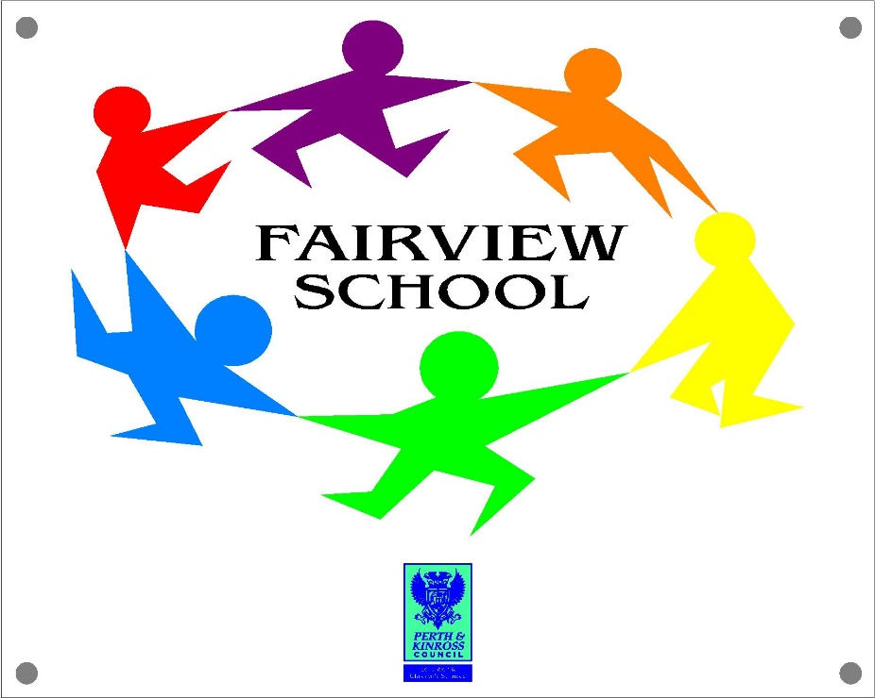

FAIRVIEW SCHOOL

Parent and Carer Communications Policy

Created October 2019, Update October 2022

INTRODUCTION

At Fairview, we believe that good communication between school and the home is essential. Children and Young People achieve more when schools and parents/carers work together. Parents/carers can help more if they know what the school is trying to achieve and how they can help.

At Fairview we aim to have clear and effective communications with parents and the wider community. Effective communications enable us to share our aims and values through keeping parents well informed about school life. This reinforces the importance of the role that parents play in supporting the school in educating their children.

This policy seeks to define the means by which Fairview maintains good communications with parents and other stakeholders. It provides an overview of what parents can expect of the school and, in turn, what the school will expect of parents.

This policy complies with relevant Perth and Kinross Council policy documents, including the Customer Service Standards (July 2010).

PRINCIPLES
Communicating with stakeholders, particularly parents/carers, is a core part of what we do, not an afterthought.
We will always try to share as much information as possible about any issue.
If we cannot share information we will explain why.
We will endeavour to work as transparently as possible by offering clear explanations for major decisions.
We will communicate in a timely fashion and try to avoid parents receiving information about the school from other sources first.
We will communicate in a voice which is courteous, jargon free and warm.
Where information relating to the school is available in the public domain, we will direct people to it.
We acknowledge that some information is of a confidential nature and will always respect that confidentiality.
We will do our best to communicate with all school communities.

All staff will adhere to Perth and Kinross Council Code of Professionalism and Conduct.

.
AN A- Z OF PARENTAL COMMUNICATION WITH THE SCHOOL

We communicate with parents/carers through a range of different strategies. Some of our communications are the result of a statutory requirement; others reflect what we believe is important to our school:

ABSENCE:
If a child is absent from school, and we have no indication of the reason, the school
secretary will contact a parent ( by telephone, if possible) to find out the reason for
absence.

CHILD/ YOUNG PERSON’S PLAN
All pupils have an Annual review to evaluate and develop an action plan regarding
all aspects of their life. Representation from all professional services working with the
family are invited to attend.

DIARY
Children in all classes have a home-school diary. This enables parents to record a wide range of information that they wish to share regularly with the teacher. Teachers use the home-school diary to record achievements, and as a regular channel for communication with parents. The school has 3 main diary formats (See Appendix 1). For specific reasons some pupils may have a bespoke Diary which has been agreed by the class teacher and the Senior Management Team.

EMAIL
The school holds parental email addresses for many pupils and is increasingly moving towards this as the means of communication in preference to paper. Such changes will be subject to consultation with parents in advance.

GROUPCALL
This facility allows the school to send short text messages to parents and is usually used only for matters that require to be drawn to parents’ attention urgently such as unexplained absences, school bus or club cancellations or severe weather closures.

IEPS
For all children/ young people in Fairview there is a need to provide individualised
planning (over and above the group/ class planning already completed by the class
teacher). Long Term targets are agreed as part of the Child/ Young Person’s plan but
Class Teacher’s should continue to communicate with parents around these targets each
term. This can be in person, via a telephone conversation or in written communication.

INFORMATION RETURNS
Throughout the session parents will be asked to make returns to the school by a stated deadline. These could be for a number of reasons, such as information data updates, confirmation of attendance of a pupil on a school trip or activity, feedback on reports etc. Whatever the reason, it considerably eases the administrative burden to the school when parents adhere to the deadlines provided.

MY LEARNING
Details of individual’s learning objectives/opportunities are shared with parents/carers via a termly My Learning plan. IEPs are also highlighted on these plans in green. This is shared on Seesaw and evidence is gathered throughout the term showing how these learning objectives/ opportunities are being developed and achieved.

NEWSLETTER
Details of school events, reminders, requests for help and news are shared in our monthly newsletter.

OPEN AFTERNOONS/ EVENTS
Parents/Carers are invited to Open Afternoons twice a year. There are other opportunities to attend events in school across the year e.g. Christmas Show, Sports Day, Prize Giving and Fundraising Events.

PARENT’S EVENING AND SCHOOL REPORTS
Parents/Carers are invited to attend Parents’ Evenings twice a year. At the end of the May children/ young people will receive an End of Year written report. At Fairview we support pupil voice to share a comment on what is going well for them in school in this report. A copy of the Child/ Young Person’s plan is also shared as and when these occur throughout the year.

PUBLIC ACCESS DOCUMENTS
The school makes available, a range of documentation for parents/carers. We keep a master set in the school office and we make this available on request. It contains copies of all school curriculum policies, minutes of Governing Body meetings and copies of policies that the Governing Body are required to have in relation to charging and remissions, sex education, health and safety, curriculum, performance management, admissions and action planning following inspection. It also contains a range of national and LA documentation. A copying charge may be levied where requests for printed materials are made.

SCHOOL HANDBOOK
A school handbook is made available to all parents through the school website and is updated by December of each year. This handbook meets the requirements of the Education (School and Placing Information) (Scotland) Regulations 2012

SEESAW
Seesaw is the Online Learning Journal which is used for all pupils who have been
given permission to use this. Across each term staff share My Learning plans
alongside evidence of achievements across the areas highlighted for that Term.
Teacher’s also share’ Magic Moments’ which are often not planned for. Seesaw is not
a Diary and should only be used as a reminder for Parent’s and not be relied upon.
Teacher’s do not access this daily so communications should come via the diary
and/or via the office.
Seesaw is also used by the Senior Management Team and Class Teacher to share
whole class/ school notifications.

SOCIAL MEDIA
Parents/ Staff should not use social media personal/private messaging to make contact. Consideration should be given regarding the nature of comments made about members of staff on social media platforms. Where a parent has a concern or complaint this should be raised with the school directly so this can be addressed through the complaint’s procedure.

STANDARDS AND QUALITY REPORT
The school is required under the Standards in Scotland's Schools etc (Scotland) Act (2000) to publish an annual report including key performance measures such as those relating to attainment and attendance. This report is published on the school website in September.

WEBSITE
The school website provides information about the school and an opportunity to
promote the school to a wider audience. The website contains the school handbook
and links to the Twitter page which shares ‘what’s happening’ on a regular basis.
The school website (blogs.glowscotland.org.uk/pk/FairviewSchool). Staff lists and responsibilities are also kept on the school website in the information section.

STAFF COMMUNICATIONS TO PARENT’S/ CARER’S- LETTERS
Copies of class letters sent home are kept in the school office.

TALKING WITH STAFF
Parents are welcome to raise matters with the school by telephone [01738 473050] or by visiting reception. In many cases, including where a message has to be passed on to a teacher, such enquiries can be dealt with directly by the school office staff. Office staff will call the class with the message where appropriate or will send an email to the class teacher to respond to when they are able to. However, if you need to talk with the class teacher in more detail, please make an appointment for a telephone conversation or a meeting in person, as all class teachers are class committed.
Staff keep notes of these interactions in their class communication book as a record for reference.

TWITTER ACCOUNT
This is particularly useful for providing updates on pupils’ achievements both within the school and in terms of extra-curricular activities. https://twitter.com/OnlineFairview

UPDATING THE SCHOOL ON PERSONAL MATTERS
All our pupils can be affected by things going on at home or in their personal lives and thesein turn can have an impact on their learning. It is very helpful for the school to be made aware of anything that a young person may be experiencing away from school that could be having an impact on how they are feeling in school. This could be something such as a family bereavement or friendship difficulties. [Insert how parents should notify the school of such circumstances].

Updating the school in the event of change of contact details

It is very important that the school has current contact details for parents and other relatives. Parents are requested always to notify the school of such changes, both to their own contact details and those of relatives. This can be a particular problem for the school when it comes to mobile phone numbers. [Insert how parents should notify the school of changes].

SEEKING PARENTS’ VIEWS
The Parent Council
The Parent Council, which meets monthly and is attended by the headteacher, is a key vehicle for parents to share their views with the school leadership. These meetings are also used by the school leadership to provide parents with updates on a wide range of issues, ranging from small changes to procedures to very significant government policy changes. The school is committed to harnessing the potential of the Parent Council as a key forum for interaction with parents, and will always seek to support initiatives raised through this body.

Parental Involvement in school self-evaluation and annual planning
The school is also keen to involve parents, as well as other stakeholders, in its annual processes of self-evaluation and planning. Parents’ representatives are invited to take part in the annual strategic planning day, which takes place towards the end of each academic session.

Consultation on proposed change
The school is committed to consulting parents wherever possible, particularly in cases where significant changes in policy or procedures are under consideration. As well as pupils themselves, parents are key stakeholders within the school community and their views are valued and will be taken into consideration in the making of decisions.

On-going evaluation of events
The school is also committed to seeking regular feedback from parents on activities such as parents’ nights and we will always issue evaluation forms to seek parents’ views on how such events might be improved.

Annual parental survey
In addition to these methods of seeking parental views, the school also conducts a formal parental survey, covering a wide range of the school’s functions, towards the end of each academic session. These questions largely remain the same each year which allows the school to note trends – either positive or negative – in terms of parental responses. A summary of this survey is shared annually with the Parent Council and, where appropriate, their views on next steps sought.

SCHOOL CONTACT DETAILS:

Email Address: Fairview@pkc.gov.uk
Phone No: 01738 423050
Website: https://blogs.glowscotland.org.uk/pk/FairviewSchool/
Twitter/Facebook: https://twitter.com/OnlineFairview
Address: Fairview School, Oakbank Crescent, Perth, PH1 1DF

Parental complaints - Should a parent wish to make a formal complaint about any aspect of the school, this should be addressed to the Headteacher. The school follows the Perth and Kinross Complaints Procedure. Such complaints can be made by email, letter, telephone or in person.

