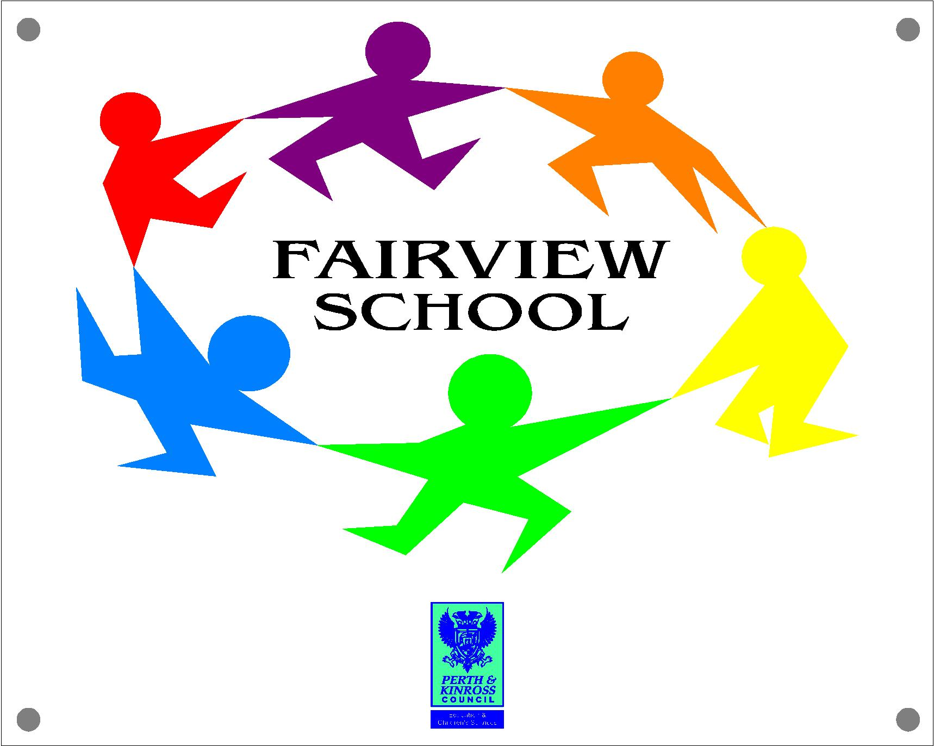 FAIRVIEW SCHOOL LEARNING and TEACHING POLICY 2018

VISION
Fairview School is passionate about learning, achievement and enjoyment for all. We will work in partnership, challenging ourselves to improve and innovate to meet the individual needs of children and young people with complex and enduring needs, in an ever changing world.

Values
Respect Integrity Empowerment Compassion

AIMS
We aim to provide the highest possible standard of teaching and learning experiences to encourage all children to develop as successful learners, confident individuals, responsible citizens and effective contributors.

We aim to:

- To provide a bright, stimulating, communication friendly and nurturing environment which is welcoming and inclusive
- To work with an ethos which fosters shared values and mutual respect, recognising the importance of each individual
- To ensure children, young people and adults are safe and protected
- To provide opportunities for high quality and enjoyable learning to take place
- To be innovative and adventurous in our approach to the curriculum, always challenging ourselves to improve
- To support healthy lifestyles by promoting healthy eating, active lifestyles and positive mental well being
- To empower children and young people so that they develop curiosity, can make choices and become as resilient and independent as possible
- To champion pupil voice in all we do
- To encourage leadership at all levels
- To provide consistent and effective transitions into nursery, between classes and post school, which build on pupils’ experiences and learning
- To encourage and enable open communication and partnerships between staff, pupils, families and other agencies
- To be an integral part of the wider community and share good practice to promote inclusion
- To work in collaboration with others to be the best we can be

CURRICULUM
We aim to be guided by the Principles for Curriculum Design outlined in Curriculum for Excellence which are:

- challenge and enjoyment
- breadth
- progression
- depth
- personalisation and choice
- coherence
- relevance

PRINCIPLES
The key principles of effective learning and teaching which underpin this policy are as follows:
- promotion of social inclusion and equality for all
- setting of high and realistic expectations ensuring success for all
- active engagement of learners and promotion of high self esteem
- development of commitment, responsibility and independence in learners
- promotion of creativity, flexibility and innovation
- following Curriculum for Excellence at all times with a focus on the NIF and CEC priorities to improve outcomes for all learners

LEARNING, TEACHING and ASSESSMENT
PLANNING

In planning, teachers pre-determine those aspects of work which are appropriate for each group or individual in the class. Each programme of study has clear and relevant learning outcomes which are communicated to pupils and parents and reviewed with all those involved in the learning and teaching process.
Experiences and outcomes in a Curriculum for Excellence are covered at appropriate levels to ensure a broad, general education. Senior Phase is planned around appropriate certification e.g. SQA, ASDAN etc.
Where appropriate, specialist staff are involved in the collaborative planning process.

INTER-DISCIPLINARY LEARNING

Interdisciplinary learning allows pupils to see, make and understand links between discrete subject areas. Effective inter-disciplinary learning is a collaborative piece of work, project or course which is planned and coordinated between disciplines and which delivers one cohesive piece of learning or area of study.

Effective interdisciplinary learning:

- can take the form of individual one off projects or longer courses of study
- is planned around clear purposes
- is based on experiences and outcomes drawn from different curriculum areas or subjects within them
- ensures progression in skills and in knowledge and understanding
- can provide opportunities for mixed stage learning which is interest based

ASSESSMENT
Assessment whether it be formative or summative is used to measure progress and to identify the next steps in learning in order to meet the needs of the pupils. Effective assessment is at the heart of effective learning and teaching and leads to an improvement in the quality of learning and teaching. Assessment is therefore a dynamic process.

Through assessment, teachers and staff ensure that learning is appropriate to the needs and abilities of each individual pupil. Pupils where appropriate are encouraged to evaluate their own progress and help one another to do their best with support from teachers, staff and parents, and set targets and next steps for learning.
The method of assessment in our school is:

- linked to forward planning
- informed by current teaching approaches
- an ongoing, formative, continuous process using assessment is for learning strategies (AifL) especially in BGE
- is moderated using ‘progression pathways’
- Summative in Senior Phase measured through SQA accreditation etc
- used to provide guidance for the next steps in the learning process to pupils and parents
- used to inform reporting to parents, the Authority and HMIe. Accountability

LEARNING and TEACHING STRATEGIES
Teachers have a responsibility to lead learning in their classrooms and pupils have a responsibility to be actively engaged in their learning. Effective teaching means adopting a range of roles depending on the circumstances. A range of teaching approaches, including, for example, the appropriate use of ICT, critical skills and collaborative learning, cooperative learning, experiential learning, Maslow’s hierarchy of needs, active learning, four phase model and AiFL in order to maximise opportunities for all pupils.

Teachers and staff draw on a wide range of communication skills and deploy these according to the particular circumstances. Lessons are well planned and well structured; teaching is flexible in order to meet the expectations of Curriculum for Excellence.

Teachers and staff take account of learning preferences, different aptitudes, emotional intelligence and self-esteem in order to ensure that all learners are actively engaged in meaningful teaching and learning.

Teachers:
- endeavour to meet the needs of all abilities in the class to ‘get it right for every child’
- give support to learners experiencing difficulties
- extend pace and challenge for all learners at a level appropriate to the child
- provide work which is relevant and meaningful to the experiences and interests of all pupils in line with Curriculum for Excellence outcomes
- engage pupils actively in their learning
- provide opportunities for pupils to formulate their own questions, to express their own thoughts, to make their own meanings and to share their knowledge and understanding with one another, thereby challenging and extending the pupils’ thinking
- employ praise and encouragement as a means of motivating pupils

TRACKING and MONITORING

The school is developing an electronic system to accurately track data on learners’ progress. This information will be shared with pupils, staff, parents and partners and will be clearly linked to the end of year school report. Tracking information helps form a learner’s individual profile as they move through key stages in school.

The quality of learning and teaching is tracked through a robust quality assurance system.

SELF EVALUATION

All staff engage in self-evaluation of learning and teaching using the quality indicators and related advice from ‘How Good Is Our School?’ with a view to continually improving the quality of programmes of study and learning and teaching experiences.

Information is gathered from:

- shared classroom experiences, discussions with and evidence of pupils’ work
- teacher, department and management discussions
- professional review
- evaluations from pupils, staff, parents and partners
- results of assessments and achievements, curriculum for excellence levels and SQA results
- Quality Improvement Officer visits, Authority Reviews and HMIe Inspections

The self-evaluation process reflects on the effectiveness of learning and teaching and the impact that it is having on continuous improvement within the school.
Next steps identified from self-evaluation, with guidance from the Authority and HMIe, inform the annual school improvement plan, which details areas for continued school improvement. All improvement is clearly liked to the NIF and CEC priorities.

Staff, pupils and parents continually work together to improve learning and teaching for all our pupils at Fairview School.

CONTINUING PROFESSIONAL LEARNING
The needs of staff in the development of Learning and Teaching are addressed in a variety of ways:

- working with staff, promoted staff and quality improvement officers
- sharing examples of good practice within school, the Authority and wider community
- accessing CPL opportunities
- disseminating good practice through discussion, shared classroom experiences, team-teaching and visits to other schools
- a robust ERD process

IMPACT
A focus on these principles and aims ensures that:

- The needs of all learners are met to ensure we ‘get it right for every child’ (following GIRFEC Guidelines).
- The NIF and CEC priorities are met and outcomes have been improved for all learners
- The school is developing as a learning organisation where managers and staff recognise themselves as learners and are actively engaged in continuing professional learning.
- Pupils and staff work collaboratively and a learning partnership with home is promoted.
- A range of well-planned effective learning and teaching approaches are used where reliable, dynamic assessment and reporting is an integral part of the process.
- Continuous improvement in performance at individual, group and school level takes place.

