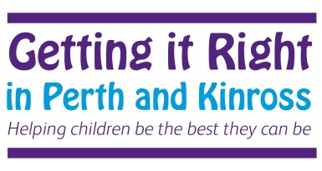

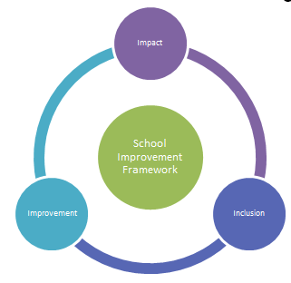

Mutual Trust and
Respect
Openness, Honesty and Integrity
Fairness and Compassion

Pa

School Improvement Framework Map and School Improvement 2019-20

The School Improvement Framework Map
The Scottish Government’s vision for education:  • Excellence through raising attainment:  • Achieving equity  NIF Key Priorities:  • Improvement in attainment, particularly in literacy and numeracy  • Closing the attainment gap between the most and least disadvantaged children  • Improvement in children and young people’s health and wellbeing  • Improvement in employability skills and sustained, positive school-leaver destinations for all young people | National Improvement Framework –Drivers for Improvement  - School Leadership  - Teacher Professionalism  - Parental Engagement  - Assessment of Children’s progress  - School Improvement  - Performance information  The ECS Strategic Implementation Plan – Raising Attainment for All 2016 - 2019 will be a key document in supporting schools to use the NIF expectations as part of their improvement journeys. | Tayside Plan for Children, Young People and Families 2017-2020  - Our children will have the best start in life, they will be cared for in nurturing environments and ready to learn;  - Our children, young people and their families will be meaningfully engaged with learning and combined with high quality learning experiences, all children and young people will extend their potential;  - Our children and young people will be physically, mentally and emotionally healthy;  - Our children and young people who experience particular inequalities and disadvantage will achieve health, wellbeing and educational outcomes comparable with all other children and young people;  - Our children and young people are safe and protected from harm at home, school and in the community.
Education Services  - ELAVs / LAVs  - Professional Learning  - Professional Dialogue  - Building Capacity in Partnership  Schools & Centres  - Strategic 3 Year Plan  - Outcomes and measures of Impact  Actions 2018  - Self-evaluation / Standards and Quality  - LMG Action Plans will detail the work around outcomes for session 2019-20 | NIF Key Priorities  Tayside Plan  PKC Plan  PKC Outcomes  Schools & Centres  Stakeholders | PKC Statement of Intent:  Our vision is of a confident and ambitious Perth and Kinross with a strong identity and clear outcomes that everyone works together to achieve. Our area will be vibrant and successful; a safe, secure and healthy environment; and a place where people and communities are nurtured and supported.
Support and Scrutiny  - Education Scotland – Inspection  - Care Inspectorate  - Validated Self Evaluation  - Services for Children’s Scrutiny (Child Protection) | PKC Outcomes  - Raising achievement for all;  - Supporting vulnerable children and  - families;  - Improving the quality of life for  individuals and communities; and  - Enabling the delivery of high quality  public services | P & K Community Plan 2017-2027  - Giving every child the best start in life  - Developing educated, responsible and informed citizens  - Promoting a prosperous, inclusive and sustainable economy  - Supporting people to lead independent, healthy and active lives  - Creating a safe and sustainable place for future generations

Curriculum Rationale
Values  The totality of learning experienced by all our children enables them to develop relevant knowledge, skills and attributes to be lifelong successful learners, confident individuals, responsible citizens and effective contributors in a global society.  All stakeholders effectively work together to provide an inclusive, relevant and motivating learning environment for all.  Each child’s achievements are celebrated.  Pupils feel safe, secure and nurtured. | Totality of the Curriculum  Children, families, staff and our community are involved in both planned and spontaneous opportunities which develop the life and ethos of the school.  There is a considered blend of discrete subject development and interdisciplinary learning designed around contexts which are relevant and meaningful to our children.  Opportunities are planned for all children to develop and achieve their potential as individuals. | Learning and Teaching  All staff have a shared understanding of effective learning and teaching approaches which are embedded in practice consistently across the school. A variety of high quality strategies and tools are employed appropriately and effectively to ensure that each child is engaged, challenged and enjoying their learning..
Experiences and Outcomes  Relevant Experiences and Outcomes are used to plan meaningful learning experiences for every child. This ensures consistent, progressive development of their knowledge, skills and attributes. | 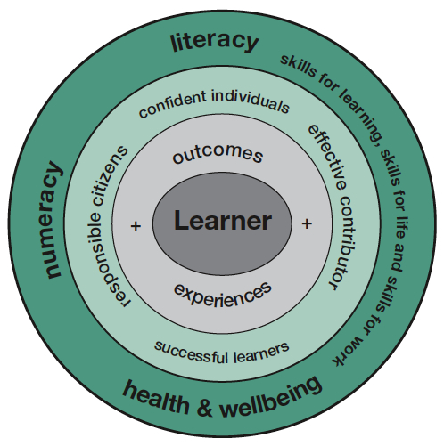 | Entitlements  Each child experiences a broad, coherent, relevant curriculum which meets their needs. All children have appropriate opportunities to develop the skills for learning, life and work, including the skills and attributes of the four capacities.  All our children engage in learning experiences which enable them to develop their understanding of their place in the world supported by their families and our community.  Our children, families, staff and community have high expectations of themselves and the school and play a significant role in improving our school. Every child experiences success.
Support  Transition support at all levels and stages demonstrates best practice in ensuring each child is supported appropriately.  All stakeholders are clear about agreed policy and practice in this area. Support needs for each child are identified, addressed and reviewed as needed to ensure that learning experiences meet their needs and that we make best use of all available resources. | Principles  The seven principles of curriculum design underpin all planned learning experiences and are consistently used as an integral part of the quality assurance process. | Assessment  The continuous cycle of learning, teaching and assessment is built on a sound foundation underpinned by the principles of Assessment for Learning and is individualised based on need.

School Improvement Plan - Priorities and Outcomes
What are the outcomes that you plan to achieve for your children, young people and families for this session?
Improvement Outcome: Staff and pupils health and wellbeing will be improved.

NIF Priority: Improvement in children and young people's health and wellbeing | NIF Driver(s):School Improvement | HGIOS4 QI(s): 3.1 and 2.1
School Lead: SMT, H&W Coordinator, Staff Wellbeing Working Group | Completion Date: June 2019 | Review Date: Ongoing
What impact will you measure?  What’s going to be different or better? | How will you measure it?  What and by when? |  | Progress at Review Date
Universal Support
Pupils  -There will be a reduced number of V&A incidents.  -Pupils will be more regulated, how this achieved shared with parents  -Staff will be more qware of strategies to encourage self-regulation through the Emotion Works dialogue tool.  Pupils will be given support to develop healthy lifestyles – healthy eating, fitness, outdoors…  Staff  Staff will feel more relaxed.  Staff will feel they have an understanding of their own self-regulation  Attendance will improve  There will be a staff health wellbeing working group  Staff will have identified what they need  There will be less stress toolkits in relation to work  Staff will feel more supported in their teams  Policies/self evaluation in place to support the promotion of health and wellbeing and safeguarding. | Pupils  -Data – ongoing  -Observations, discussions with staff, pupils and parents – related to number of incidents  -Observation, questionnaire analysis – twice yearly  - Observations, discussions with staff and pupils, number of physical opportunities, timetables showing physical activity and outdoor learning  Journey towards Health Promoting Schools  Staff  Attendance data  Questionnaires  Observations  Discussions/ERDs  Number of stress toolkits  Journey towards Health Promoting Schools  Policies in place  Self evaluation carried out
Targeted Support
Pupils  As above but with specific focus on identified pupils involved in high number of incidents.  Targeted group in relation to self-regulation  Targeted physical activity group related to pupils with high BMI  Targeted healthy eating groups related “fussy eaters”  Staff  Targeted to support staff with specific work stress related issues. | Pupils  Less incident forms  Measuring of BMI  Observations of eating habits  Staff  Less toolkits  ERDs

School Improvement Plan - Priorities and Outcomes
What are the outcomes that you plan to achieve for your children, young people and families for this session?
- Improvement Outcome: Development, and tracking, of curriculum pathways.
NIF Priority: Improvement in attainment | NIF Driver(s):School Improvement, Assessment of Children’s progress | HGIOS4 QI(s): 2.2 & 2.3 &1.3
School Lead: SMT, TLCs | Completion Date: June 2021 | Review Date: Ongoing
What impact will you measure?  What’s going to be different or better? | How will you measure it?  What and by when? |  | Progress at Review Date
Universal Support
There will be work carried out towards developing a more relevant curriculum for all learners  There will be a curriculum pathways document produced which staff have been involved in creating.  Pupils will be better prepared for leaving schools.  Staff learning activities will be linked to curriculum development (including skills)  Information passed on at transition points will focus on achieved skills  Families will feel more confident and supported to take forward learning  Focused learning opportunities on skills development  Policies in place/Self evaluation to support relevant curriculum e.g. total communication policy  The library will be developed to take into account the changing pupil population and pathways and have more appropriate resources to support learning. | Work will have been carried out  Staff discussions  In-set programmes  SeeSaw evidence  Documents produced and shared  Discussion with transition team and post school providers  Questionnaries, discussions  Observaiton of greater independence  Timetables  Planning documents  Policies in place  Self evaluation carried out.
School Improvement Plan - Priorities and Outcomes
What are the outcomes that you plan to achieve for your children, young people and families for this session?
Improvement Outcome: Increase family engagement in order to promote positive relationships, better learning and behaviour.

NIF Priority:  Improvement in children and young people's health and wellbeing | NIF Driver(s):Parental engagement | HGIOS4 QI(s): 2.5 & 3.2
School Lead: SMT, SSCOs | Completion Date: June 2020 | Review Date: Ongoing
What impact will you measure?  What’s going to be different or better? | How will you measure it?  What and by when? |  | Progress at Review Date
Universal Support
- Greater number of parents attending events – both social, sharing learning and training (and Parent Council).  - Parents will feel more confident that they know what their children are learning at school and how they can support them.  - Parents will be given increased opportunities to build relationships with other parents and build support networks.  - Parents will be supported to attend training and/or social events.  - Parents will feel more involved in the everyday learning that goes on throughout the school through the use of SeeSaw.  - Policies will be in place to support effective parental engagement. | - Baseline numbers from current year events. Number of training/other events provided – baseline from current year.  - Questionnaires/discussion/observations  - Questionnaires/discussion/observations  - Is there an increase in attendees. Questionnaires/discussion/observations  - Measure level of interaction. Questionnaires/discussion/observations  - Policy will be in place.
Targeted Support  As above but more personalised approached through SSCO direct contact. | As above

