Monday  | Tuesday | Wednesday | Thursday | Friday
P3-P7 Karate  3.45-4.45pm  Aytoun Hall  Led by Cathy Clifford   | P4-P7 Hockey  4-5pm  Astro  Led by Ailsa Wyllie and Pam Bryson   | P6-P7 Pickleball  5pm-6pm  Games Hall  Led by Cat   | P7 Transition Rugby club- Boys and Girls  3.45pm-4.45pm  Grass pitches  Led by Perthshire rugby club   | P5-P7 Netball  3.45-4.45pm  Games Hall  Led by Senior Pupils and Cat  
 | 2015’s Football  5pm-6pm  Astro  Led by Martin Howitt   |  | P5-P7 Badminton  4.45pm-5.30pm  Games Hall  Led by Senior pupils and Cat  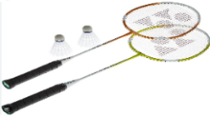
 |  |  | 2015’s Football  5pm-6pm  Astro  Led by Martin Howitt | 
Extra-Curricular Cluster Clubs Term 3 (from 17/2/25)

