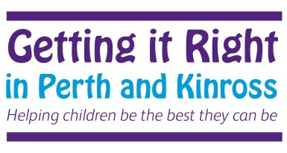

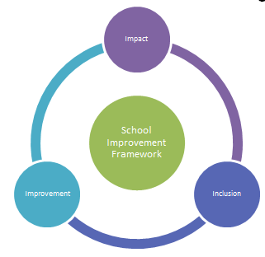

Mutual Trust and
Respect
Openness, Honesty and Integrity
Fairness and Compassion

Pa

School Improvement Plan 2018-2019
Braco Primary School

Braco Primary School
Knowing our Gaps – Data and Analysis
Key Local Data | Braco Primary has 46 pupils PEF allocation = £1200 = 1FME (no longer in school)  School population:  Acorn 1: 61% 28 pupils  Acorn 2: NIL  Acorn 3: 20% 9 pupils  Acorn 4: 17% 8 pupils  Acorn 5: NIL  SIMD:  1+2: NIL  3+4: NIL  5+6: NIL  7+8: 93% 43 pupils  9+10: 7% 3 pupils  Of the 8 pupils in Acorn 4 and the 43 pupils in SIMD 8  Stage ACORN 4 SIMD 8 SIMD 9  P1 1 6  P2 2 10  P3 0 6  P4 4 5  P5 0 3 3  P6 1 5  P7 0 8  Current tracking data for the above children shows that:  - Most pupils in P1 are on track or are secure in national expectations in Literacy (L&T – 83% R – 83% W – 83%). Of these pupils 17% have ASN (1 pupil)  - Most pupils are on track or ahead in Numeracy (83%). Of these pupils 17% have ASN (1 pupil)  - Most pupils in P4 are on track or are secure in national expectations in Literacy (L&T – 86% R – 86% W – 75%) Of these pupils 25% of pupils have ASN (2 pupils)  - Most pupils are on track or ahead in Numeracy (86%). Of these pupils 14% have ASN (1 pupil)  - The majority of pupils in P7 are on track or secure in national expectations in Literacy (L&T – 88% R – 88% W 63%) Of these pupils 12% have ASN (1 pupil)  - Most pupils in P7 are secure in national expectations in Numeracy (88%). Of these pupils 12% have ASN in Numeracy specifically.
Analysis of What This Reveals in Terms of the Attainment Gap | All P1 pupils are in SIMD 8, P4 SIMD 8 and 9 and P7 all pupils are in SIMD 8.  In P1 our only Acorn 4 child is secure at their national expectation.  In P4, 1 child in Acorn 4 is not secure at their national expectation – they have additional support needs.  In P7 the children in Acorn 3 are performing, either secure or almost at the national expectations.  Attainment and tracking data across all stages in the school shows that there is a need to focus on literacy (in particular writing towards second level).
Identification of Target Populations | Out of the whole school we have 8 pupils not meeting their learning Milestones, 5 of these pupils have ASN and 4 of these pupils sit within Acorn 3/4  These pupils will receive targeted interventions through Word Aware groups, Write to the Top strategies, Active Literacy sessions and Hi 5 for 3 pupils with specific Reading Difficulties.
Areas for Collaborative Action | Work with LMG colleagues to  - moderate practice across schools  - share resources and best practice  - engage with strategies for effective feedback and metacognition as an LMG  Link with other agencies and ECS staff as appropriate

Performance Information | Key Priorities 2017-2020 | School Leadership
- Staff to continue to develop an understanding of the National Improvement Framework, HGIOS4 and HGIOELC and the implications for practice  - Staff to engage with Four Arenas of Participation (HigiOUR School)  - Continue to analyse and interpret data – national, local and school (including SIMD and ACORN) to identify trends and ways forward with a close focus on identified pupils as part of Closing the Gap  - Continue to use Scottish National Standardised Assessments. Interrogate data collected from formative and summative assessments to enable a more robust data analysis | - Forest School to continue to be a resource used to raise attainment in Health and Wellbeing Literacy and Numeracy  - Through moderation, develop a shared understanding of progression through a level and achievement of a level in addition to moderation of the Learning Intentions and Success Criteria  - Close the Gap in attainment and achievement  - 1+2 will continue to be ongoing development  - To continue developing a Restorative Approaches working towards Peer Mediation  - Learners have improved performance in Literacy skills and enhanced vocabulary  - Learners have improved attainment in and engagement with Numeracy | - Leadership opportunities within school and authority for all staff  - Close working relationships with our cluster schools on Moderation and aspects of the School Improvement Plans  - HT and PT Development Days  - HT to work on authority developments  - SMT to use data to analyse significant educational gaps to prioritise support challenge and intervention – Closing the Gap  - Staff to engage in research for school developments  - Staff responsibility for their committees and subsequent activities  - Continue Community Engagement for School Transformation Project
School Improvement | 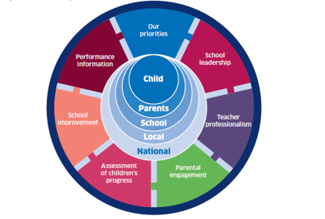 | Teacher Professionalism
- Use and understand challenge questions in HGIOS4 and HGIOELC to evaluate practice  - Closing the Gap – narrow the equity gap by identifying and tracking relevant pupils’ progress using appropriate interventions  - Raising attainment in Literacy and Numeracy – staff to engage CLPL opportunities  - Establish learning pathways for Literacy and Numeracy using the benchmarks  - Further develop holistic assessments at planning the learning meetings  - Develop forest school initiate focusing on Literacy, Numeracy and HWB |  | - Moderation opportunities in school and across LMG  - Staff to engage with relevant CLPL which has an impact on practice  - Develop a shared understanding of the Benchmarks and learning pathways  - Skills development to be a feature of classroom practice  - Peer monitoring to flourish within own school and outwards to cluster schools
Assessment of Children’s progress | LMG Priority | Parental Engagement
- Access a range of resources to assess pupil progress, e.g. Benchmarks, Standardised Assessments, WTTT assessment etc  - Staff to gain confidence to analyse and interpret data, identify priorities for learning and target support and interventions for individual pupils  - Record and track Pupil progress through Tracking module and own tracking table  - Pupils, staff and parents will confidently engage with learning conversations, supported by learning journals, identifying strengths and next steps in learning | - Staff from across the LMG will work together collegiately to achieve excellence and equity. They will engage in ongoing professional learning which will include sharing best practice, professional reading, action based research and teacher learning communities. | - Sustain parental partnerships through focus groups and Parent Council activities  - Improve consultation process with Parent Council and parents regarding SIP, SQR and Self-Evaluation  - Rhyme time to encompass all young children in the community  - Parents invited to Get Togethers, School Events, Sharing the Learning events and fundraisers  - Parental workshops along with pupils in the evenings  - Learning Journals go home 3 times per year  - Parent Contact Evenings  - Stage engagement in Parent Council Meetings

Curriculum Rationale

Values  Staff work in partnership with community, families and pupils to provide a nurturing learning environment for pupils that is articulated in our revised school Vision, Values and Aims.  Embedded are the principles of Restorative Practice and Nurturing approaches within the school and community.  Staff, families, pupils and the wider community contribute to the life and work of the school and are included in the self-evaluating process.  Opportunities to work with the local and wider community are created.  Every pupil is recognised for their achievements which are celebrated. Pupil Voice is heard through a variety of mechanisms e.g. Pupil Council, Visible Planning with their teacher, Focus Groups, Questionnaires for HWB as well as a general school questionnaire and through Learning Journals. | Totality of the Curriculum  There is a blend of discrete subjects and interdisciplinary learning that provides rich, highly-motivating and relevant contexts for pupils. There are planned opportunities for personal achievement through academic, sporting and cultural activities. These are celebrated at weekly Get-Togethers and the Celebrations & Achievements Ceremony/Celebrating Success. The ethos and life of the school is developed through a wide range of experiences. The curriculum is delivered within a safe and caring environment with an ethos of achievement and success. Our curriculum includes, recognises and celebrates the wider achievement of pupils thus enabling them to reach their full potential.  Es and Os are used to plan, Benchmarks are used to assess and track children’s learning and clearly show the ongoing developments of all. Opportunities are planned for all children to develop and achieve their potential as individuals. | Learning and Teaching  Opportunities are created to work with community groups through IDL and Forest Schools.  Staff will continue to ensure learning and teaching is engaging and active, real and relevant, planned to support and challenge all learners. Tasks will be differentiated to meet the needs of the learner and take account of their learning styles, alongside relevant interventions as appropriate.  A variety of high quality strategies will be employed in order to deliver effective learning experiences for children. These will include AiFL and Forest School and use of appropriate technologies. Within the single class setting, teaching strategies are used that meet the needs of all learners with independence within the learning tasks being encouraged. Pace and challenge for all continues to be maintained through the differentiation of appropriate learning opportunities. Visible planning mechanism is in place that records the children’s learning across the 4 contexts.
Experiences and Outcomes  Experiences and outcomes are planned and developed through the four contexts for learning and provide a varied and rich learning environment. Teachers identify opportunities for inter-disciplinary learning, Active and Co-operative Learning. Teachers understand experiences and outcomes and are confident in using them to deliver effective learning experiences for children to a consistently high standard. Teachers will evaluate all aspects of planning and assessment of pupils’ learning. Staff will record and report on pupils’ attainment and achievements, informed by progress within levels. Teachers will continue to plan and provide differentiated experiences and outcomes in all areas of curriculum. Children understand clearly the importance of target setting and having learning discussions on a regular basis where they are encouraged to share and discuss their learning and next steps which are then shared with parents/carers through Learning Journals. Children are fully engaged within the schools developments and self-evaluations and are clear about their different roles and responsibilities within the school. | 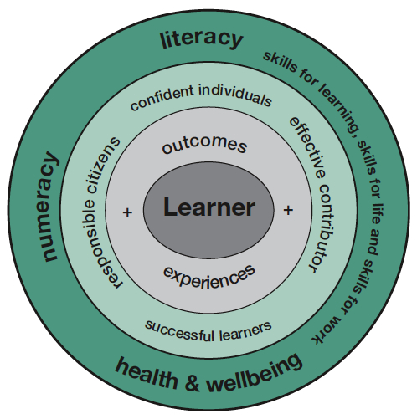 | Entitlements  Our school will provide for every pupil a broad, coherent, progressive and relevant general education that includes an understanding of Scotland’s place in the world today. There will be appropriate support for learning, in order for the school to get it right for every child. Effective transitions will be in place for pre-school to P1 and for P7 to S1 and from class to class. Staff will plan learning experiences and outcomes which will enhance skills for learning, life and work so that all our young people will lead purposeful lives within society.  Each child, staff member and parent/carer is valued and within a climate of mutual trust and respect, all are encouraged to share their views within a positive framework and upholds GIRFEC, Child Protection, Restorative Approaches and P&Ks Anti-Bullying Strategy.
Support  Staff will support pupils by reviewing their progress and planning next steps in their learning. We provide appropriate support and challenge for all pupils and continue to ensure their opportunities for success. Transitions are planned, supportive, informative and timeous. There will be provision for appropriate support to accommodate children’s learning needs.  Staff will continue to participate in CPD opportunities to develop and share knowledge and understanding in order to provide an enhanced provision, with a particular focus on Forest Schools, Restorative Approaches, Nurturing Principles and Pupil Profiling which will be reflected in the interactions between staff and pupils. We will work with support agencies effectively to ensure the Health and Well-being of all pupils. Child protection guidance is adhered to and pertinent information shared appropriately.  All staff know each child as an individual providing exceptional care and welfare, experiences that meet the individual needs of each child in terms of appropriate challenge and support.  Professional dialogue within our staff team and beyond is actively encouraged. | Principles  Braco Primary School endeavours to apply the 7 Principles across the curriculum areas - Challenge and Enjoyment, Breadth, Progression, Depth, Personalisation & Choice, Coherence and Relevance.  The principles will be applied systematically across the totality of the curriculum, including the life and ethos of the school. | Assessment  We ensure that the cycle of learning, teaching and assessment is continuing to be under review. Pupil Profiles (Learning Journals) are in place for all pupils to record their achievements and to review and share with their parents. Staff scrutinise the results of standardised testing in order to establish breadth, challenge and application of learning.  Through moderation within and out with our school and choosing appropriate resources, we will review the balance of IDL and discrete subjects.
2

School Improvement Plan - Priorities and Outcomes
What are the outcomes that we plan to achieve for our children, young people and families for this session?
Improvement Outcome:
Learners have improved performance in talking (enhanced vocabulary), listening, writing and reading measured against prior levels of learning
NIF Priority: | NIF Driver(s): | HGIOS4 QI(s):
- Improvement in attainment particularly in literacy in particular oral communication and writing  - Closing the Attainment Gap | School leadership  Teacher professionalism  Parental engagement  Assessment of children’s progress  School improvement  Performance information | 2.2 Curriculum  2.3 Learning, teaching and assessment  2.4 Personalised support  3.2 Raising attainment and achievement
School Lead: Class Teachers | Completion Date: May 2019 | Review Date: November 2018  March 2019
What impact will you measure? | How will you measure it? |  | Resources / Pupil Equity Fund | Progress  Red Amber Green
The quality of learning & teaching and level of learner engagement in the learning process.  Children’s confidence  Raised levels of literacy attainment  Overall improvement of vocabulary/grammar and information finding for the target groups  Overall improvement of attainment/achievement of a level | Programme of class visits by SMT  Learning rounds model pre/post development.  Learner conversations.  Diagnostic baselines of reading and spelling ages with mid-point review  Robust analysis of data – baseline/mid-point reviews  Tracking and prediction information supported by benchmarks  Increase of vocabulary evidence within written tasks  Pupil participation in class presentations  Planning and tracking meetings  Scrutiny of forward plans  Evaluations of interventions |  | Active Literacy  Word Aware  Hi 5

School Improvement Plan - Priorities and Outcomes
What are the outcomes we you plan to achieve for our children, young people and families for this session?
Improvement Outcome:
Learners have improved attainment in and engagement with Numeracy measured against prior levels of learning supported by a Numeracy Pathway
NIF Priority: | NIF Driver(s): | HGIOS4 QI(s):
- Improvement in attainment particularly in Numeracy  - Closing the Gap | School leadership  Teacher professionalism  Parental engagement  Assessment of children’s progress  School improvement  Performance information | 2.2 Curriculum  2.3 Learning, teaching and assessment  2.4 Personalised support  2.5 Family Learning  3.2 Raising attainment and achievement
School Lead: Class Teachers | Completion Date: May 2018 | Review Date: November 2018  March 2018
What impact will you measure? | How will you measure it? |  | Resources / Pupil Equity Fund | Progress  Red Amber Green
Improved confidence in Numeracy across all stages  The quality of learning & teaching and level of learner engagement in the learning process  Raised levels of Numeracy attainment  Improved Family engagement in Numeracy activities at home to develop real life skills | Learning conversations, Teacher observations, Learning Journals  SMT Monitoring and Peer good practice visits,  Staff feedback on the effectiveness of the Numeracy pathway  Diagnostic baselines, National Standardised  Assessments, Tracking and prediction information supported by benchmarks, robust analysis of data  Families attending offered events, Parent focus group (Talking Teas)  Planning and tracking meetings  Scrutiny of forward plans  Evaluations of interventions |  | Big Maths  Mental Maths boxes  Good Practice Visits  Maths sacks

Pupil Equity Fund 2018-2019 Planning and Reporting

PEF Allocation £ 1200

Please refer to the 2018 National and PKC Guidance when completing this table.

Improvement Outcome | Theme  i.e. Attendance, Attainment etc. | Intervention/Approaches | Measures of Impact | School Lead | Projected Spend  (£) | Projected Spend Timescale
Learners have improved performance in talking (enhanced vocabulary), listening, writing and reading measured against prior levels of learning | Attainment | Hi5 | Feedback from Training  Evidence of writing/reading  Standardised Assessments in Reading  WTTT Assessments  Renfrew Word Finding Assessment | Susan Ross | 1200 | By Jan 2019

