  - the spina bifida bingo night!
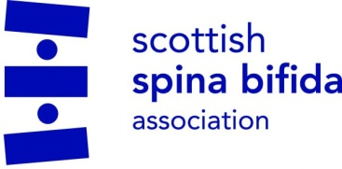
Thursday 3rd March, 6-8.30pm
Holy Family Church Hall
Claredon Place
Dunblane FK19 9HP
Raising awareness for Spina Bifida Hydrocephalus Scotland!

Come join us for some cake, coffee and a bit of bingo fun!
Lots of prizes to be won!

£
£1.50 for first bingo card and pen, £1 for cards thereafter.

