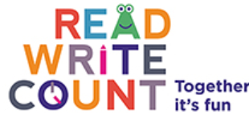
Read, Write, Count: Together it’s fun
The Read, Write, Count Campaign (for P1 – P3 pupils and their families) has recently launched with a TV advert which will run through the month of February. The ad is part of a campaign to encourage parents to spend more time doing fun literacy and numeracy activities with their children. There will also be adverts on large outdoor poster sites, on trolleys in Asda and in digital advertising. Read, Write Count has an excellent website (www.readwritecount.scot), a Facebook page and twitter account. Simply search for ReadWriteCount, like and follow.
Perth & Kinross Council is celebrating the launch of the National Read, Write Count Campaign which is aimed at the parents of children P1-P3. Storyteller Gerard Durkin will be entertaining families at the North Inch Community Library on Saturday 6 February 2016, between 11.00 a.m. and 12 noon. This event is free to children and their families. Places must be booked by contacting the North Inch Community Library. (01738 454406). Promotional gifts will be handed out to families on the day.

