COPING WITH STRESS

Free 8 Week Course
Available to anyone aged 16+ living in Crieff or the surrounding areas
Learning relaxation ecnques
Getting my point across

Dealing with panic attacks

Starts Friday 29/1/16
10.00 – 12.00
To book a place please contact
Val, Anne or Donny
The Wellbeing Support Team
Crieff Learning Centre
5 Lodge Street
PH7 4DW
01764 657860/1
or email VCannon@pkc.gov.uk

Information on stress

How to cope with stress and anxiety
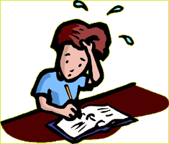

If you would be interested in future courses please let us know

