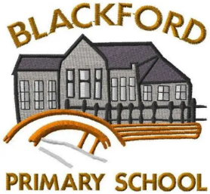
Blackford Primary School
May 2026 Newsletter

Welcome to our May newsletter at Blackford Primary School—a month where our classrooms are buzzing with energy, curiosity, and achievement as we make the most of the brighter days and exciting learning opportunities. From whole school successes to extracurricular clubs and upcoming events, this edition celebrates the hard work, kindness, and team spirit that make our school such a special place to learn and grow.
Increasing motivation and wellbeing in our classrooms
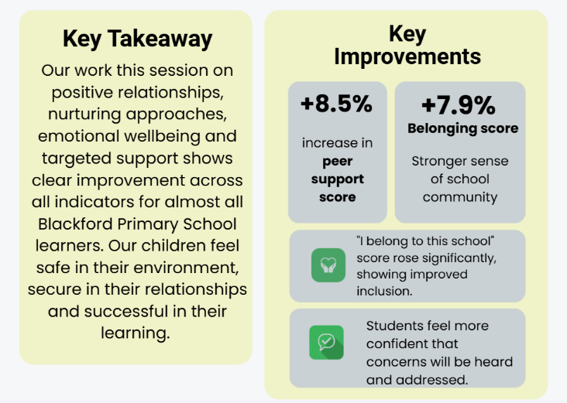
We are delighted to share very positive results from our recent Glasgow Motivation and Wellbeing data, with improvements across all indicators.
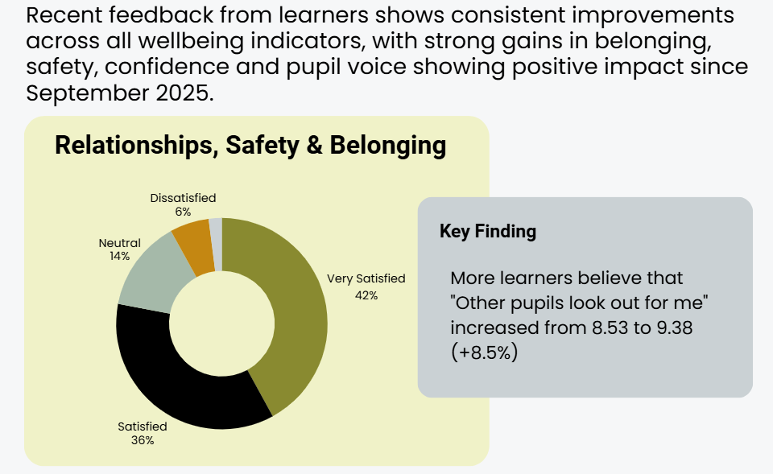
Our children tell us they are feeling more confident, supported and ready to learn, which reflects the nurturing approaches and strong relationships across the school. Their answers tell us that more pupils feel calm and settled in class, showing the impact of our focus on wellbeing and positive learning environments. These encouraging results highlight our ongoing commitment to helping every child feel valued, motivated and able to succeed.

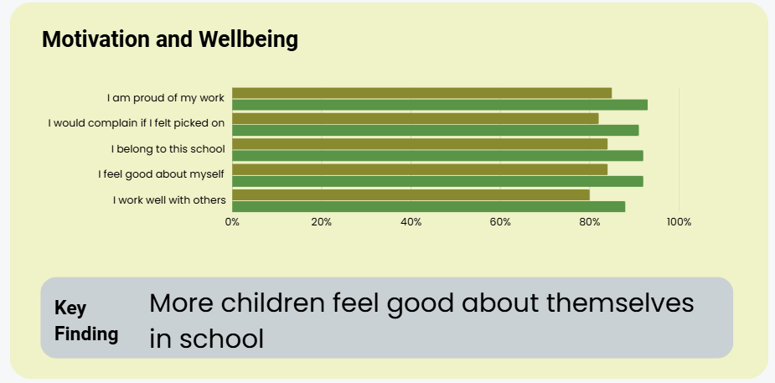

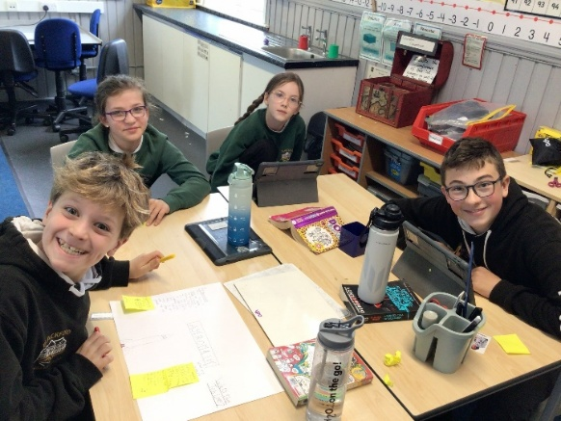
Skills Development Scotland
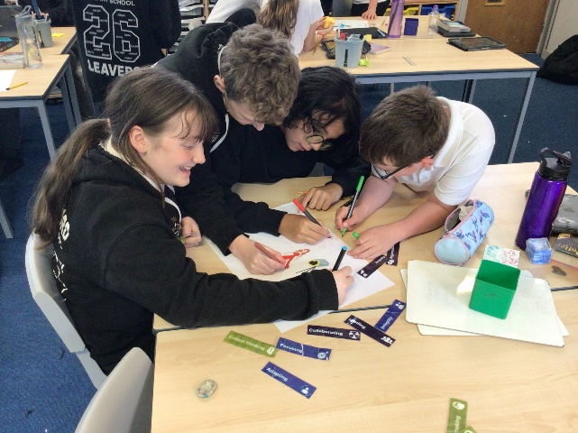
Our P6/7 class recently enjoyed a visit from Careers Advisors at Skills Development Scotland, who delivered an engaging session on meta-skills and the wide range of career pathways available to them. Pupils explored important skills such as communication, creativity and resilience, and how these can be developed throughout their learning.
The visit linked strongly to Developing the Young Workforce (DYW), helping pupils to make connections between their learning now and the opportunities available to them in the future.

Pupils have also enjoyed the motivating and engaging lessons taught by our visiting student Teacher, Miss Ailsih Byrne. We wished her a fond farewell on Friday 22nd May and wish her every success in her future teaching career.

The class have also been delighted to hear that their funding bid to Foundation Scotland, which they worked hard compiling, has been successful and we have been awarded £1000.00 to spend on our intergenerational project, making IT more accessible to residents of Blackford who may struggle with it. We will be hosting IT cafes, where pupils will guide residents on various aspects of IT, supporting digital inclusion and skills sharing.

P3/4/5: Busy Bees (and Mini Master Chefs!)
P3/4/5 have hit the ground running this term! We’ve been busy cooking up tasty treats for our “Our Planet” topic (the sampling part was clearly the favourite), then writing our own recipes—watch out, MasterChef at home!
We’re also training hard for Sports Day and the Highland Games with lots of running, jumping and throwing (some of us very competitively…). In science, we’re growing spider plants and beans and keeping a close eye on who wins the “fastest grower” race.
Our glockenspiel tunes have been so good that even P1/2 can recognise them—and yes, they’re getting stuck in everyone’s heads! Lots of us have also been enjoying clubs like coding, athletics and ukulele… safe to say it’s been a very busy (and fun!) start to term.
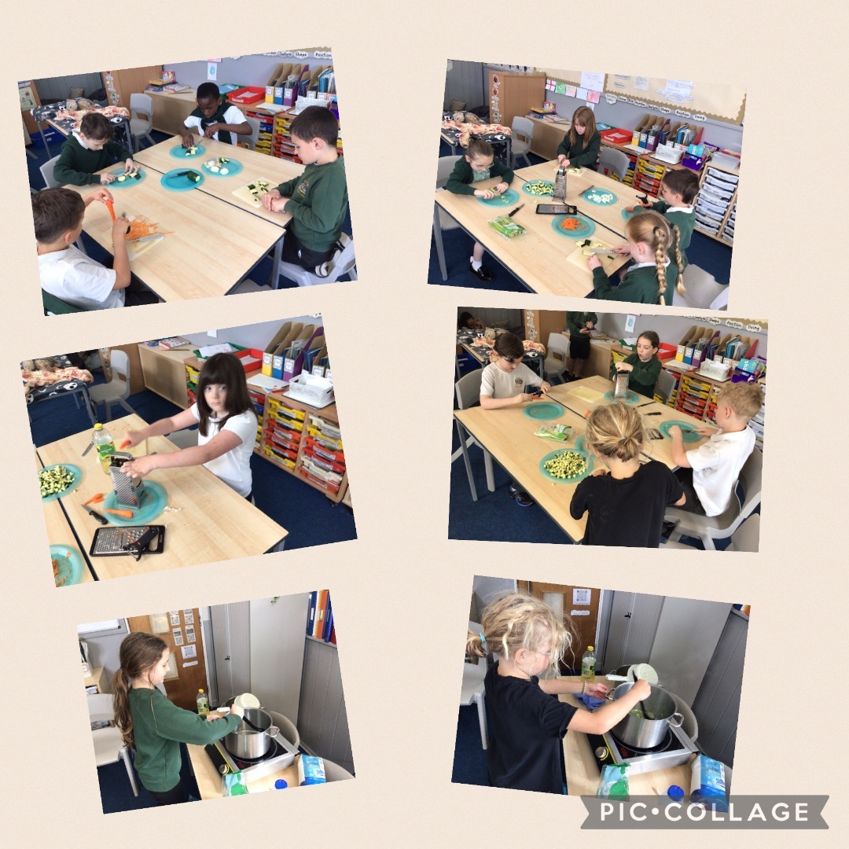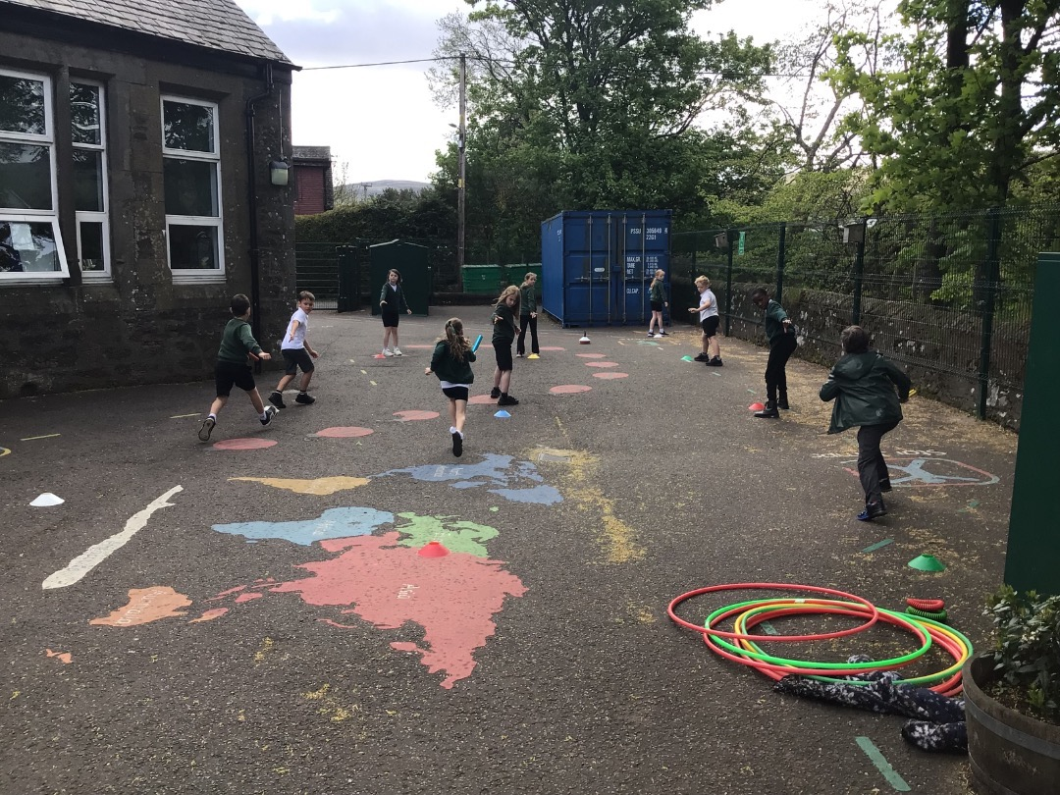

P1/2 Butterfly Adventure
Our P1/2 class has been busy becoming mini scientists as we explore the fascinating life cycle of butterflies. We began our journey with five tiny caterpillars - Cappy, Fred, Lulu, Ryan and Connie – we have loved watching them grow bigger and bigger each day by munching lots of their tasty food. The children were amazed to see the caterpillars begin the next exciting stage of metamorphosis as they formed their chrysalises.
Through this topic, the children have been developing their knowledge of living things and life cycles while building important skills in observing, predicting, recording changes and asking scientific questions. The class has also been learning about responsibility and care as we look after our growing caterpillars each day.
To make our learning even more exciting, we have linked up with another local Primary 1 class at TCSOA who are studying butterflies too! The children have been learning how to send emails and are about to take part in video calls to share updates, compare observations and celebrate each stage of the butterfly journey together.
We can’t wait to see our butterflies emerge soon!
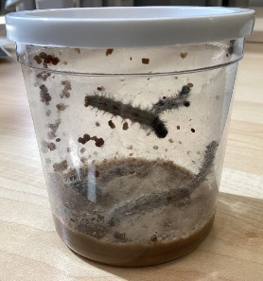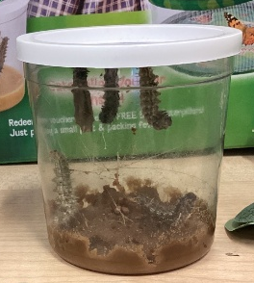

Transition Time!
Our classroom has been full of excitement as we welcomed the new Primary 1 children for the first of their transition visits. The current P1 pupils were wonderful role models, helping the new children feel happy, safe and included by showing them around the classroom, sharing activities and encouraging them to join in. It has been lovely to see friendships beginning to grow already.
At the same time, our current P2 pupils have been preparing for their own exciting next step as they get ready to move up to Primary 3 and P5s have been spending time with Mrs Hansen in the P6/7 classroom. Through transition activities, discussions and visits, the children have been building confidence and independence while learning about the new opportunities and challenges ahead.
These experiences are helping all of the children develop important skills including communication, kindness, teamwork and resilience as they prepare for their next stage of learning.
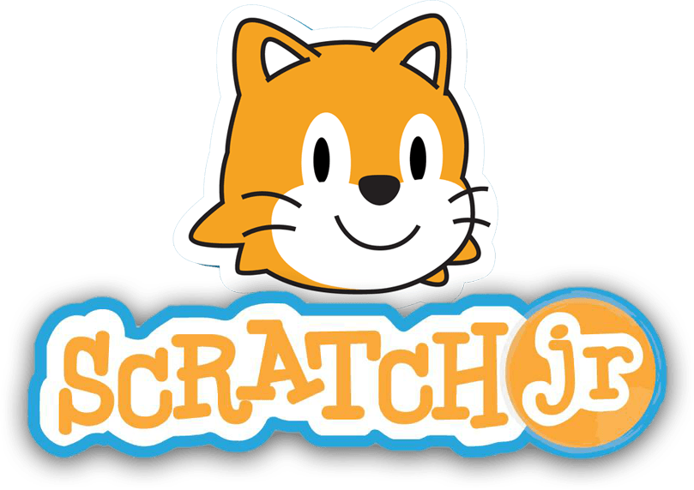
Coding Club
Our Coding Club ran over four exciting weeks, giving pupils a brilliant opportunity to build skills while having fun. Through hands-on activities, learners developed confidence in coding, strengthened their problem-solving and creativity, and worked together to share ideas and overcome challenges. The sessions were full of energy, curiosity and laughter, with pupils taking real pride in their projects. Most importantly, they were building key digital and teamwork skills that will support them in the future—sparking interest, confidence and a love of learning that will last well beyond the club.

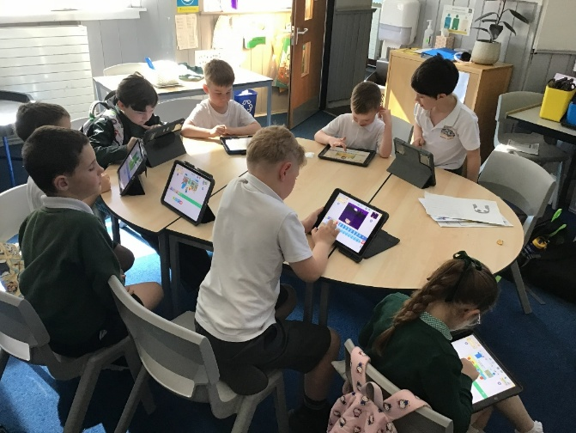

Athletics Club Extracurricular sports
Our Athletics Club has been a hive of energy this term, with lots of children having fun while building their skills for County Sports, Sports Day and the Blackford Show. From sprint stars to long jump surprises, many pupils have discovered talents they didn’t even know they had! It’s been fantastic to see confidence grow, friendships strengthen and plenty of smiles along the way. 🏃‍♀️🏅

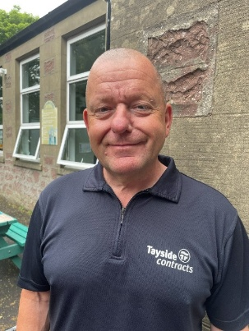
A big welcome back to Jim the Janitor who has (re)joined our team after several years of working in other learning communities. Jim has already helped us to improve bits around the school grounds as well as always having a smile for staff and children.

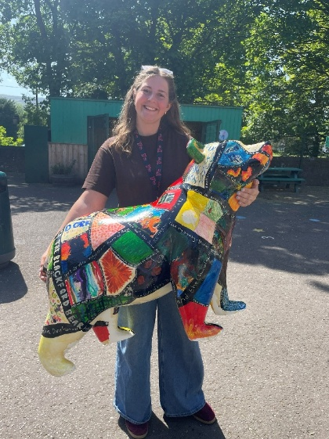
Bruce the Blackford Book Bear
Blackford Primary School has been proudly working with Wild at Heart and YMCA Tayside to create our very own bear for Perthshire’s Big Adventure Trail! After a whole-school vote, Bruce the Blackford Book Bear was born, with every pupil and staff member helping to decorate him. Tying in perfectly with our reading focus, each child added a favourite book quote or title—sharing their love of stories for all to see. Bruce is now off on his own adventure around Auchterarder before returning home to us. A fantastic team effort—well done, everyone! 🐻📚

Dates for the Diary
9th June- Gala Games Night, 6-730pm Moray Institute
10th June- TCSoA P7 transition parent event
11th June - Play and Stay for new P1 2026/27 pupils
11th and 12th June- P7 transition days- Auchterarder
15th- 19th June - Blackford Primary Health Week
16th June- County Sports Finals
18th June- Sports Day 130pm- 315pm
26th June - P6/7 class assembly and sharing the learning event 930-1030am
29th June - Blackford's Got Talent
30th June - School trip Blairdrummond Safari Park
2nd July- School service 1130am Blackford Parish Church
2nd July- 12noon end of term - Children collected from Blackford Parish Church

