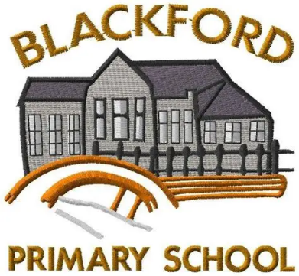
Blackford Primary School
March Newsletter
March has been a vibrant and productive month in school, with pupils representing us across the local authority, developing new skills, and performing strongly in national assessments. We’ve also enjoyed celebrating a range of wonderful achievements, and we’re delighted to share some of these highlights with you in this month’s newsletter.

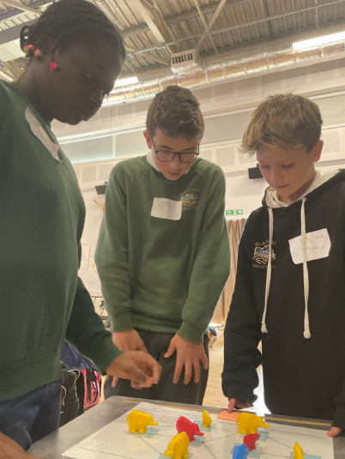
Enterprise Maths Challenge
Matty, Vivian and Harry (P7) proudly represented Blackford Primary School at the Enterprise Maths Challenge held at North Inch Campus. Our school was one of only 20 primary schools across the local authority selected to take part in this exciting celebration of maths. Here’s what the pupils had to say about their experience:
Matty: “It was good to compete against the other schools there. I loved the maths relay.”
Vivian: “We had lots of things we could add to the poster about influential factors. I liked going to see a different school.”
Well done to all three for their enthusiasm and fantastic effort!

Peer Mediation Training
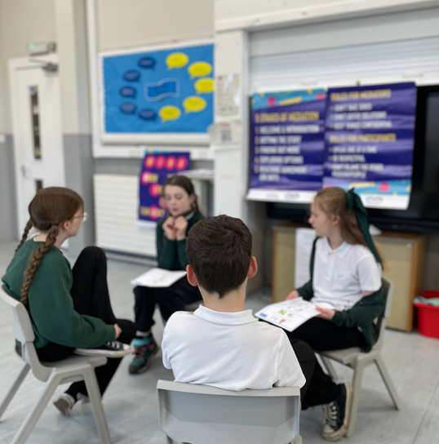
Our P6 pupils successfully completed their Peer Mediation training this month. The programme—delivered by Peer Mediation Scotland and supported by our Community Link Worker, Susanne Finnigan—has prepared the children to lead a new initiative that will further strengthen the nurturing, positive ethos of our school.
Through the training, pupils have been developing valuable social and communication skills that will support them not only as peer mediators, but throughout their lives whenever they face conflict or disagreements.
Here’s what the children had to say about the experience:
Emily: “We can’t wait to start mediating with the children.”
Eric: “I know how to listen properly to people. I feel confident that I can deal with conflict better now.”
Belle: “I feel really listened to; especially when people say things like… ‘What I’m hearing is…’
We are incredibly proud of our P6 mediators and look forward to seeing them put their new skills into action.

P3/4/5 Learning Update
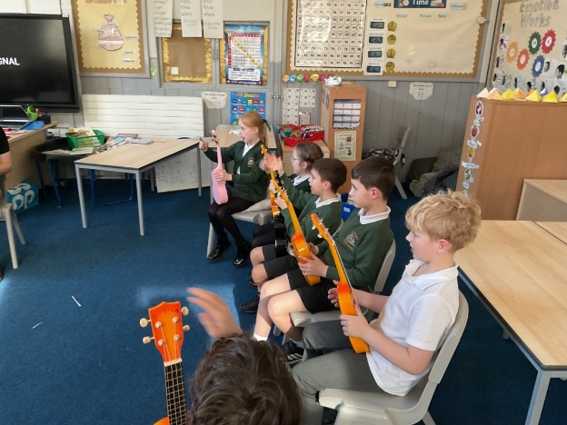
P3/4/5 have had an exceptionally busy and exciting term, filled with amazing learning experiences across the curriculum.
Our Ancient Egypt topic has been a particular highlight. Pupils created stunning masks inspired by Tutankhamun and even took part in a fun and memorable ‘mummification’ ceremony! Their enthusiasm and creativity have been fantastic to see.
We also enjoyed our first ukulele session, and the class is looking forward to developing their musical skills further over the coming weeks.
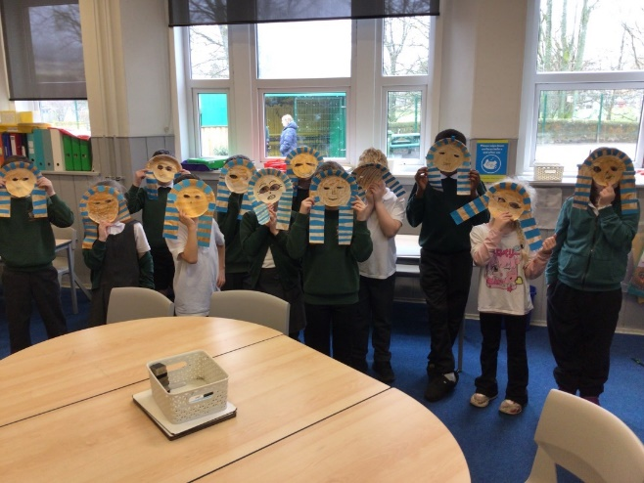
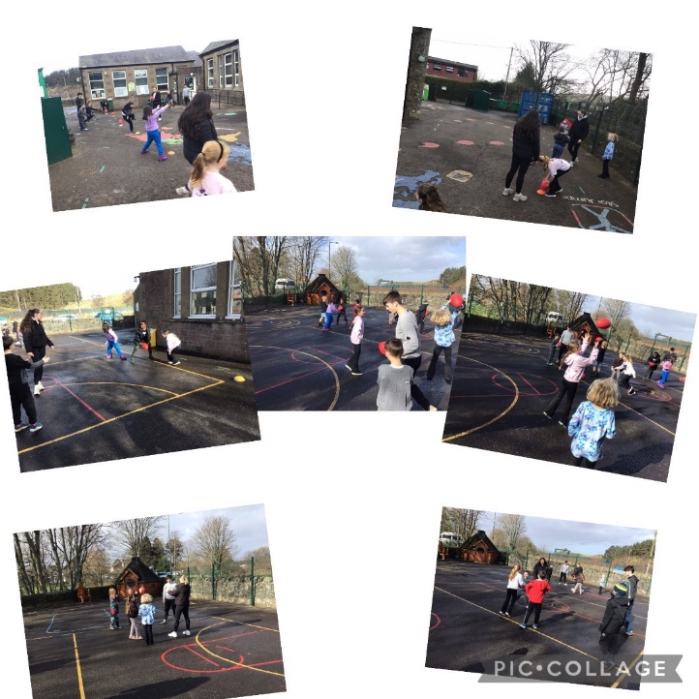
Another standout this term has been our rugby sessions, led by senior pupils from The Community School of Auchterarder. These sessions have been eagerly anticipated each week, and the children have shown great progress in both skill and confidence. Well done to P3/4/5 for such a productive and energetic term of learning!

P7 Residential at Abernethy
P7 enjoyed a wonderful week-long residential trip to Abernethy Outdoor Centre, located near the village of Nethy Bridge in the beautiful Cairngorm National Park. The class took part in a fantastic range of outdoor activities, including dry slope skiing, orienteering, rafting, and zip wiring — all while surrounded by stunning ancient Caledonian pine forest.
We were incredibly lucky to experience glorious spring sunshine throughout the week, making the adventure even more memorable. The pupils showed great resilience, teamwork, and enthusiasm, and it was a week full of fun, challenge, and new achievements.
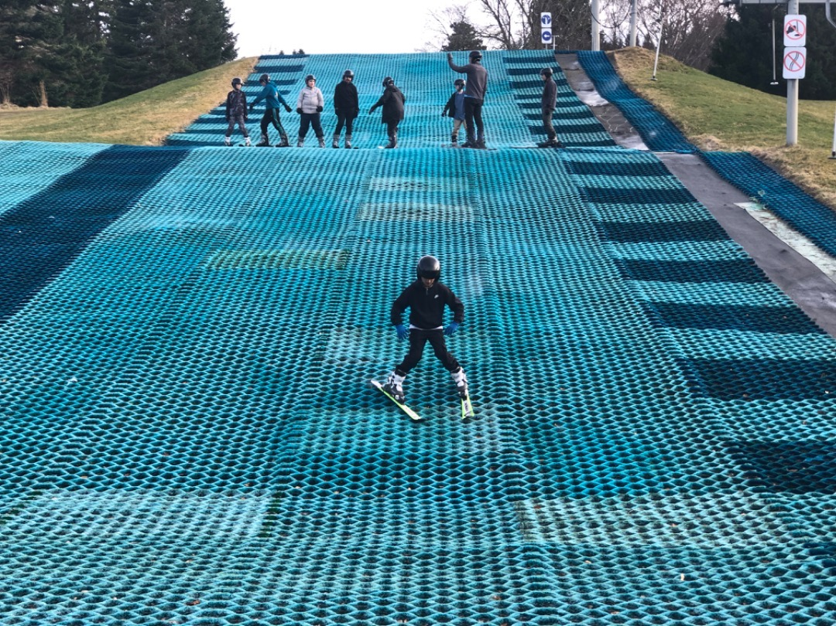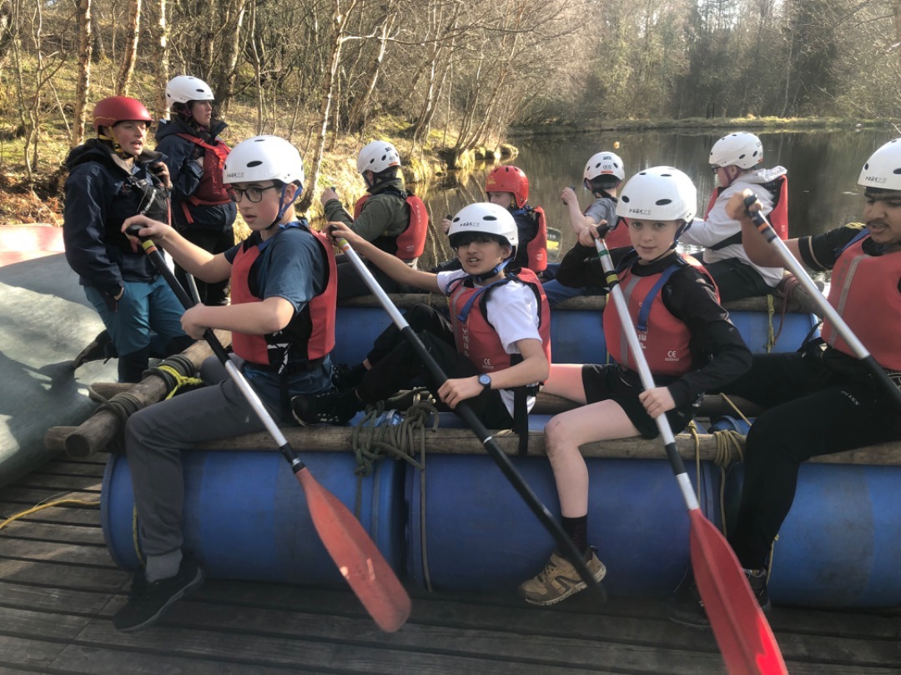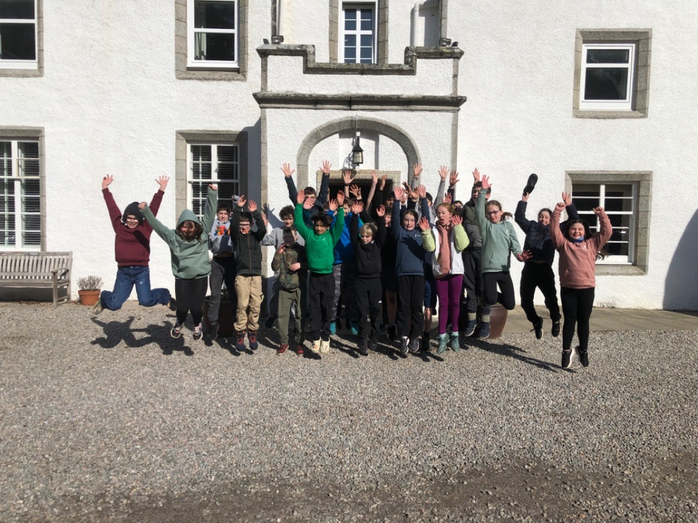

As part of the P6/7 context learning on Scottish Politics, we enjoyed a visit from MSP Jim Fairlie where the children quizzed him on life as a politician and posed some hard-hitting questions regarding education and the environment.
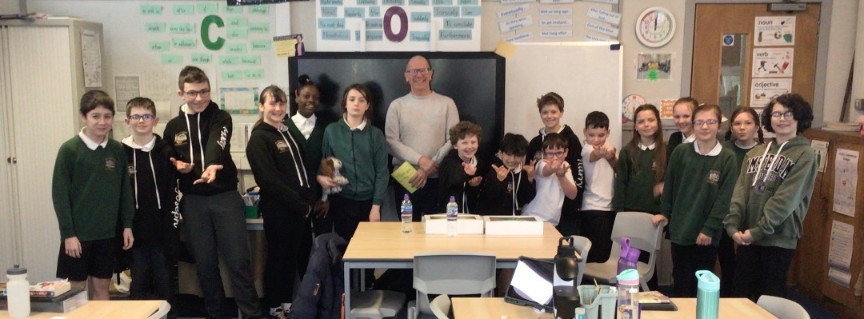

Forest School and swimming have played a significant role in P6/7 learning this term. During our outdoor learning sessions, pupils developed a range of core skills through activities such as fire lighting, den building, and Nordic weaving. These hands-on experiences have helped build resilience, teamwork, and confidence in the outdoors.

Our 10-week block of swimming lessons at Strathearn Community Campus has also been hugely beneficial. Every child has grown in confidence in and around the water, showing excellent progress throughout the programme. The block concluded with a lifeguarding session, giving pupils the chance to learn important safety skills that are valuable both in and out of school.
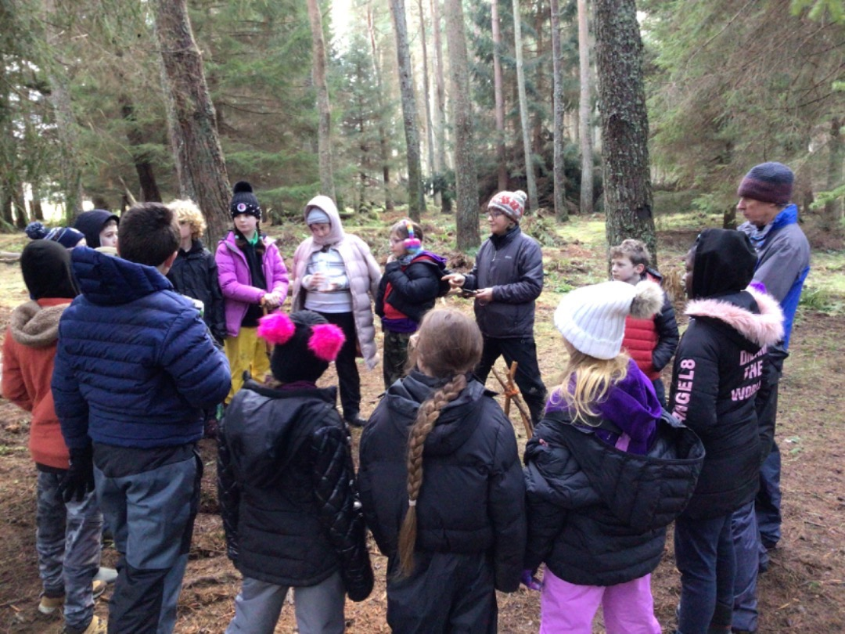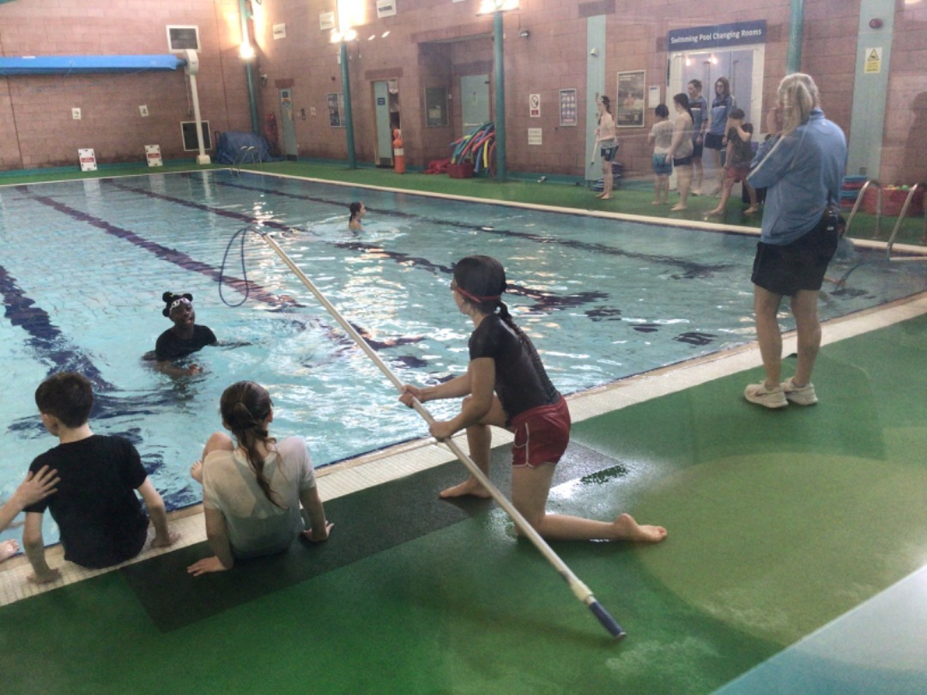

P1/2 Learning Update
P1/2 have been busy developing their skills in Science and Literacy this term. The children have loved making predictions, carrying out practical experiments, and reacting with plenty of “oohs, ahhs and wows!” They have also been working hard on writing up their experiments using their “bossy words” to sequence each step clearly.
In PE, the class has been building their personal fitness levels through fun HIIT sessions set to some of their favourite songs — a definite highlight each week!
We have also thoroughly enjoyed our Rugby sessions, led by senior pupils from The Community School of Auchterarder. These sessions have given the children opportunities to learn new skills, develop teamwork, and try out new approaches to the game.
Well done to P1/2 for a brilliant term of learning and enthusiasm!

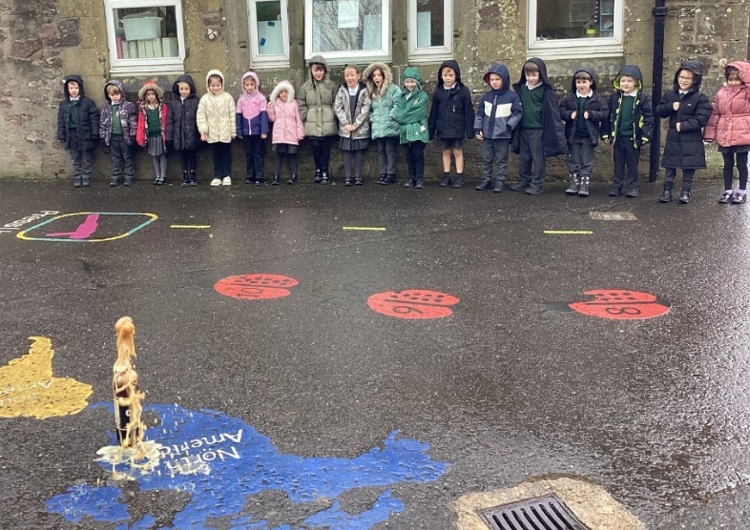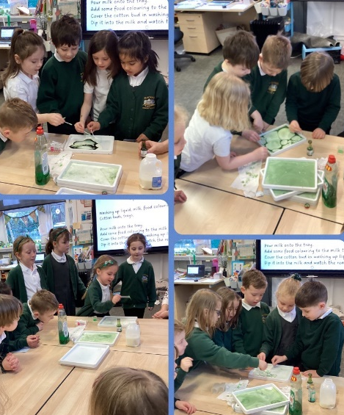

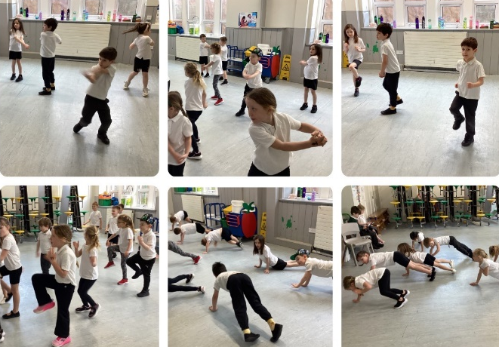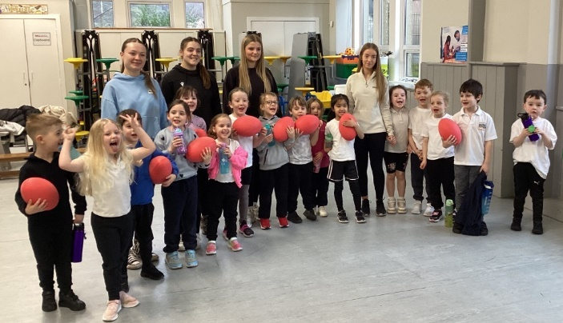

Dates for the Diary:
Friday 3 April – Friday 17 April 2026 – Spring Holiday
Saturday 4 April 2026, 7–10pm – Community Event – Blackford Bowling Club
Monday 20 April 2026 – Summer Term Begins
Monday 27 April 2026 – School Photos
Thursday 28 May 2026 – Sports Day
Saturday 30 May 2026 – Highland Games – Blackford Highland Games Field
Thursday 11 June 2026 – Moving Up Day
Thursday 11 & Friday 12 June 2026 – P7 Transition Days – The Community School of Auchterarder
Monday 15 June 2026 – Health Week Begins
Monday 29 June 2026 – Summer School Trip – details to follow
Tuesday 30 June 2026 – Blackford’s Got Talent – School Hall
Friday 3rd July 12noon- End of Term Service – Blackford Parish Church (children dismissed from the church at 1230)
Friday 3rd July 1230 – school holidays commence

