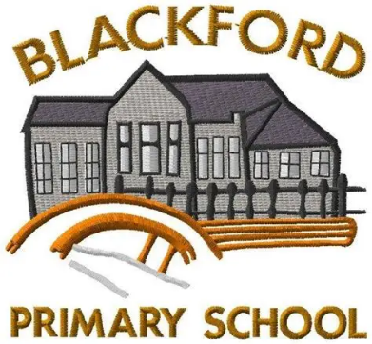
Blackford Primary School
Half term Newsletter Feb 2026
February has been an incredibly busy and exciting month in school, with pupils shining across a wide range of activities. We’re especially proud to have celebrated some fantastic awards this month. We are delighted to share these highlights with you in our newsletter.

Celebrating Our Silver School Sports Award!

We are delighted to announce that our school has achieved the Silver School Sports Award – a fantastic recognition of our growing commitment to physical activity, leadership, and wellbeing across the school.
Since the start of session 2025/26, our pupils have embraced a wide range of new opportunities. Our P6/7 Sports Leaders have been trained to support and lead activities across the school, helping to inspire younger pupils and build confidence through sport. P1–5 are enjoying rugby sessions delivered by senior pupils from CSoA, developing teamwork and resilience. We have been listening carefully to pupil voice by consulting learners about which sports they would like to see in our lunchtime clubs and now have a variety of lunch clubs on offer. We’ve also developed pupil leadership through dance sessions led by our senior pupils, bringing energy, creativity and fun to our school day.
Looking ahead, we have exciting plans to build on this success. We will be launching a Pupil Sports Committee, seeking parent volunteers to expand our offer, and introducing family fitness sessions to encourage healthy habits for the whole school community.
Well done to everyone involved – pupils, staff and families – for helping us achieve this brilliant award. Here’s to aiming even higher!
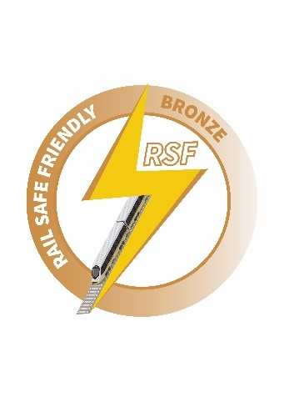
Celebrating our Bronze Rail Safe Friendly Certification
Prior to Christmas we worked with our classes to deliver an important addition to our PSHE curriculum about how to be safe around railways. This development helped us to start our journey as an accredited Rail Safe School.
The children enjoyed hearing about the safety messages and wanted their parents to hear more about it too. If you would like to learning more about helping your child to be safe around railways, please use the QR code above.

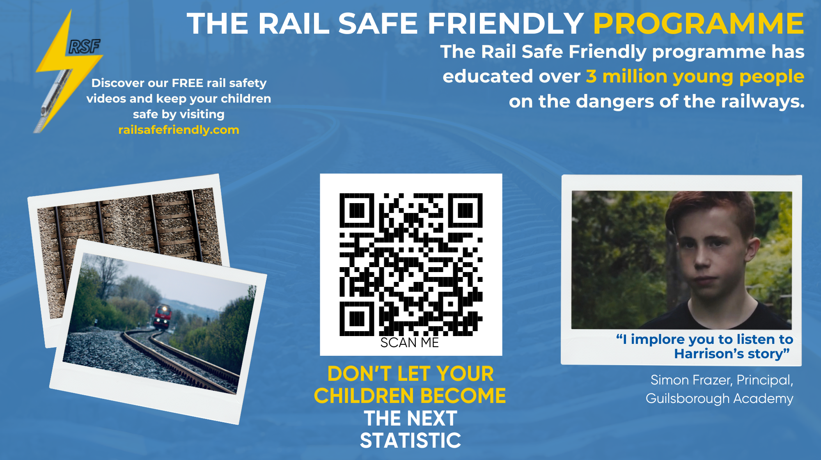

Reading Schools Week – 2-6th February
Classes threw themselves into the Scottish Book Trust’s Reading Schools celebration earlier this month, and the whole school was buzzing with book-loving energy! We shared favourite reads from home, swapped recommendations with friends, and even had a whole-school DEAR moment – Drop Everything and Read – which the staff enjoyed just as much as the pupils!
From redesigning book covers to crafting colourful bookmarks, our classrooms turned into creative studios. Pupils loved listening to stories read by their teachers and through online storytelling sessions. A big highlight was our brilliant collection of “extreme reading” photos – everything from reading at a bus stop to balancing on top of a bedroom bookshelf!
Thank you for supporting this fantastic initiative. We can’t wait to dive into more exciting Reading Schools adventures with the Scottish Book Trust!

News from our classrooms
Our children wanted to do a newsletter takeover for their class updates this month- let’s hear what they have to say!

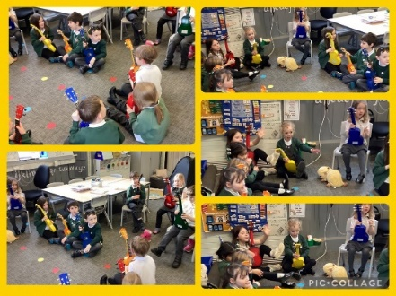
P1/2
We have started to learn to play the ukelele with Mr Bathgate. In our first session we explored the different parts of the ukelele through song. “A ukelele has a body, a neck and a head…” – we all agree that it’s very catchy!
Willow – “It was really good and super fun.”
Zuzanna – “It was amazing and really good fun.”
Brodie – “It was excellent and can’t wait for our next lesson!”
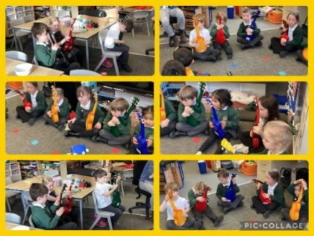
We were very proud of our Gruffalo in Scots performance this month. Our class was made up of narrators, as well as, a tod (fox), a hoolet (owl), a snake, a moose (mouse) and a Gruffalo.
Melody played the role of the Gruffalo – “I had to work hard to learn all of my lines.”
Sophie was sharing the role of the wee broon moose – “I felt shy to begin with but got more confident the more we practised.”
Ava – played the hoolet and said, “I loved being the owl, I had to practise at home and at school to learn my lines and know what to do.”
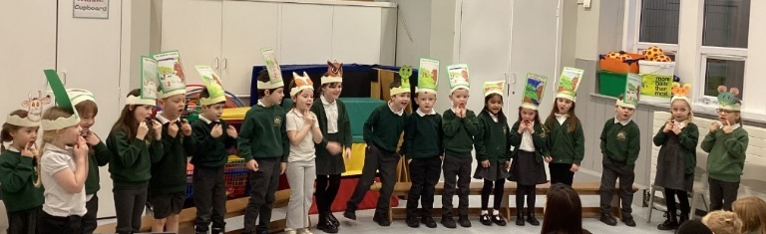
Charlie W. was one of our narrators and said, “I had to talk quite loud so everyone could hear me.”
Charlie U. – “I found the play easy because we had been learning the Scots’ words in class and because we had been reading the book.”
Cameron – “It was hard learning my lines but I’m glad I had extra lines to share.”
Grace – “We also sang a song, and it was so good when everyone was clapping for us.”
P3/4/5
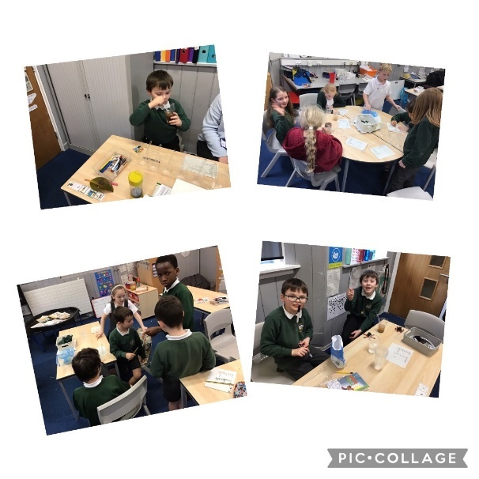
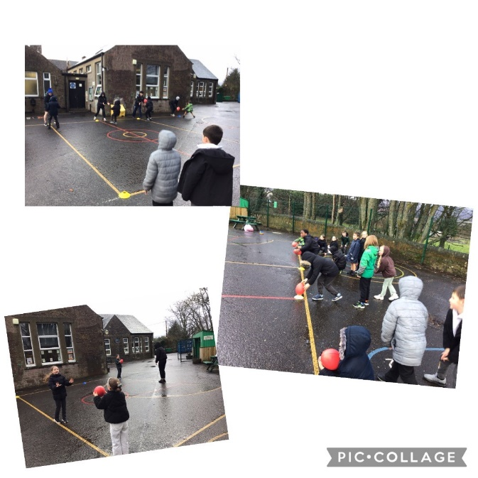The Creativity Group are coming to the end of their project and look forward to sharing their work with us. They recently enjoyed a visit to Gleneagles House as part of their learning. Here’s what they thought about the project-
Dorian “I enjoyed doing the drawings”
Noah “I enjoyed the trip to Gleneagles House”
Ethan “I loved all of it”
Dakota “ I enjoyed creating music to go with our story”
David “ I liked doing the drawings for the story”
Freya “I enjoyed creating music on the keyboard”
Aren “ I liked working with Rory because he helped us to use our imagination”
We have enjoyed creative dance sessions and some of us have had the chance to lead the learning and share our dance moves. We have all improved our fitness and stamina in PE this term and are really enjoying working with senior pupils from The Community School of Auchterarder to develop our rugby skills.
In science we have been investigating materials and have been learning about fair testing as we carry out experiments.

P6/7
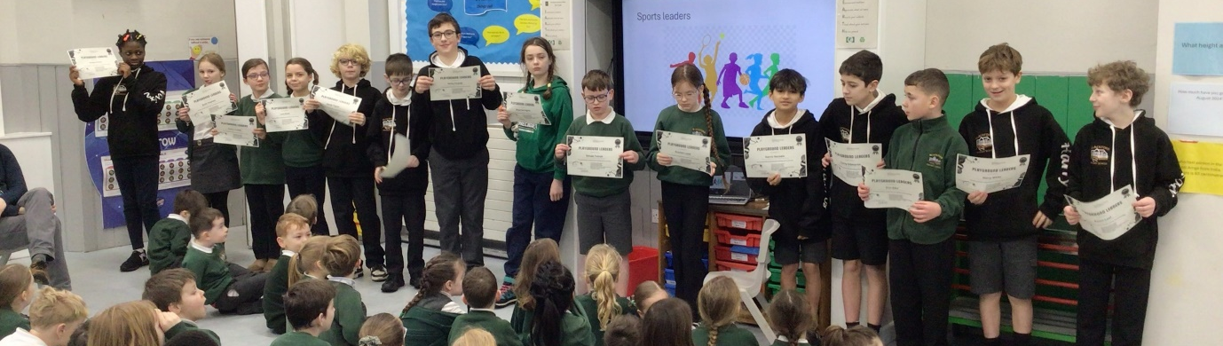
Update from our Sports Leaders
We were trained by Cat from Live Active and really enjoyed learning games and how to teach them to the younger pupils in our school. We really enjoy it when the children join in and enjoy playing and taking exercise. It’s important for our bodies to exercise but we like making it fun for everyone too.
“I like ‘jungle’s on fire’ because the little children run around like crazy animals! They are supposed to animals!” Lara
“It’s fun but sometimes it is tricky to help the little children feel confident joining in. That is a skill I’ve learned. We help them and then they enjoy it” Vivian
“ It is really good for everyone’s health to get out, get sweaty and have fun!” Kelisse
Dates for the Diary
- Fri 27th Feb - Last Friday of the month, Dress down Friday - school fund donations via parent pay
- Tue 3rd March- Rag Bag collection
- Wed 4th March P6/7 Forest Schools
- Thurs 5th March- World Book Day ( see information below)
- Week beginning 9th March - Issue mid-year reports
- Mon 9th March- P6/7 MSP Jim Fairlie Class Visit 11am -12noon
- Thursday 12th March – P6/7 Forest School

- Mon 16th- Fri 20th March- P7 Residential Trip to Nethybridge
- Mon 23rd March Rotary Quiz @ Aberuthven PS - info to be sent to parents/ carers of pupils involved
- Mon 23rd March- Parent Contact session 1
- Tue 24th March- Parent Contact session 2
- Wed 25th March- NSPCC workshops for P1/2/3 and P6/7
- Fri 27th March- Primary Enterprising Maths Challenge Day 2026- info to be sent to parents/ carers of pupils involved
- Thurs 2nd April - Easter Service 14:45
- Term ends: Thursday 2 April 2026 15:15 Children leave from Blackford Parish Church
​Spring holiday: Friday 3 April 2026 to Friday 17 April 2026

