**Anti Bullying Policy**

**October 2024**

|  |
| --- |
| **Be happy, Positive and Successful**  ***Values***  *In Blackford Primary School we try to be honest, helpful, fair, caring, gentle, kind and wise.*  ***Aims***   * *To promote a welcoming environment where our children are happy, safe, confident, responsible and caring; encouraging self -discipline, independence and respect for themselves and others* * *To promote opportunities for active, cooperative and independent learning through effective teaching* * *To work in partnership with families, carers and the wider community to provide high quality, meaningful learning experiences and to encourage and promote a lifelong, positive approach to health and wellbeing* * *To support children to be resilient, and to realise and achieve their full potential, recognising attainment and achievement* |

At Blackford Primary School we are committed to supporting every member of our school community to enjoy a school experience built on positive relationships.   
  
Bullying, prejudice, and discrimination are never acceptable. Young people and staff have the right to learn and work in a safe, fair and secure environment. The emotional health and wellbeing of young people and staff is paramount in creating an environment for successful learning, teaching and development.

This policy is closely linked to our school Relationships Policy.  
  
Our understanding of bullying is based on the [United Nations Convention for the Rights of the Child](https://www.unicef.org.uk/wp-content/uploads/2016/08/unicef-convention-rights-child-uncrc.pdf), the Scottish Government publications - [Getting it right for every child (GIRFEC)](https://www.gov.scot/policies/girfec/) and [Respect for All: The National Approach to Anti-Bullying for Scotland’s Children and Young People](https://www.gov.scot/binaries/content/documents/govscot/publications/advice-and-guidance/2017/11/respect-national-approach-anti-bullying-scotlands-children-young-people/documents/00527674-pdf/00527674-pdf/govscot%3Adocument/00527674.pdf) and the [Perth and Kinross Council Anti-Bullying Strategy](https://www.pkc.gov.uk/media/40989/Anti-Bullying-Strategy/pdf/Antibullying_Strategy_1_.pdf?m=636471161244000000).

All young people have rights to which they are entitled. We are a Silver Rights Respecting School. We promote the rights of every member of our school community. We teach and celebrate the Articles of the United Nations Convention on the Rights of the Child (UNCRC) including:

|  |  |
| --- | --- |
| Article 2 | The right to protection against discrimination |
| Article 3 | The right for my best interests to be the top priority |
| Article 19 | The right to be protected from being hurt or badly treated. |
| Article 29 | The right to an education which develops your personality and your respect for other’s rights and the environment. |

Bulling behaviour breaches the UNCRC.

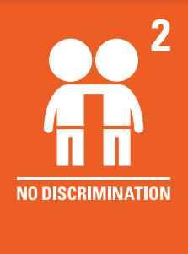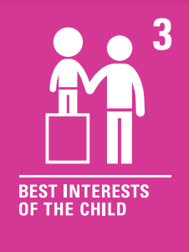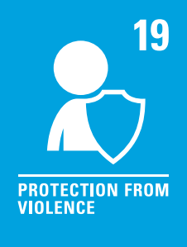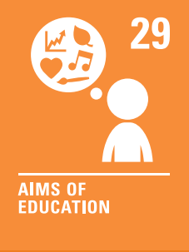

**What is Bullying?**

Bullying is behaviour that is unkind or hurtful and has an impact on a child or young person’s feeling of agency, their ability to feel in control and complete actions as they would have done previously. Bullying takes place in the context of relationships; it is behaviour that affects the individual’s self-confidence and can make them feel hurt, threatened, frightened and left out.

This definition is based on the description of what is bullying by Scotland’s anti-bullying service, respectme.

This behaviour may happen in person or online and can include hurtful comments and name calling, threats of violence, unkind, abusive messages and behaviour which makes people feel like they are not in control of themselves or their lives. In some instances, bullying may be motivated by prejudice. This list is not exhaustive.

**Bullying and Protected Characteristics**

We are committed to challenging all prejudiced based bullying and language.  
The Equality Act 2010 supports progress on equality, particularly in relation to nine protected characteristics, which are:

* Age
* Disability
* Gender reassignment
* Marriage and civil partnership
* Pregnancy and maternity
* Race
* Religion or belief
* Sex
* Sexual orientation

Wherever language or behaviour is felt to be discriminatory or prejudiced it will be challenged and addressed. Appropriate reporting, education and consequence will follow to ensure all parties are aware this has been taken seriously and must not be repeated.

**Behaviour**

It is important that our school community hold a shared understanding of what bullying is. In our school community, bullying will be recognised as negative behaviours which are apparent over a period of time, targeting an individual or group of individuals.

Any incidents with arise during a school day will be dealt with by a member of staff using Restorative Practice as soon as staff are able, preferably that day. Restorative Practice encourages pupils to learn from choices they have made and find a positive pathway forward, which in turn helps to restore any damage done to relationships between members of our school community. Any necessary consequences will be discussed during the restorative conversation and agreed by some of those involved. Staff encourage pupils to help set consequences which aim to restore any damage which may have been done. To protect and restore dignity of pupils following an incident, consequences are not always shared with all involved in the incident.

Staff aim to share details of any incident with families as soon as we are able to. We encourage carers and parents to discuss the incident at home with their own children.

**Promoting Positive Relationships**

In line with our values, we promote happy, respectful and trusting friendships. Through our formal and informal curriculum, we will encourage kindness and compassion. We will help our pupils to be assertive, reflective, kind and restorative.

We will celebrate and seek to be good role models of the characteristics we promote.

School values, children’s rights, positive relationships, classroom and whole school behaviour processes are taught throughout the school. Behaviour expectations are reviewed at the start of each term in classes and through regular assemblies, class charters, review of UNCRC etc.

**Responding to Allegations of Bullying Behaviour**

When bullying behaviour has been identified, it will be addressed without undue delay. The children or young people impacted will be central to planning and decision making. All parties will be kept informed of next steps. We will seek wherever possible to restore relationships. Those found to have bullied others will experience appropriate consequences. The nature of these consequences may not be shared with others, these may include; an appropriate withdrawal of privileges, a time out or detention, an exercise designed to aid reflection, a temporary removal from class or as a last resort a temporary exclusion from school. There are clear criteria around the suitability and duration of any exclusion from school as well as a clear appeals process.

One of the keys to addressing bullying behaviour is for it to be accurately reported without delay. Any staff member can be approached by any member of the school community. Staff will then follow our school procedure by sharing this information with our HT.

**Our HT will then:**

- log the bullying concern

- speak with all parties

- share information with parents

- take appropriate action

- record what happened

- check back to ensure the situation has been addressed appropriately and resolved.

If intervention is needed by any other parties such as social work, services for young people, school nurse, school counsellor or police, this will also be recorded appropriately.

**Processes for Young People who experience Bullying Behaviour**

This poster outlines the steps we take as a school community to respond to unkind and bullying behaviours. Together we take **responsibility** for one another and for following this process to address negative behaviours. Together we are building our **resilience** to respond well to negative behaviours and promote kindness.   
  
**1.** We **report** all unkind or bullying behaviour. Pupils can share concerns with each othe, but it is essential that negative behaviours are reported to an adult. Any pupil, any school staff member or any member of our community can pass on information about negative behaviour and must always be assured that information shared will be responded to appropriately. An Unkind or Bullying Behaviour Reporting Form will be filled out and details formally logged on the record system which is accessible to local and national authorities. This record will be updated throughout the process of addressing these behaviours.   
**2.** When a report is made it is important that the person experiencing the negative behaviour and the person who reported it are supported to **request** the course of action which they feel is most appropriate to address the negative behaviour.

**3.** School staff will investigate the reported behaviour and consider the views of all parties before establishing a plan to **repair** the damage done by the unwanted behaviour. This plan will be shared with the appropriate parties to ensure there is clarity on how progress is being made towards a resolution. The repair plan will be carried out.   
**4.** After an agreed period of time the parties involved will be contacted to **review** the process and ensure that there has been no repeat of the unwanted behaviours. If necessary, a follow up process can begin to address ongoing unwanted behaviours.   
External agencies such as police or social work can also be involved as appropriate to ensure pupil safety.