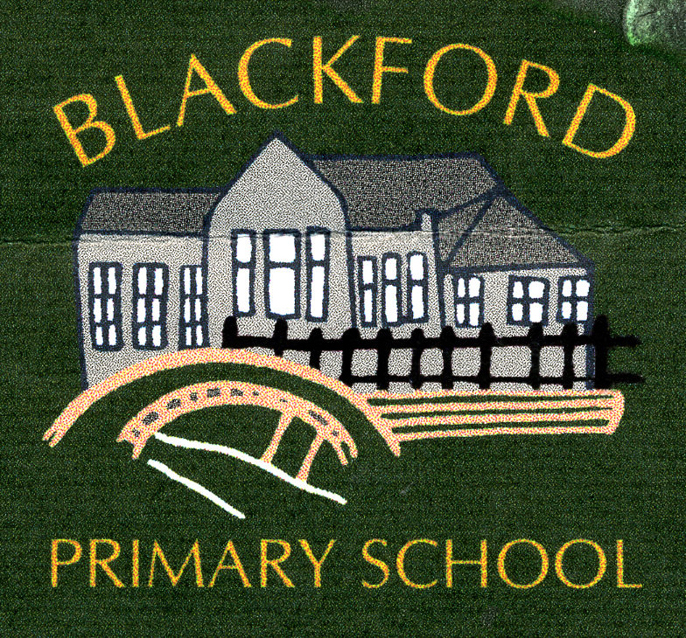

STANDARDS AND QUALITY REPORT
2023 – 2024

Be happy, Positive and Successful

Values
In Blackford Primary School we try to be honest, helpful, fair, caring, gentle, kind and wise.

Aims
- To promote a welcoming environment where our children are happy, safe, confident, responsible and caring; encouraging self -discipline, independence and respect for themselves and others
- To promote opportunities for active, cooperative and independent learning through effective teaching
- To work in partnership with families, carers and the wider community to provide high quality, meaningful learning experiences and to encourage and promote a lifelong, positive approach to health and wellbeing
- To support children to be resilient, and to realise and achieve their full potential, recognising attainment and achievement.

Attainment, Attendance and Progress
Attendance
2021/22 | 94%
2022/23 | 91%
2023/24 | 91%

Attainment and Achievement
In P1, P4 and P7 the majority of children have attained appropriate levels in Literacy and Numeracy, and a few are exceeding expected levels. Almost all children with additional support needs have made good progress from their previous levels of learning.
The children have had opportunities for wider achievement this session. These have included Guitar lessons, a Christmas show, Judo, Athletics and Forest School sessions. They have also had opportunities to compete in events such as the Cluster Sports, County Sports, Blackford Highland Games, and to access clubs in Auchterarder such as Cheer Leading, Netball, Hockey & Football. P6/7 successfully completed swimming lessons and Bikeability training, with all children making significant progress. We will be working to increase these wider achievement opportunities next session, particularly for our younger children.
Engagement with some families to support attendance has had positive results, with attainment and wellbeing improving in line with increased time in school.
Following a rigorous accreditation process we are delighted to have received our Eco Green Flag Award. This was achieved through a collective effort from pupils, staff and members of our local community (including businesses). The Eco priorities included Climate Action, Water and Litter and Waste. Increased awareness of issues impacting upon our climate was evident through the whole school participation in a Marine Litter project. The introduction, and effective use, of recycling points in school resulted in a 42% reduction in litter within our school grounds and surrounding areas. Using the monitoring results from the last year, alternative Eco initiatives will be focussed on next session.

Learning
Staff have continued to embed the Explicitly Teaching Writing approach throughout the school which has increased engagement in writing and had a positive impact on attainment. Moderation activities across our local schools and a shared understanding of the National Improving Writing Programme have increased staff confidence in assessing children’s work and progressing learning.
Interventions such as Wave 3 and Precision Teaching have impacted significantly on individual pupils and small groups, enhancing literacy and numeracy development. Pupil Equity Funding has provided opportunities to further support a few children in a nurturing environment resulting in increased engagement in learning.
Health and Wellbeing continued to be a high priority for children throughout this session. The children have been well supported through ongoing classwork and outdoor activities to build resilience, increase confidence and sustain positive relationships. A few children and families have also been supported by the Community Link Worker and School Nurse to improve their wellbeing and resilience going forward.
We continue to work collaboratively with our local schools and pre-school settings to support children and families transitioning in and out of our school. This includes meetings to share information, discussion groups for children and parents, visits from staff, and opportunities to visit the school. Through this process families feel supported when children move to their new setting.
Children’s Rights remain a focus of school assemblies and in classrooms, with staff and children relating them to school life and home life. We will revisit the rights around wellbeing next session as we develop as a nurturing school.
Digital learning is evident in all classes, and technology is used to support children who may be experiencing barriers to learning. The school is well resourced with ipads and laptops. Children are often asked to be ambassadors and share their digital skills with others.
All staff have received core training in Nurturing Relationships and have reflected on the 6 Nurturing Principles. We will be working to enhance wellbeing and resilience with the children across the school next session through developing our nurturing approaches.
Leadership
Children continue to have opportunities to take on leadership roles within classes and across the school. This has been particularly evident through activities linked to Blackford Gala, Forest School, Gardening, Buddies, Blackford’s Got Talent, St Andrew’s Day, Enterprise, the Eco Group and School Council. Staff have continued to undertake leading roles in improving experiences for children through Eco Schools, Digital Schools, and Literacy.
All teachers continue to be involved in regularly tracking and monitoring pupil progress, and they consider all the data that is available to them when planning learning experiences. The wide variety of data now available, and our ability to provide appropriate interventions, helps ensure the needs of children are met effectively.
The school has a good capacity for continuous improvement:
Quality Indicator | Evaluation
1.3 Leadership of Change | Good
2.3 Learning, Teaching & Assessment | Good
3.1 Ensuring Wellbeing, Equality and Inclusion | Good
3.2 Raising Attainment & Achievement | Good

Improvement Priority for 2024-25

Wellbeing and learning needs remain central to ensuring the school can support children and families in moving forward. This will be achieved by:

    - Ensuring high quality learning and teaching is experienced by all children as part of an engaging, motivating and relevant continuous curriculum experience
    - Enhancing progression in learning for children through continued effective application of Nurture principles

This report has been compiled in consultation with Pupils, Parents, Staff, Community Link Worker and School Nurse through professional discussion, assemblies, and engagement with the Parent Forum.

