Balbeggie Primary School  Fund Meeting Minutes | 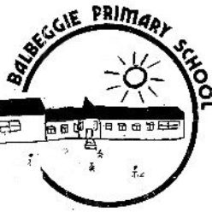

DATE | 28.2.25
PRESENT | Vicky Donaldson, Debbie Hamilton, Jennifer MacFarlane, Lauren Brown
APPOLOGIES | N/A

Balance of school fund on date of meeting | £816

Item No | Topic/Actions | Owner | Timeframe | Complete  Y /N
1 | Payment for Curling still to come out however all children have now paid for this trip. | JM | End March
2 | Nursery budget- Nursery would like buy more paint and paper from their budget if there is enough funds. | JM | End term 3
3 | Nursery would like to hold fundraisers to raise funds for trips and outings. | JM | End term 4
4 | AOB
5 | Date of next meeting

