OUR Scottish Supper
Our Scottish Supper was fun. It was held in the gym hall. We took pictures of our mums and dads. Some of us got to serve the Food and drinks.
We learned some poems and dances. We got some of our parents to join in and dance with us. We had to organise
The jobs . We made homemade short bread. There were
Meters and greeters . We sang a song called the red yoyo song. There was a music manager who put on the music.
We listened to Scottish music when the parents were eating there Scottish dinner .We wrote letters/invitations
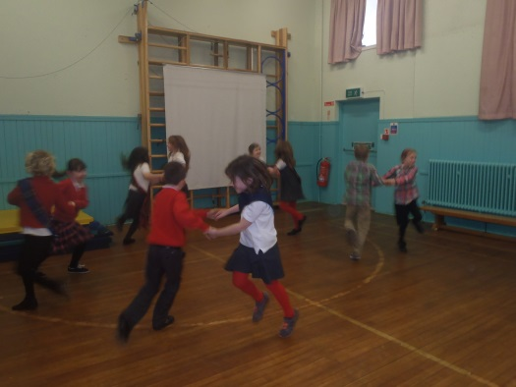
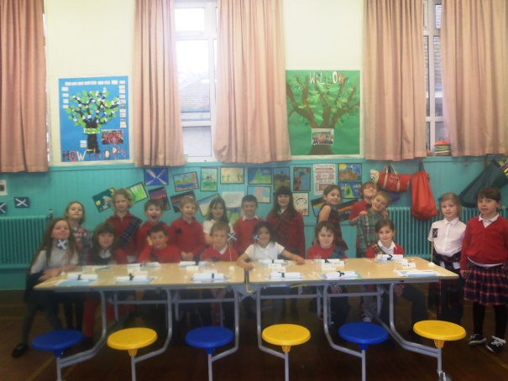
To our parents . The parents were eating haggis neeps and tatties. We cooked the vegetables with some other parents helping. The parents were very helpful. We had lots of fun.

