Being ‘Word Aware’ at Abernethy Nursery

The Word Aware Way

The practitioners at Abernethy Nursery follow the STAR method to teach new vocabulary.

S is for SELECT:

The practitioner will select useful words which are likely to be encountered again in spoken language or reading.

T is for TEACH:

We will the teach the children about the phonological sound of the word, its meaning and how it is used in a sentence.

A is for ACTIVATE:

The practitioners will then carry out activities linked to the word during small group times and will create an action and a symbol linked to the word.

R is for REVIEW:

Once a word is taught, it is placed on word wall. These words then need to be repeated in both writing in in spoken language. In addition, we play games to consolidate our understanding of these words and will send out a post each week to allow you to share the word of the week with your child at home.

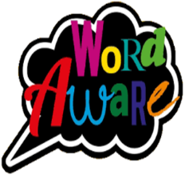
How to help at home
- Use every opportunity to support your children to chat freely – the more opportunity to develop fluency in speech, the better.
- Give your child plenty of time to process information and time to respond.
- Repeat the new words across the day- not just once! A child aged between 3 and 5 years old need to hear a word at least 12 times, in a variety of contexts before its embedded.
- Ask your child about their WOW (Word of the week) words and see what they can tell you!
- Check Seesaw regularly as our WOW words and focus story will be communicated though weekly posts.
- Please let us know if you hear you child using our WOW words in the correct context during conversations at home.
The importance of developing vocabulary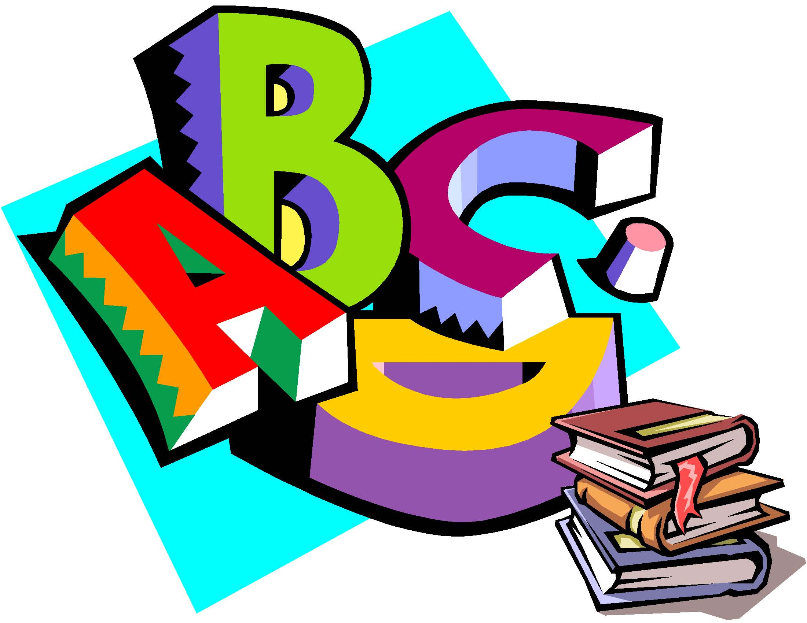
- Spoken vocabulary at 5 years old impacts on reading comprehension at 15 years old. Vocabulary not only relates to reading comprehension, but it also impacts all other areas of the curriculum
- Children who start school with a limited language skills find reading more challenging. By the age of 12, they may be up to 5 years behind in their reading ability.
- Vocabulary at the age of 5 can predict educational outcomes at age 30.
This is why we carry out the Word Aware programme. It is a structured, yet practical approach to promote the vocabulary development of all children.
Any Questions 

If you have any questions about the Word Aware Programme, please do not hesitate to ask one of the members of our wonderful team.
2026/27

