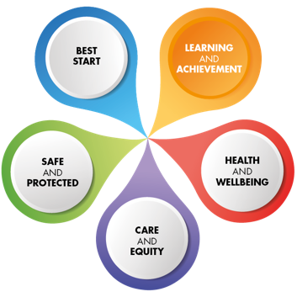






Early Years, Primary & Secondary
Data Analysis & Self-Evaluation Document
SCHOOL: Fairview School and Nursery SEED: 5340047

School Improvement Profile: Fairview School
Section A: School Profile:
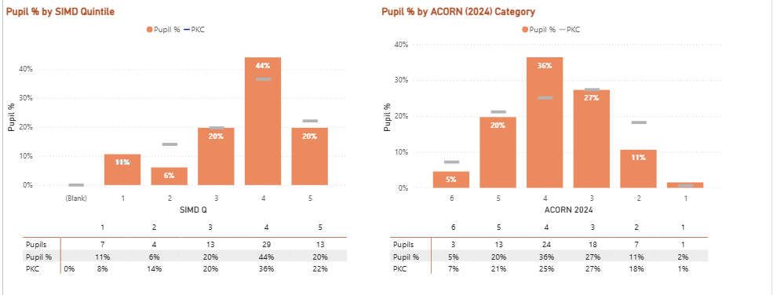
| Primary | Cohort | All | 24 | 100.00% |
| Primary | Female | All | 10 | 41.67% |
| Primary | Male | All | 14 | 58.33% |
| Primary | ACORN 5/6 | All | 6 | 25.00% |
| Primary | SIMD 1/2 | All | 4 | 16.67% |
| Primary | ASN | All | 24 | 100.00% |
| Primary | EAL | All | 3 | 12.50% |
| Primary | BME | All | 1 | 4.17% |
| Primary | FSM | All | 4 | 16.67% |
| Secondary | Cohort | All | 41 | 100.00% |
| Secondary | Female | All | 17 | 41.46% |
| Secondary | Male | All | 24 | 58.54% |
| Secondary | ACORN 5/6 | All | 9 | 21.95% |
| Secondary | SIMD 1/2 | All | 6 | 14.63% |
| Secondary | LAC | All | 2 | 4.88% |
| Secondary | ASN | All | 41 | 100.00% |
| Secondary | EAL | All | 2 | 4.88% |
| Secondary | BME | All | 4 | 9.76% |
| Secondary | FSM | All | 8 | 19.51% |
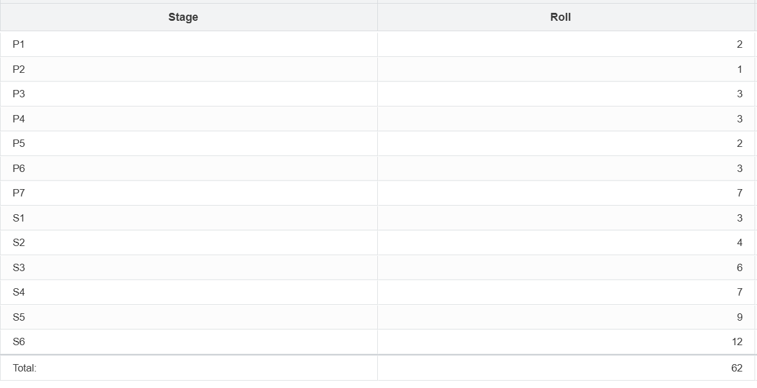
Attendance, Absence and Exclusion
Attendance (Year or Year to Date)

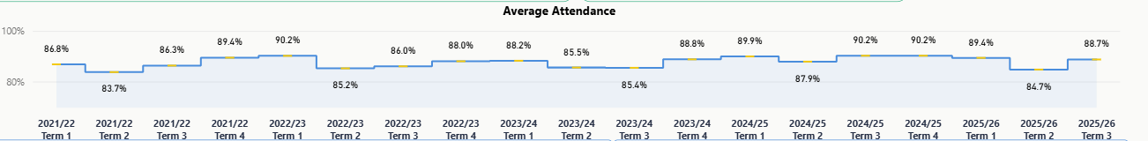

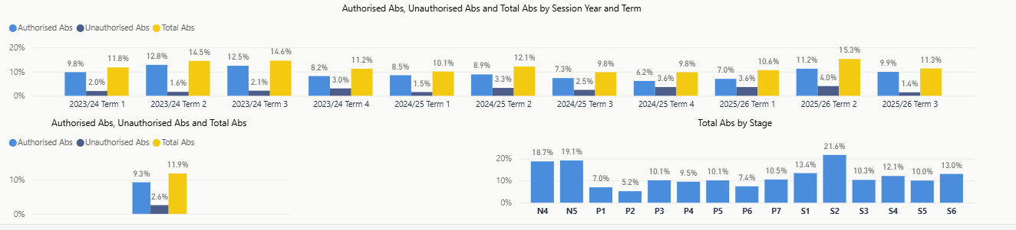

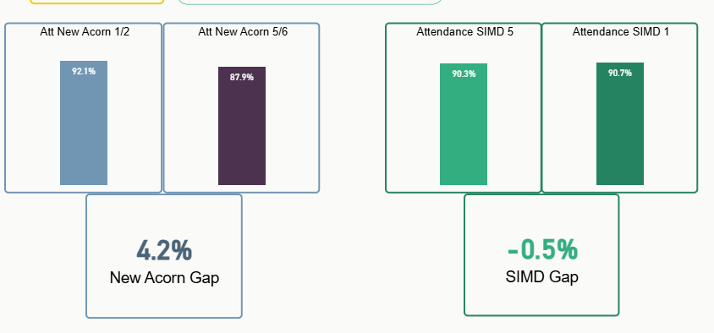
Incidents of distressed and/or challenging behaviour
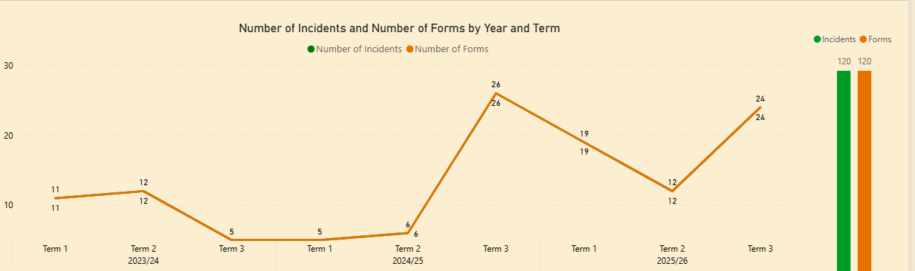
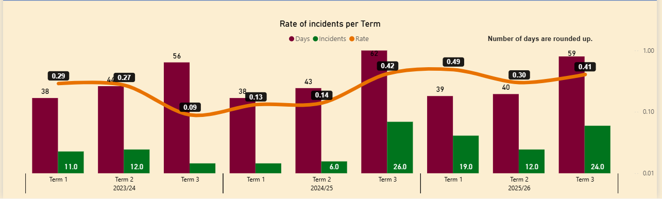

Comparison based on term 1 -3 for comparison
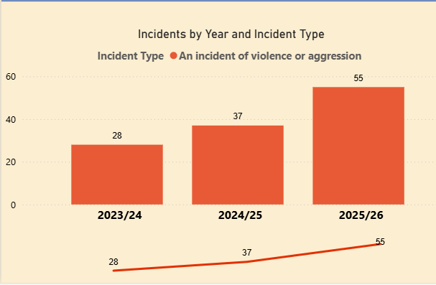

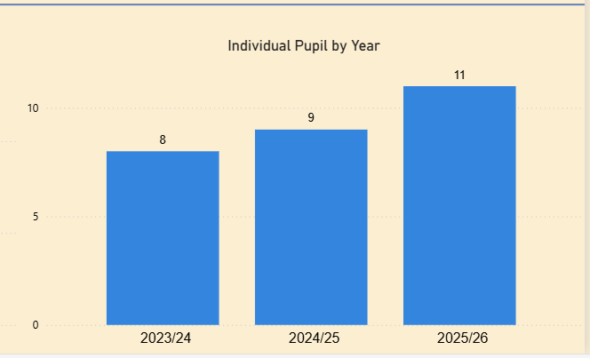
USE OF CALM incidents of violence and agression
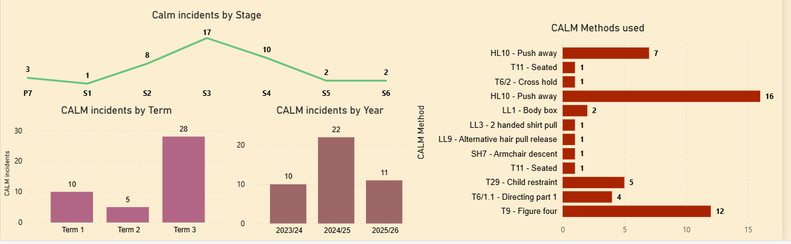
USE OF CALM: distressed and/or challenging behaviour
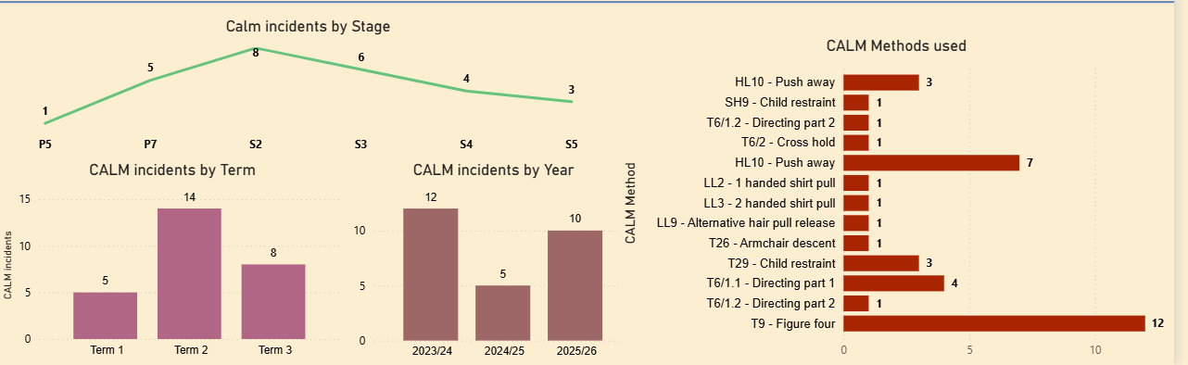

What does the data tell you about your context?

Category | Key Factual statements
- Acorn  - Attendance  - EAL  - Incidents of distressed/challenging behaviour | The number of families living in Acorn 5/6 for our primary (25%) is higher than for the secondary (22%).  We have a falling attendance pattern currently which can be detailed around medical needs of a few pupils which impacts on the data.  5 pupils marked as EAL  Increasing numbers of incidents overall across all data sets, often related to small number of pupils of whom staff are aware and supporting
 | What might this data indicate?
- Acorn  - Attendance  - EAL  - Incidents of distressed/challenging behaviour | Primary pupils may be more impacted by poverty, however, very aware of the impact of disability on income. We know that generally poverty is not the only or main barrier for our families.  Continue to monitor and support as often due to medical needs/family reasons. Targeting specific pupils whose attendance needs may not to be due specifically to medical reasons.  Need to take into account parents understanding of English and support any other EAL needs, although many pupils non-verbal so this would be important/  Changes in curriculum could support this area, increased focus on self-regulation and emotional awareness. Getting pupils ready to learn as a focus and the different curriculum pathways – e.g informal curriculum – low demand. Greater focus on sensory needs and developing play. Push for planned environmental changes to go ahead. Continued focus on Low Arousal and Nurture.

Attainment Gaps: Analyse the gaps

Gap area | Next steps
- Attendance  - Experiences  - Parental engagement (due to Geography of the school) | Continue to monitor, link in with other agencies, continue to support families. Multi agency approach. Target specific pupils whose low attendance may not be related to medical issues, Continue to support pupils whose low attendance is due to medical reasons with keeping in touch with school through the use of the CLW.  Continue to monitor the cost of the school day to make sure all pupils have access to as many wider achievement opportunities and ensure cost is not a barrier, continue to fundraise.  Continue to support, through PEF, family learning, family network building and other family engagement activities – family wellbeing support pupils wellbeing which impacts on attendance and attainment. Monitor the use of Learning Journals

Areas for Collaborative Action

Gap area | Next steps
- Attendance  - Experiences  - Parental engagement | Through various multi agency platforms continue to monitor and support our families.  Continue to develop network for DYW but also community learning activities and group for Senior Phase and transitions. Link in with CLW  Working with AHPs and a range of other agencies to support families – CLW and PEF funded posts.  Trying new model for parent council and fundraising/charity group.

1.3  LEADERSHIP  OF  CHANGE | How well are you doing?  What’s working well for your learners? | How do you know?  What evidence do you have of positive impact on learners? | What are you going to do now?  What are your improvement priorities in this area? | How would you evaluate this QI using the HGIOS 4/HGIOS ELC 6-point scale?
- Developing a shared vision, values and aims relevant to the school and its community. | Fairview has a clear and shared vision and values which are increasingly visible in day-to-day practice. Staff demonstrate high expectations for all learners and are able to articulate how the Fairview values inform learning, teaching and relationships. Work on low-arousal approaches and the universal offer has strengthened a shared understanding of how pupils are supported to be ready to learn. The work on the Fairview Way has increased consistency along with increased visibility of values in Get Togethers | • Inset and staff meeting materials linked to vision and values  • Observations and environmental audits  • Planning and tracking discussions  • Parent and partner questionnaires  • QA calendar evidence | - • Further strengthen how pupils influence and experience the vision (e.g. pupil-friendly media)  • Improve use of data to better evidence impact  • Maintain visibility of values through staff practice and environments | 4
- Strategic planning for continuous improvement | Strategic planning is collaborative and informed by staff evaluation. Most staff are confident engaging in improvement activity and professional learning opportunities. The use of a QA calendar, has improved focus and clarity around monitoring and evaluation. The use of the newsletter to enhance understanding of school approaches has been beneficial | • Collegiate calendars and minutes  • SIP and self-evaluation dialogues with staff  • PRDs and professional learning records  • Observation evidence  - Newsletters | • Strengthen shared understanding of curriculum pathways and rationale – offer parent sessions throughout the year and ensure support staff have opportunities to enhance their understanding  • continue to increase pupil and family involvement in improvement planning  • Continue to manage the pace of change based on staff feedback | 4
- Implementing improvement and change | Most staff engage positively with change, particularly where it improves equity, wellbeing and inclusion. Staff voice informs professional learning priorities. Low-arousal and sensory-informed practice has increased capacity for pupils to cope with change. However, staff evaluation highlights inconsistency in implementation across classrooms and times of day. | • Observations and professional dialogue  • Training records and inset evaluations  • Team meeting minutes  • PEF and Cost of the School Day evidence  - PRD evidence  - Fairview Way | • Increase consistency of implementation across classes  • Develop more staff leadership opportunities  • Improve how impact of change is measured  - Encourage more sharing of resources  - Reduce change fatigue by embedding | 4

2.3  LEARNING,  TEACHING AND  ASSESSMENT | How well are you doing?  What’s working well for your learners? | How do you know?  What evidence do you have of positive impact on learners? | What are you going to do now?  What are your improvement priorities in this area? | How would you evaluate this QI using the HGIOS 4/HGIOS ELC 6-point scale?
- Learning and engagement | Staff use detailed knowledge of pupils to plan engaging learning experiences which are engaging based on their knowledge of their pupils, with an increasing focus on communication, independence and pupil voice and choice through the use of play. Learning is increasingly responsive and inclusive, with more opportunities for community engagement and wider achievement in most classes.  Commitment to children’s rights is embedded and positive relationships | • Classroom observations  • Planning and tracking meetings  • Pupil council evidence  • RRS accreditation evidence  • Attendance and engagement data (play)  - Learning Journals  - My Learning Plans and evaluations  - Teacher radar charts and self evaluation  - Accreditation of Gold RRS | • Refocus on consistent use of total communication in all learning contexts  • Ensure timetables are purposeful, challenging and relevant  - Roll out SCERTS  - Ensure all classes are accessing relevant community activities  - Continue to embed the use of play as a vehicle to improve engagement, communication and regulation  - Roll out core curriculum  - Ensure digital use is always relevant and learning focused | 4  4  4
- Quality of teaching | Teaching is increasingly aligned to the school’s shared vision and universal offer. Staff use a range of strategies and environments to support learning. Practice shows a strong focus on process, skill, play acquisition and independence rather than outcomes alone. | • Lesson observations  • Planning documentation  • Inset and professional learning records  • Self-evaluation consultations  - PRDs  - Team meeting discussions  - Radar charts  - Sharing good practice sessions  - Moderation | - Improve use of digital and assistive technology  - Strengthen questioning, feedback (which can be difficult) and observational assessment  - Increase opportunities for research-informed practice  - Increase peer sharing of practice  - Radar charts show that the most challenging area is to involve pupils in their own planned learning. | 4  4  4
- Effective use of assessment | Assessment is predominantly formative, observational and appropriate for ASN learners. Staff teams use a range of information to understand progress, including community learning experiences and partner input. | • Moderation records  • Team meetings  • My Learning Plans  • Partnership feedback  - Observations  - SNSA where appropriate  - Accreditation data | • Strengthen confidence in baseline assessment  • Improve consistency in tracking progress across pathways  • Increase moderation with other schools  - Increased moderation | 4  4  4
- Planning, tracking and monitoring | Staff have a clear understanding of learners’ progress and can discuss this confidently. New planning formats support reflection and consistency. Nursery staff effectively use plan-do-review cycles to improve learning opportunities. | • My Learning Plans  • Tracking meetings and minutes  • Pupil reports  - Quality Assurance  - Planning discussions  - Tracking discussions  - Moderation | • Increase learner involvement in planning  • Strengthen use of tracking data to build on prior learning  • Fully embed new nursery tracking systems  - Implement and share the new core curriculum documents which will allow focus on barriers to learning through the individual My Learning plans | 4  4  4

3.1  ENSURING  WELLBEING  EQUALITY AND  INCLUSION | How well are you doing?  What’s working well for your learners? | How do you know?  What evidence do you have of positive impact on learners? | What are you going to do now?  What are your improvement priorities in this area? | How would you evaluate this QI using HGIOS 4 /HGIOS ELC 6-point scale?
- Wellbeing | Wellbeing is a strong feature of school life. Staff understand their role as duty bearers and prioritise dignity, respect and emotional safety. Low-arousal approaches and strong relationships support regulation and readiness to learn. Strong consideration of the environment for learning. Staff wellbeing continues to be a major focus which supports pupil wellbeing. The school support family wellbeing well. | • Wellbeing group minutes  • Child’s Plans  • Attendance and engagement data  • Family feedback  • RRS evidence  - Breakfast Club | • Increase modelled play opportunities  • Refresh GIRFEC understanding  • Strengthen pupil voice in planning meetings  - Continue to promote staff wellbeing. E.g wellbeing cafes and wellbeing groups  - Bring plans for trim trail and music room to fruition | 5
- Fulfilment of statutory duties | The school meets statutory requirements and staff demonstrate awareness of their responsibilities. Induction practice supports consistency and confidence for new staff. | • Policy compliance  • Induction records  • E-learning modules  - CP folders  - Attendance data | Maintain high compliance through regular review | 5
- Inclusion and equality | Fairview ensures that all pupils can access opportunities regardless of need or financial circumstance. PEF funding and targeted supports reduce barriers and promote equity. Pupils are increasingly involved in decision making which is relevant to them. | • Cost of the School Day evidence  • Finance and PEF records  • SSCO and CLW reports  • Survey data from parents  - Fundraising  - Gold RRS Award  - Events group, pupils council  - Awareness of SIMD/PEF data | • Track impact of PEF more robustly  • Further develop outdoor learning provision including for PMLD students  • Expand pupil participation across school life | 5

3.2  RAISING ATTAINMENT  AND  ACHIEVEMENT | How well are you doing?  What’s working well for your learners? | How do you know?  What evidence do you have of positive impact on learners? | What are you going to do now?  What are your improvement priorities in this area? | How would you evaluate this QI using the HGIOS 4/HGIOS ELC 6-point scale?
- Attainment in literacy and numeracy | Learners follow personalised pathways with appropriate targets, particularly in communication and wellbeing. A total communication approach is embedded with specialist support. | • My Learning Plans and evaluations (data)  Tracking data  • Observations  • Learning journals  • Professional dialogue  - Pupil council and event’s group  - SNSAs where appropriate | • Improve tracking of attainment including work on trackers  • Strengthen use of observation evidence  - Strenghten whole school community understanding of curriculum offer  - Strengthen understanding and implementation of total communication approaches. | 4
- Attainment over time | Staff use informal assessment and baseline information to track progress over time. Transitions are well planned to ensure continuity. | • Tracking documents  • Transition paperwork  • Team meeting minutes  - Observations  - My Learning plans | • Formalise assessments across pathways  • Improve consistency of professional judgement | 4
- Overall quality of learners’ achievement | Learners achieve across a wide range of contexts, including accreditations, community, DYW and wider achievement programmes which build confidence and skills. | • Wider achievement records  - SQA/ASDAN data  - Tracking data  - Evaluated My Learning plans  • Observations  Pathways  • Curriculum pathway documentation  - Pupil reports | • Strengthen tracking of wider achievement  • Improve two-way communication with families which is reasonable to ensure families know what pupils are learning | 4
- Equity for all learners | All learners are supported to achieve positive destinations. Financial barriers are actively addressed and attendance is closely monitored. | • Attendance and destination data  • Cost of the School Day evidence  • CLW and DYW records | • Continue targeted attendance support  • Improve evaluation of community participation impact with awareness of a changing cohort. | 4

Overall analysis:
This document is a detailed self-evaluation and data analysis report for Fairview School and Nursery, focusing on school improvement across various domains including attendance, behavior, leadership, learning, wellbeing, and attainment. It outlines current data, interpretations, and planned next steps to enhance educational outcomes and equity for learners.
• Attendance and behavior context: Primary pupils are more affected by poverty indicators, with a noted decline in attendance mainly due to medical needs of some pupils. Incidents of distressed or challenging behavior are increasing, often linked to a small number of pupils receiving support. English as an Additional Language (EAL) pupils are few but requireconsideration in communication support. [1] [2]
• Data implications: Poverty is not the sole barrier for families; medical and family reasons impact attendance. The school aims to monitor attendance closely, target pupils with non-medical attendance issues, and support EAL needs considering many pupils are non-verbal. Curriculum changes focus on self-regulation, emotional awareness, sensory needs, and play to improve behavior and readiness to learn. [3] [4]
• Attainment gaps and next steps: Attendance is monitored with multi-agency support, targeting pupils with low attendance unrelated to medical issues. The school continues to address the cost of school day to ensure access to wider achievements and supports parental engagement through family learning and wellbeing activities. [5] [6]
• Collaborative actions: The school plans to maintain multi-agency family support, develop community learning and senior phase transition activities, and work with allied health professionals and other agencies. New models for parent council and fundraising are being trialed. [7] [8]
• Leadership of change: Fairview has a clear shared vision and values which guide practice, with staff demonstrating high expectations. Improvements include low-arousal approaches and the “Fairview Way” for consistency. Strategic planning is collaborative with a quality assurance calendar, though further pupil involvement and better use of data are planned. Implementation of change is generally positive but inconsistent, with plans to improve consistency, staff leadership, andimpact measurement. [9] [10]
• Learning, teaching, and assessment: Staff use detailed pupil knowledge to plan engaging, inclusive learning with a focus on communication, independence, and play. Teaching emphasizes process and skill development. Assessment is mostly formative and observational, with plans to improve baseline assessment confidence, tracking consistency, and moderation. Planning and monitoring are clear, with new formats supporting reflection; increasing learner involvement and embedding nursery tracking are priorities. [11] [12]
• Wellbeing, equality, and inclusion: Wellbeing is prioritized with staff supporting dignity, respect, and emotional safety through low-arousal approaches and strong relationships. Staff wellbeing is also emphasized. The school meets statutory duties and actively addresses financial barriers to equity using PEF funding. Plans include increasing play opportunities, refreshing GIRFEC understanding, and enhancing pupil participation and outdoor learning. [13] [14]
• Raising attainment and achievement: Learners follow personalized pathways with emphasis on communication and wellbeing, supported by total communication approaches. Progress tracking and use of observation evidence are to be improved. Transitions are well planned, with a focus on formalizing assessment and professional judgment consistency. Wider achievement is broad, including community and DYW programs, with plans to strengthen tracking and family communication. [15] [16]
• Equity and positive destinations: The school supports all learners to achieve positive destinations, addressing financial barriers and closely monitoring attendance. Targeted attendance support and improved evaluation of community participation impact are ongoing priorities. [17] [18]

