Values  Staff work in partnership with community, families and pupils to provide a nurturing learning environment for pupils that is articulated in our revised school Vision, Values and Aims.  Embedded are the principles of Restorative Practice and Nurturing approaches within the school and community.  Staff, families, pupils and the wider community contribute to the life and work of the school and are included in the self-evaluating process.  Create opportunities to work with the local and wider community.  Every pupil is recognised for their achievements which are celebrated. | Totality of the Curriculum  There is a blend of discrete subjects and interdisciplinary learning that provides rich, highly-motivating and relevant contexts for pupils. There are planned opportunities for personal achievement through academic, sporting and cultural activities. These are celebrated at weekly Get-Togethers and the Celebrations & Achievements Ceremony/Celebrating Success. The ethos and life of the school is developed through a wide range of experiences. The curriculum is delivered within a safe and caring environment with an ethos of achievement and success. Our curriculum includes, recognises and celebrates the wider achievement of pupils thus enabling them to reach their full potential.  Es and Os are used to plan. Assess and track children’s learning and clearly show the ongoing developments of all. | Learning and Teaching  Opportunities will be created to work with community groups through IDL and Forest Schools.  Staff will continue to ensure learning and teaching is engaging and active, real and relevant, planned to support and challenge all learners. Tasks will be differentiated to meet the needs of the learner and take account of their learning styles.  A variety of high quality strategies will be employed in order to deliver effective learning experiences for children. These will include AiFL, Co-operative Learning, Forest School and use of appropriate technologies. Within in the single class setting, teaching strategies are used that meet the needs of all learners with independence within the learning tasks being encouraged. Pace and challenge for all continues to be maintained through the differentiation of appropriate learning opportunities. Visible planning mechanism is in place that records the children’s learning across the 4 contexts for learning.
Experiences and Outcomes  Experiences and outcomes are planned and developed through the four contexts for learning and provide a varied and rich learning environment. Teachers identify opportunities for inter-disciplinary learning, Active and Co-operative Learning. Teachers understand experiences and outcomes and are confident in using them to deliver effective learning experiences for children to a consistently high standard. Teachers will evaluate all aspects of planning and assessment of pupils’ learning. Staff will record and report on pupils’ attainment and achievements, informed by progress within levels. Teachers will continue to plan and provide differentiated experiences and outcomes in all areas of curriculum. Children understand clearly the importance of target setting and having learning discussions on a regular basis where they are encouraged to share and discuss their learning and next steps which are then shared with parents/carers through learning journals. Children are fully engaged within the scholls developments and self evaluations and are clear about their different roles and responsibilies within the school. | 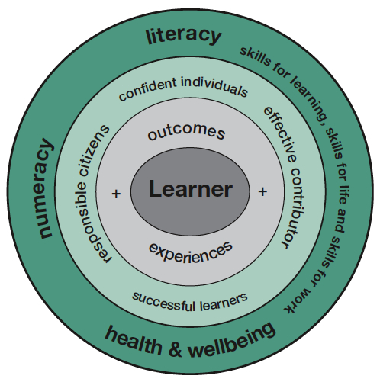 | Entitlements  Our school will provide for every pupil a broad, coherent, progressive and relevant general education that includes an understanding of Scotland’s place in the world today. There will be appropriate support for learning, in order for the school to get it right for every child. Effective transitions will be in place for pre-school to P1 and for P7 to S1. Staff will plan learning experiences and outcomes which will enhance skills for learning, life and work so that all our young people will lead purposeful lives within society.  Each child, staff member and parent/carer is valued and within a climate of mutual trust and respect, all are encouraged top share their vies within a positive framework and upholds GIRFEC, Child Proteaction and P&Ks Anti-Bullying Strategey.
Support  Staff will support pupils by reviewing their progress and planning next steps in their learning. We will provide appropriate support and challenge for all pupils and continue to ensure their opportunities for success. Transitions are planned, supportive, informative and timeous. There will be provision for appropriate support to accommodate children’s learning needs.  Staff will continue to participate in CPD opportunities to develop and share knowledge and understanding in order to provide an enhanced provision, with a particular focus on Forest Schools, Restorative Approaches, Nurturing Principles and Pupil Profiling which will be reflected in the interactions between staff and pupils. We will work with outside agencies effectively to ensure the Health and Well-being of all pupils. Child protection guidance will continue to be adhered to and pertinent information shared appropriately.  All staff know each child as an individual providing exceptional care and welfare, experiences that meet the individual needs of each child in terms of appropriate challenge and support.  Professional dialogue within our staff team and beyond is actively encouraged. | Principles  Braco and Greenloaning Primary Schools will endeavour to apply the 7 Principles across the curriculum areas - Challenge and Enjoyment, Breadth, Progression, Depth, Personalisation & Choice, Coherence and Relevance.  The principles will be applied systematically across the totality of the curriculum, including the life and ethos of the school. | Assessment  We will ensure that the cycle of learning, teaching and assessment is continuing to be under review. Pupil Profiles (Learning Journeys) will be in place for all pupils to record their achievements and to review and share with their parents. Staff will take a closer look at the results of standardised testing in order to establish breadth, challenge and application of learning.  Through moderation and choosing appropriate resources, we will review the balance of IDL and discrete subjects.
Schools and centres will refer to and take account of the GIRFEC Wheel and My World Triangle

