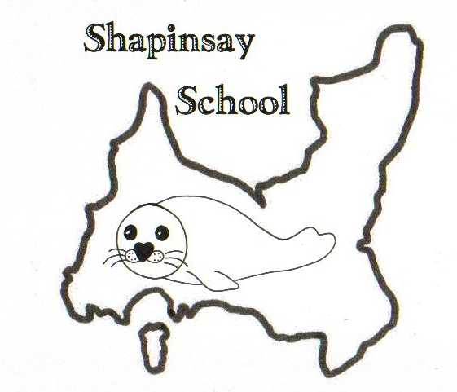

SHAPINSAY COMMUNITY SCHOOL
Welcome Leaflet

Welcome
We hope that this short leaflet will help to you find information quickly about our school.

If you have any questions, please do not hesitate to contact the school using the contact details below.

Emma Clements,
Headteacher

School Contact Details
Emma Clements – Headteacher
Shapinsay Community School
Balfour, Shapinsay, Orkney.
01856 711218
Website: https://blogs.glowscotland.org.uk/or/shapinsayschool/
admin.shapinsay@glow.orkneyschools.org.uk
emma.clements@orkney.gov.uk

About the School
We provide education for children from the age of 3 – 12 (Nursery – P7), along with some eligible 2 year olds.
The school is of non denominational status. Currently the primary children are taught in one class and the nursery children in another.

Organisation of the School Day
Start Time: 9.00
Morning Break: 10.45 – 11.00
Lunch Time: 12.15 – 13.00
Finish Time: 15.00
PE can take place on any day with class teachers so we ask that pupils have a PE kit in at all times.
Music tuition (violin / viola) takes place on Thursdays for older pupils.

School Dress Code
Children should wear appropriate clothing in school (including shoes) and have an appropriate PE kit in at all times. We ask that children do not wear jewellery to school (stud earrings can be worn but may need to be taped for PE). Pupils can wear school jumpers but uniform is not compulsory, other than for trips.

School Catering
We have a kitchen on site where school lunches are cooked. Menus are sent home termly and we ask that children stick to their choices wherever possible. Children can choose packed lunch or school lunch on any day. Packed lunches and School meals are eaten in the dining room. School meals are paid for online at www.orkney.gov.uk/MealPay. Nursery and P1-5 children receive free school meals. Please contact the school for more information.

Travel to and from school
Children living within or near Balfour Village can either walk to school or be dropped off. We ask that parents reverse into the designated parking spaces outside the school building and that they do not use the space allocated for the minibus. Children walking to school should walk on the pavements. All children are given fluorescent jackets to wear during the winter months and they should wear them to and from school.

School Transport
Orkney Islands Council provides school transport for pupils who live out with walking distance as outlined in the School Transport Policy. Parents of children living outwith walking distance of the school will receive information about bus routes with enrolment forms when your child starts school.

Transport for Pre-School Children
There is no provision of transport by the local authority for pre-school age children.

General Supervision
Before school begins supervision is very limited, therefore pupils should not arrive at school until as near to the school start time as possible. Children are supervised from when the school bus drops them off. Children walking to school or being dropped off by car should not arrive before 8.45.
During intervals the Janitor supervises the children. Teachers are also available to help. There is always access to the building and the children are made aware of this.

School security
Once the children are in school the front door should be locked. Visitors to the school are asked to sign in. There is a doorbell to ring for visitors.

Communication with Home
From time to time your child will bring home important and routine communications from the school; we do try to keep this to Mondays wherever possible. Parents are encouraged to check their child’s schoolbag for these communications. If you wish to contact the school please speak to or email the Headteacher, phone the school or put a note in with your child.

Unexpected/Severe Weather Closures & Transport Disruption
Please see the school handbook for more information. Updates will be sent to Radio Orkney and will be available via the Orkney Islands Council site. We will always try to contact parents as soon as possible individually as well, and by using the Parents WhatsApp group.

Infectious Diseases
Colds, flu and gastroenteritis are the most common infections affecting children of school age. It is important that you keep your child off school if they are unwell and for 48hours after they stop vomiting or diarrhoea.

Parents
At Shapinsay Community School, we welcome all parents into the school. We hold regular events where parents are invited in as well as yearly written reports. All parents and children are also invited to use the Tapestry app to share information from school. All parents are automatically part of the Parent Council forum. Meetings are held termly. For more information please contact Anna Lidderdale, Parent Council chair, via the school.

Medical Needs
Children with medical needs will need to have a full plan, co-created with parents and staff in order to ensure that their medical needs are met.

Our School Values
- Safe
- Respectful
- Hardworking

At Shapinsay Community School we encourage all children to abide by the school values. We expect all children to behave appropriately and to take responsibility for their actions. In this way we are able to ensure the happiness and safety of the children in our care. Children who do not follow the school values appropriately are dealt with on an individual basis following discussion with an adult in the school. Where necessary, parents may also be asked to meet with school staff to discuss their child’s behaviour. Children are always expected to apologise for any poor behaviour as well as receiving an appropriate consequence.

Homework
Pupils are given homework each week to support their learning and to encourage them to become more organised and self-supporting in their learning. Homework tasks will be given where a teacher feels a particular child or group of children may benefit from it. Homework is generally reading, spelling and maths for children in P2 – P7. Children in P1 will do phonics and reading. We ask that parents support us with homework, and keep in touch with the school regarding any issues.

