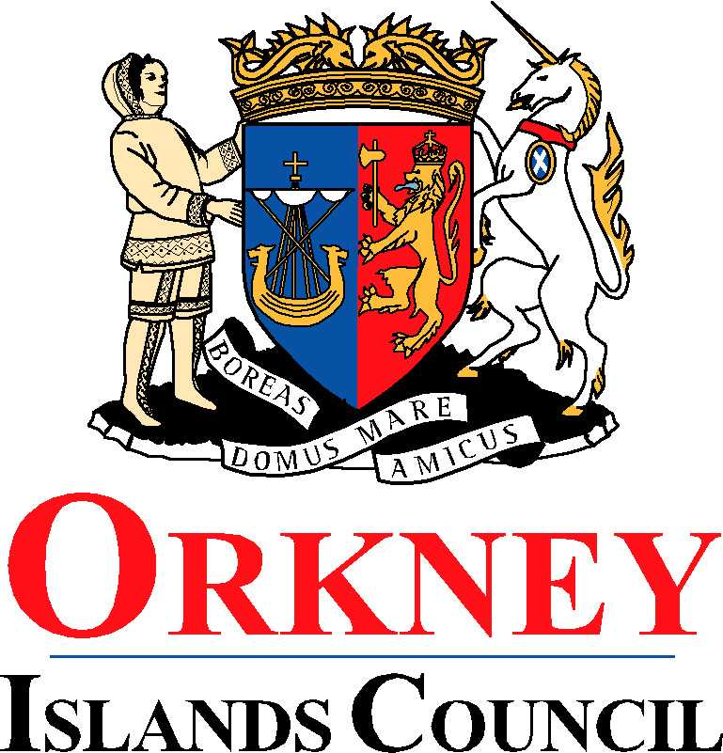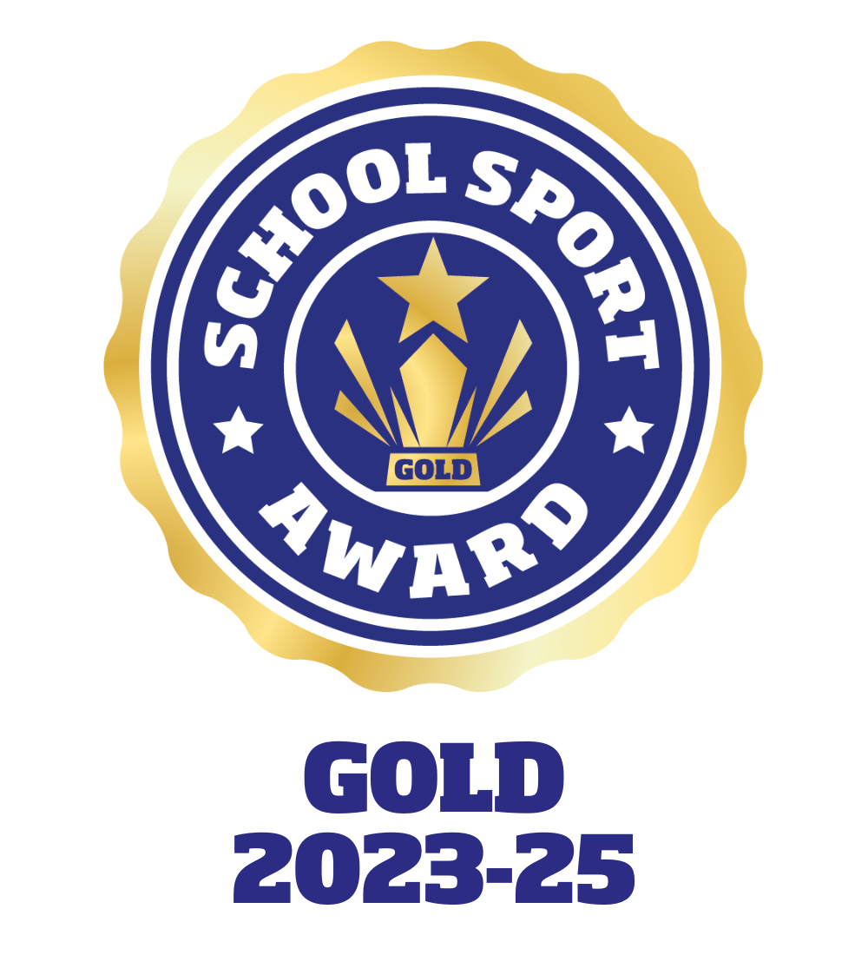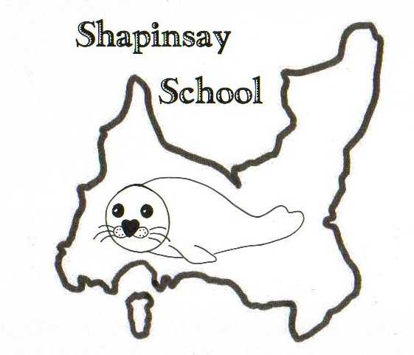

**Orkney Islands Council Department of Education, Communities and Housing**

**Shapinsay Community School** Shapinsay, Orkney, KW17 2DY

Tel: (01856) 711218 Fax: (01856) 711218

Email: [admin.shapinsay@glow.orkneyschools.org.uk](mailto:admin.shapinsay@glow.orkneyschools.org.uk)

Web: <https://blogs.glowscotland.org.uk/or/shapinsayschool>

Head teacher: Emma Clements

Tuesday 7th October 2025

Dear Parents / Carers,

**Primary Learning this week**

This week the children in the Sunshine class are learning about extreme weather. The children in the stars class are continuing to work on their warning story. All primary children are learning more about the Zones of Regulation.

**Swimming**

We have now completed all swimming sessions, so children will be in school as usual this Friday.

**Parents Evening - Wednesday 8th October**

Reminder that tomorrow is Parents Evening for those primary parents who made appointments.

**Christmas shoeboxes**

Thank you to those who put in donations.

**Pupil Committees**

Dates for Pupil Committees for this session are: 5th Nov, 19th Nov, 17th Dec, 14th Jan, 4th Feb, 18th Feb, 18th March, 22nd April, 20th May, 3rd June, 24th June.

**Dounby 50:50 Sale**

Any items that you would like to donate for Parent Council to put to the Dounby 50:50 Sale please deliver to school this week or the first week back after the holidays. Gemma will price and deliver to Dounby. If you have any questions please speak to Gemma.

**School Photos**

We are hoping to have Emily Fisher Photography come over in November to take our School photos, group and individual. We are also offering the chance to have family shoots done that day. A confirmed date will be sent out as soon as we know. If you would like a family photo taken please get in touch with the school and we will add you to the list. There will be a small charge (towards the parent council to help towards the cost of her coming) but it will likely be £10-£15, all images will be included in that price.

**P7 Transition**

P7 will have a transition letter from KGS attached to this newsletter.

**Back to School**

Children are back in school Wednesday 29th October. Enjoy your Holidays!

Kind regards,

Emma Clements

Headteacher