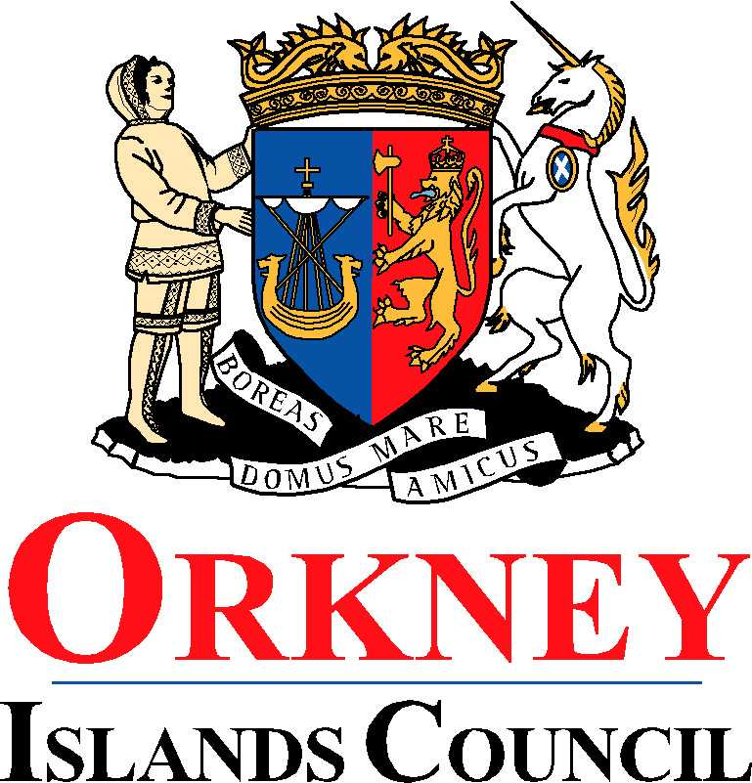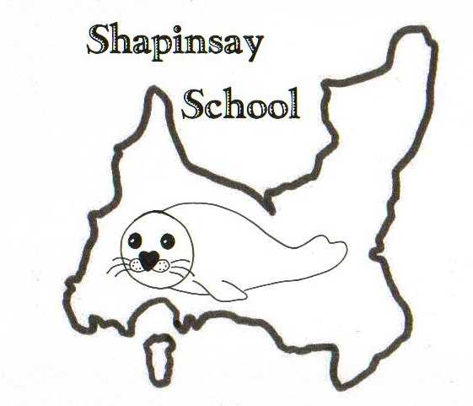

**Orkney Islands Council Department of Education, Communities and Housing**

**Shapinsay Community School** Shapinsay, Orkney, KW17 2DY

Tel: (01856) 711218 Fax: (01856) 711218

Email: [admin.shapinsay@glow.orkneyschools.org.uk](mailto:admin.shapinsay@glow.orkneyschools.org.uk)

Web: <https://blogs.glowscotland.org.uk/or/shapinsayschool>

Head teacher: Emma Clements

Tuesday 23rd September 2025

Dear Parents / Carers,

**Primary Learning this week**

This week the children in the Sunshine class are learning about climate zones around the world. The children in the stars class are learning about female scientists. All of the children are learning about the Zones of Regulation.

**Swimming**

We will be swimming again this Friday, Please can children meet at the boat by 8:45am (bus children will be dropped off there). They will need with them a bag that they can carry themselves, with swim kit and towel in. They should also have their water bottles and a snack for after swimming. School jumpers should be worn, and they should have a coat. They may wish to bring goggles as well, and a £1 coin for the locker but these are not essential. Children may also want to bring something quiet to do on the boat

**Parents Evening**

We will be offering parents of children in primary the chance to come in and meet with teachers on Wednesday 8th October. Appointments are available between 3 and 4:15, or from 6 – 7:30. There will also be a chance for parents to look at children’s work at this time.

Please complete the reply slip below and return to school to book an appointment as soon as possible.

**Flu vaccine**

Please return any letters not yet returned.

**Christmas shoeboxes**

A reminder that any filled shoeboxes or donations towards them should be returned to school by Friday 3rd October.

**Henry Programme**

We had attached a poster from Henry, Healthy Start, Bright Future for your information.

**Parent Council**

The Parent Council meeting has been changed to Monday 6th October 7pm in the music room. All welcome and encouraged to attend.

Kind regards,

Emma Clements

Headteacher

**Parent Consultations Wednesday 8th October 202**

Name of Child or Children……………………………………………………………………….

I would like an afternoon appointment 3.00pm – 4.15pm…………………………………..

I would like an evening appointment 6.00pm – 7.30pm…………………………………...

Parents signature………………………………………………………………………………….