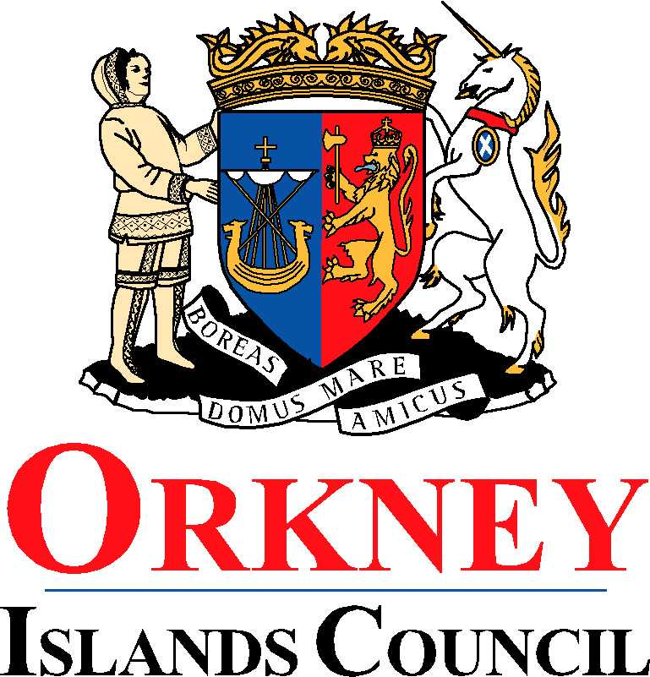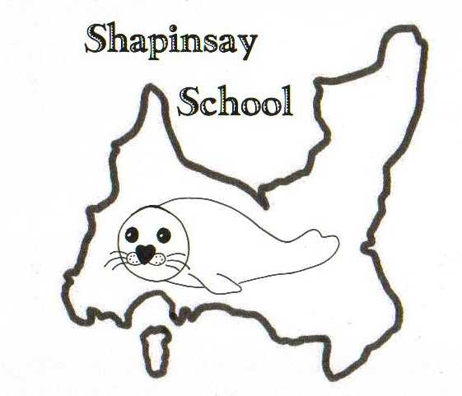

**Orkney Islands Council Department of Education, Communities and Housing**

**Shapinsay Community School** Shapinsay, Orkney, KW17 2DY

Tel: (01856) 711218 Fax: (01856) 711218

Email: [admin.shapinsay@glow.orkneyschools.org.uk](mailto:admin.shapinsay@glow.orkneyschools.org.uk)

Web: <https://blogs.glowscotland.org.uk/or/shapinsayschool>

Head teacher: Emma Clements

Tuesday 30th September 2025

Dear Parents / Carers,

**Primary Learning this week**

This week the children in the Sunshine class are learning about extreme weather. The children in the stars class are continuing to work on their warning story. All primary children are learning more about the Zones of Regulation.

**Swimming**

We will be swimming again this Friday, Please can children meet at the boat by 8:45am (bus children will be dropped off there). They will need with them a bag that they can carry themselves, with swim kit and towel in. They should also have their water bottles and a snack for after swimming. School jumpers should be worn, and they should have a coat. They may wish to bring goggles as well, and a £1 coin for the locker but these are not essential. Children may also want to bring something quiet to do on the boat

**This Friday will be our last swimming session.**

**Parents Evening - Wednesday 8th October**

We are assuming all reply slips are now in. For those who have indicated that you would like an appointment, please find your time attached. If you do not have this back and you would like an appointment please get in touch.

**Flu vaccines**

The vaccines have been given to those children who had consent forms this afternoon.

**Christmas shoeboxes**

A reminder that any filled shoeboxes or donations towards them should be returned to school by Friday 3rd October.

**Pupil Committees**

Our Pupil Committees (Pupil Council, Junior Road Safety Officers, Eco Group, Library Group and Sports Committee) meet for the first time tomorrow. If you would like to come and help with a committee please come in to school tomorrow morning. The committees will take around 45 minutes.

**Parent Council**

The Parent Council meeting has been changed to Monday 6th October 7pm in the music room. All welcome and encouraged to attend.

Kind regards,

Emma Clements

Headteacher

**Parent Consultations Wednesday 8th October 2025**

Name of Child or Children……………………………………………………………………….

Time of Appointment.....................................................................................................................