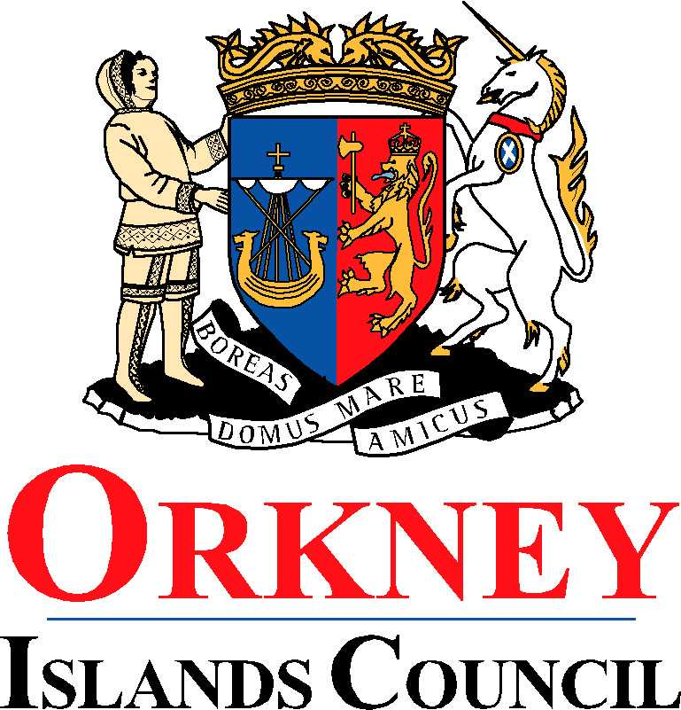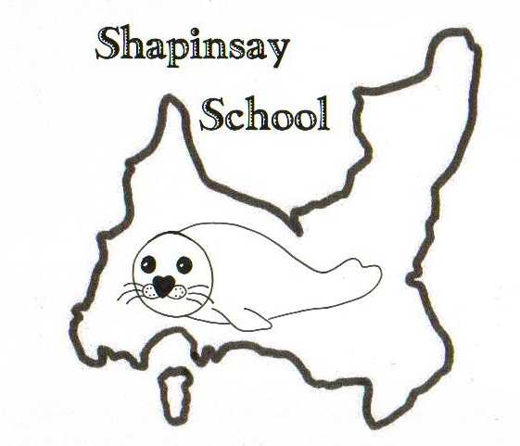

**Orkney Islands Council Department of Education, Communities and Housing**

**Shapinsay Community School** Shapinsay, Orkney, KW17 2DY

Tel: (01856) 711218 Fax: (01856) 711218

Email: [admin.shapinsay@glow.orkneyschools.org.uk](mailto:admin.shapinsay@glow.orkneyschools.org.uk)

Web: <https://blogs.glowscotland.org.uk/or/shapinsayschool>

Head teacher: Emma Clements

Tuesday 26th August 2025

Dear Parents / Carers,

**Primary Learning this week**

This week the children in the Sunshine Room are learning about weather. We are keeping a record of the weather and have made our own weather vanes and rain guages. The children in the stars room are learning about renewable and non-renewable energy and they are starting to think about climates round the world.

**Homework Reminder**

Homework will come home for children in P2 and above each week and came home yesterday. Spellings will be tested on Fridays and maths homework should be in by Friday morning. As we are swimming this term you might want to hand it in on Thursday so you don’t need to take it swimming.

**Free School Meals, clothing grant**

If you think you may be eligible for free school meals or a clothing grant, please find more details at <https://www.orkney.gov.uk/our-services/education-and-learning/grants-emas-and-bursaries/school-meals-and-clothing-allowances/>

**Overdue Library Books**

There are several books still overdue for the Library, could you please check at home and return them ASAP.

**Violin Lessons**

Reminder that violin / viola lessons take place on Thursdays.

**Swimming**

We will be swimming again this Friday, Please can children meet at the boat by 8:45am (bus children will be dropped off there). They will need with them a bag that they can carry themselves, with swim kit and towel in. They should also have their water bottles and a snack for after swimming. School jumpers should be worn, and they should have a coat. They may wish to bring goggles as well, and a £1 coin for the locker but these are not essential. Children may also want to bring something quiet to do on the boat.

Kind regards,

Emma Clements

Headteacher

_________________________________________________________________________________________________________