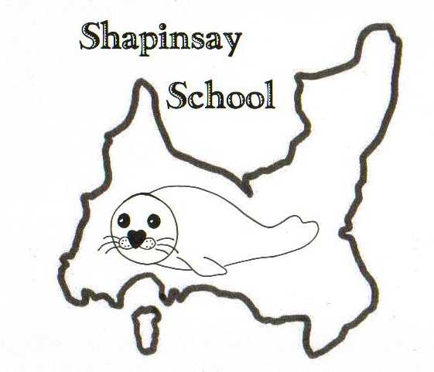

**Orkney Islands Council Department of Education, Housing and Leisure**

**Shapinsay Community School** Shapinsay, Orkney, KW17 2DY

Tel: (01856) 711218 Fax: (01856) 711218

Email: [admin.shapinsay@glow.orkneyschools.org.uk](mailto:admin.shapinsay@glow.orkneyschools.org.uk)

Web: <https://blogs.glowscotland.org.uk/or/shapinsayschool>

Head teacher: Emma Clements

Tuesday 19th August 2025

Dear Parents / Carers,

Welcome back, we hope you all had a wonderful summer. Welcome to Noah and Freddie who are joining us in the Nursery.

**Staffing**

We welcome Mrs Monika Armet into school. Toby Diamond will be joining us on Mondays and Fridays as Relief Classroom Auxiliary.

**Nursery**

Nursery will continue to operate from 9am – 1pm each day, as we have still not been able to recruit to the vacant post.

**Primary Class structure**

We will still be operating as one primary class, but the primary children will be usually working in one of two groups. One group will usually be working in the Sunshine Room with Miss Clements / Mrs Bews, while the other works in the Stars room with Mrs Armet. There will be some times where these groups mix as well, and all children will work with all teachers at some point each week.

Your child will tell you which room they are working in most of the time, so please ask them (or staff if the children aren’t clear!).

**Primary Learning this week**

This week we will be settling back into school. Our topic this term is Weather, Climate and Energy so we will be thinking about what we already know and what we want to find out more about.

**New bookbags and jumpers**

The primary children have been given new bookbags and jumpers today. Bookbags have their names on the labels, and children should have them in school each day. Nursery children will also be getting a school jumper this week if they would like one.

The new jumpers all have numbers on; please take note of your child’s number. When they outgrow it please return to school and we will give them the next size up. Please don’t name the jumpers – we have a list of who has which number in school and will update the list when needed.

School jumpers should be worn for trips outwith Shapinsay, though children are welcome to wear them other days as well.

If you have any other school jumpers at home, please return to school. If anyone wants to buy a school jumper I can pass on the details of where they were ordered from.

Many thanks to Parent Council for purchasing the new jumpers and bookbags.

**PE kits**

Please ensure children have PE kits in school each day, including suitable footwear for PE. They can be left in school. If you want to take them home for washing on Fridays please make sure they come back in on Monday.

**Swimming**

The primary children will be swimming on Fridays this term. Please can children meet at the boat by 8:45am (bus children will be dropped off there). They will need with them a bag that they can carry themselves, with swim kit and towel in. They should also have their water bottles and a snack for after swimming. School jumpers should be worn, and they should have a coat. They may wish to bring goggles as well, and a £1 coin for the locker but these are not essential. Children may also want to bring something quiet to do on the boat.

P1 –3 children will be in the leisure pool with adults from school, working on water confidence. P4 – 7 will be having lessons in the bigger pool.

We will be walking to the Picky Centre and getting a bus back to the 11.30am boat and then walking back to school in time for lunch.

Please complete the permission slip for swimming and return to school.

**Yearly Permissions and Menus**

Please find attached yearly forms and the updated menus. We apologise for all the paperwork, but could this all be returned to school by Thursday as we need it before swimming.

**Homework**

Homework will come home for children in P2 and above each week from next Monday. Spellings will be tested on Fridays and maths homework should be in by Friday morning. As we are swimming this term you might want to hand it in on Thursday so you don’t need to take it swimming.

**School Meals**

For those who pay for school meals (children in P6/7, unless children recieve free school meals), the link to buy tickets is <https://www.orkney.gov.uk/Online-Services/pay-it.htm>

The payment system is due to change in the next few weeks so we will let you know when we have more information.

Menus are attached to newsletter, please complete choices and return ASAP,

**Contacting school**

Gemma is usually in the school office on Tuesdays and Wednesdays, so feel free to phone the school. The admin email will also only be checked after school on these days. Other days please phone if needed, but people answering will likely be working with children so if possible could you communicate before or after school, or by email / message.

You are welcome to use whatsapp to message the school phone, but please don’t message staff personal phones about school things unless it’s an emergency. The school mobile number is 07351 952057. This phone will remain in school but will be checked each morning and during the day.

You can also email members of staff directly on their school emails, which will be checked during working hours.

Emma Clements – [emma.clements@orkney.gov.uk](mailto:emma.clements@orkney.gov.uk)

Leanne Bews – [leanne.bews@glow.orkneyschools.org.uk](mailto:leanne.bews@glow.orkneyschools.org.uk)

Monika Armet – [monika.armet@glow.orkneyschools.org.uk](mailto:monika.armet@glow.orkneyschools.org.uk)

Alison Meason – [alison.meason@glow.orkneyschools.org.uk](mailto:alison.meason@glow.orkneyschools.org.uk)

School Office (Gemma) - [admin.shapinsay@glow.orkneyschools.org.uk](mailto:admin.shapinsay@glow.orkneyschools.org.uk)

**What to bring when (Primary children)**

|  |  |
| --- | --- |
| Every day | Book bags (containing reading record and spelling book)  Water bottle  Snack  Packed lunch if applicable |
| Monday | PE kit if you took it home. |
| Tuesday |  |
| Wednesday |  |
| Thursday | Violin / Viola  Maths homework to hand in |
| Friday | Swimming things  Maths homework if not handed in on Thursday |

**Dates**

Please find attached the term dates for this session.

**Sunscreen**

Please send in Sunscreen labeled with child name, you can put one bottle per family.

Kind regards,

Emma Clements

Headteacher

_________________________________________________________________________________________________________

SWIMMING PERMISSION

Name of Child/Children:..........................................................................

I give permission for my child/children to attend swimming lessons on Friday’s this term.

Have any details changed on your child’s medical record? YES/NO

Have any of your contact details changed? YES/NO

If YES please specify...................................................................................................................................

Parents signature