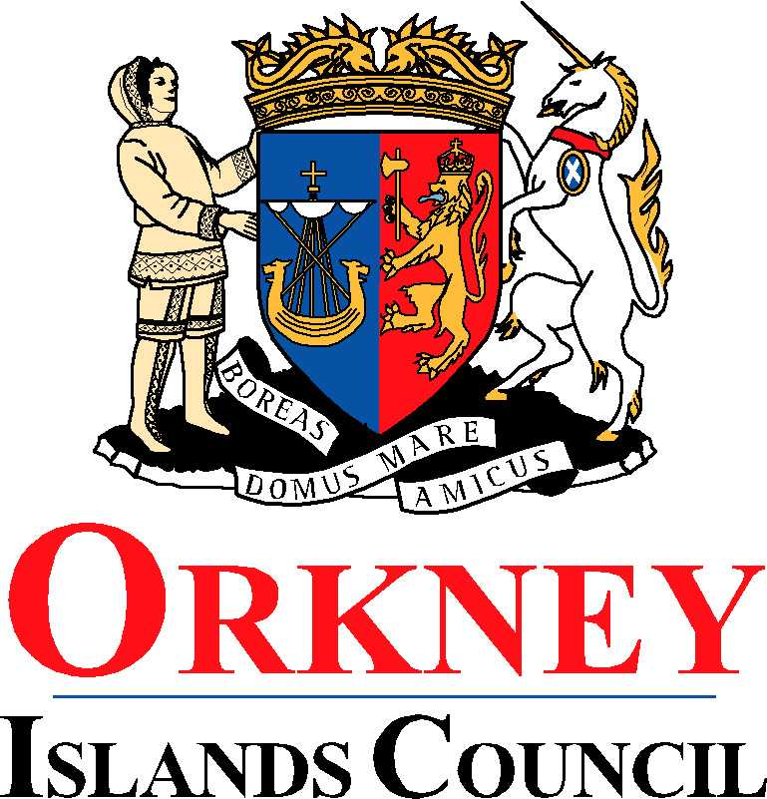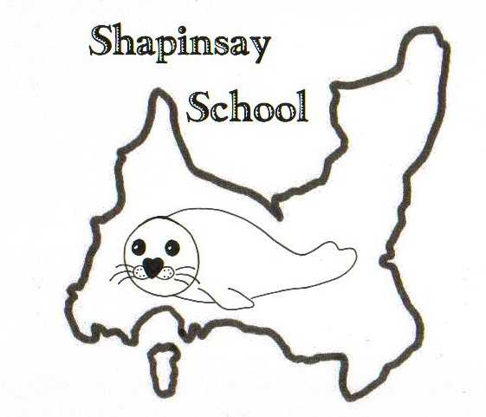

**Orkney Islands Council Department of Education, Communities and Housing**

**Shapinsay Community School** Shapinsay, Orkney, KW17 2DY

Tel: (01856) 711218 Fax: (01856) 711218

Email: [admin.shapinsay@glow.orkneyschools.org.uk](mailto:admin.shapinsay@glow.orkneyschools.org.uk)

Web: <https://blogs.glowscotland.org.uk/or/shapinsayschool>

Head teacher: Emma Clements

Monday 1st September 2025

Dear Parents / Carers,

**Primary Learning this week**

This week the children in the Sunshine Room are learning about different types of weather, and we are keeping a record of the weather each week. Children in the Stars room are comparing climate zones.

**Orkney Science Festival**

We will be having some visits as part of the OISF. On Thursday 4th the children will be taking part in Floating Fun workshops, On Tuesday 9th we have a session about birds and on Wednesday 10th we will be learning about the Ness of Brodgar.

**P6 outdoor ed**

P6 children will be attending outdoor ed sessions in Kirkwall with P6 children from Glaitness School on Friday this week and next Monday and Tuesday. Mrs Armet will be going with them, and the rest of the children will do lessons as normal with Miss Clements and Mrs Bews.

All details about the P6 trip are on the additional letter sent last week.

**Homework**

The children in the Stars class will not be set homework or spellings next week, and will have until Friday 12th to do their homework and will have their spellings sent home today tested then. This is to keep the class together as the P6s are missing several days. I will set the children in the stars class who are not going to outdoor ed something additional next week as they will be in school as normal.

**Overdue Library Books**

There are several books still overdue for the Library, could you please check at home and return them ASAP. The library van visits this Thursday and we’d really like to get them back in!

**Blythswood Shoebox Appeal**

Shapinsay kirk are once again taking part in the Blythswood Shoebox Appeal. A copy of the leaflet has been attached (if you would like an actual leaflet please get in touch – we just have limited numbers!) If you would like to make a shoebox, or to donate any items towards one please bring them to school by **Friday 3rd October**. Please note that some of the suggested items have been updated so please check the list for what to donate.

**Local Visit Consent**

A local area consent form is attached today, could all Primary Children have these signed and returned ASAP this allows us to go on local area visits without having to send out a consent letter each time. We have already got the Nursery ones back in.

**Flu Vaccine**

There is an information leaflet about Flu Vaccine attached to the newsletter.

Kind regards,

Emma Clements

Headteacher