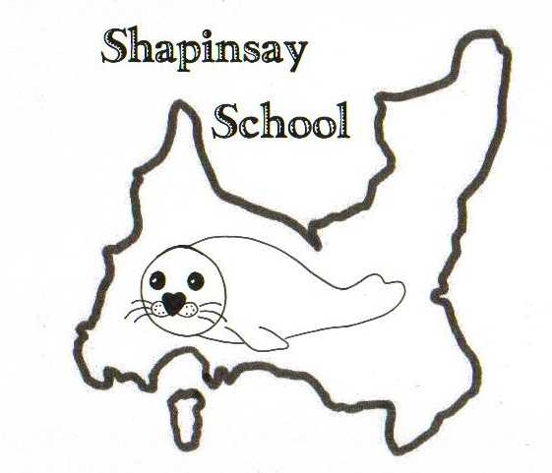

**Orkney Islands Council Department of Education, Communities and Housing**

**Shapinsay Community School** Shapinsay, Orkney, KW17 2DY

Tel: (01856) 711218 Fax: (01856) 711218

Email: [admin.shapinsay@glow.orkneyschools.org.uk](mailto:admin.shapinsay@glow.orkneyschools.org.uk)

Web: <https://blogs.glowscotland.org.uk/or/shapinsayschool>

Head teacher: Emma Clements

Tuesday 8th September 2025

Dear Parents / Carers,

**Primary Learning this week**

This week the children are taking part in more Science Festival visits. Today we have a session about birds, and tomorrow we have a session based on the cattle bones found at the Ness of Brodgar.

**Overdue Library Books**

There are several books still overdue for the Library, could you please check at home and return them ASAP. An email was sent yesterday with details of the books we are missing.

**Tuesday 16th September**

Next Tuesday Miss Clements will be out of school for Ivan’s funeral. If any of you wish to take your children please speak to us before Tuesday. We will offer children who are in school the chance to stand outside the school if they wish while the hearse passes just before lunch. Alison Meason will also be attending the funeral, and we have Lee-Anne Gray in Nursery that morning as well so she will be covering lunch in Nursery and doing the last part of the day with the children.

**Swimming**

We will be swimming again this Friday, Please can children meet at the boat by 8:45am (bus children will be dropped off there). They will need with them a bag that they can carry themselves, with swim kit and towel in. They should also have their water bottles and a snack for after swimming. School jumpers should be worn, and they should have a coat. They may wish to bring goggles as well, and a £1 coin for the locker but these are not essential. Children may also want to bring something quiet to do on the boat

**Bookbug**

Bookbug will be in the Community Centre at 10:30am Wednesday 17th September, All under 5’s welcome also.

**Flu vaccine**

Today we have put home consent letters for the flu vaccine, please complete and return to the school ASAP. If you do not want the vaccine to be given please complete that section on the form and it may be worth contacting the Dr surgery also as well as letting us know here at school.

Kind regards,

Emma Clements

Headteacher