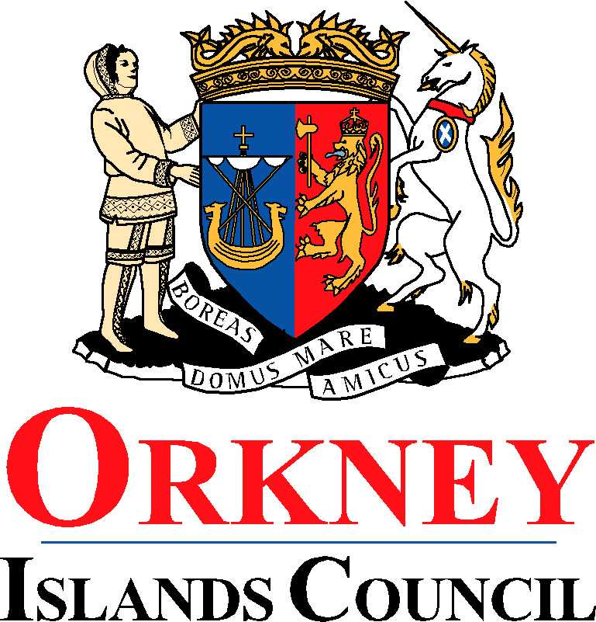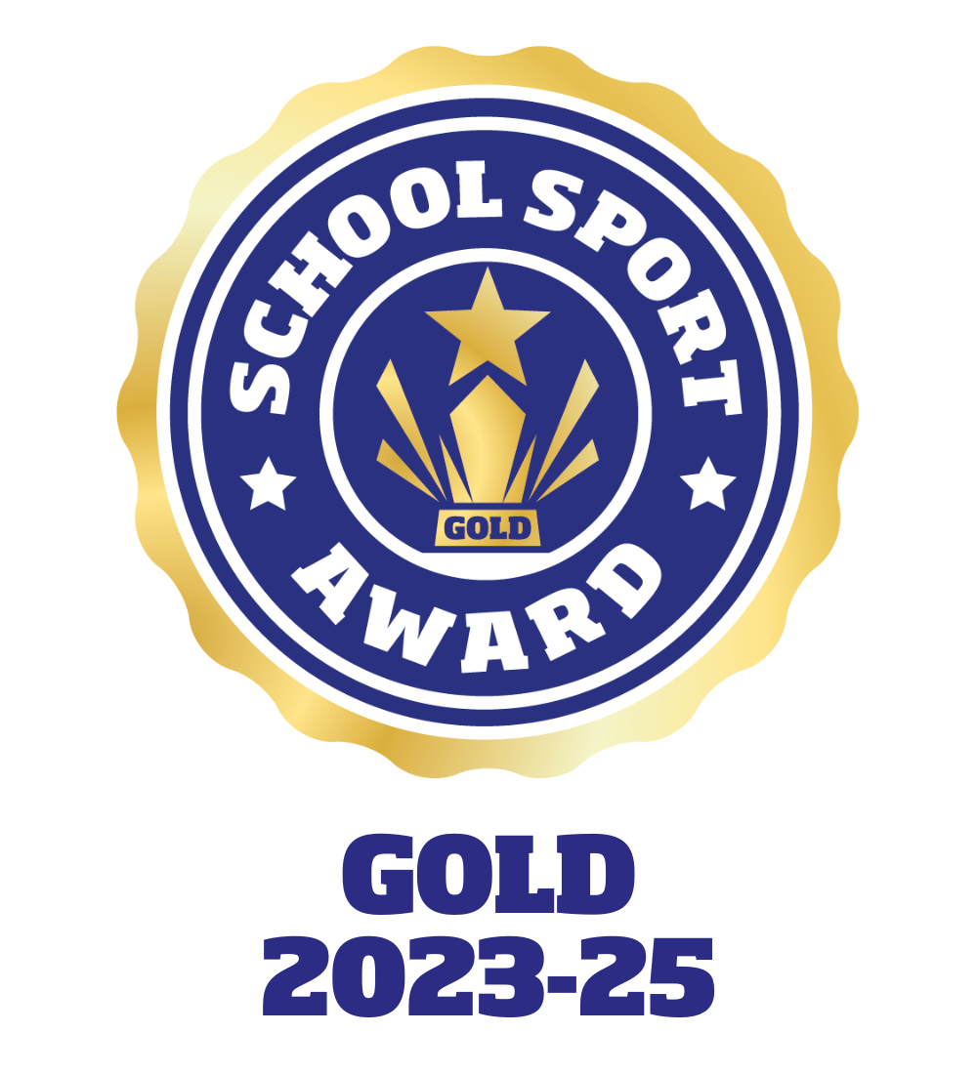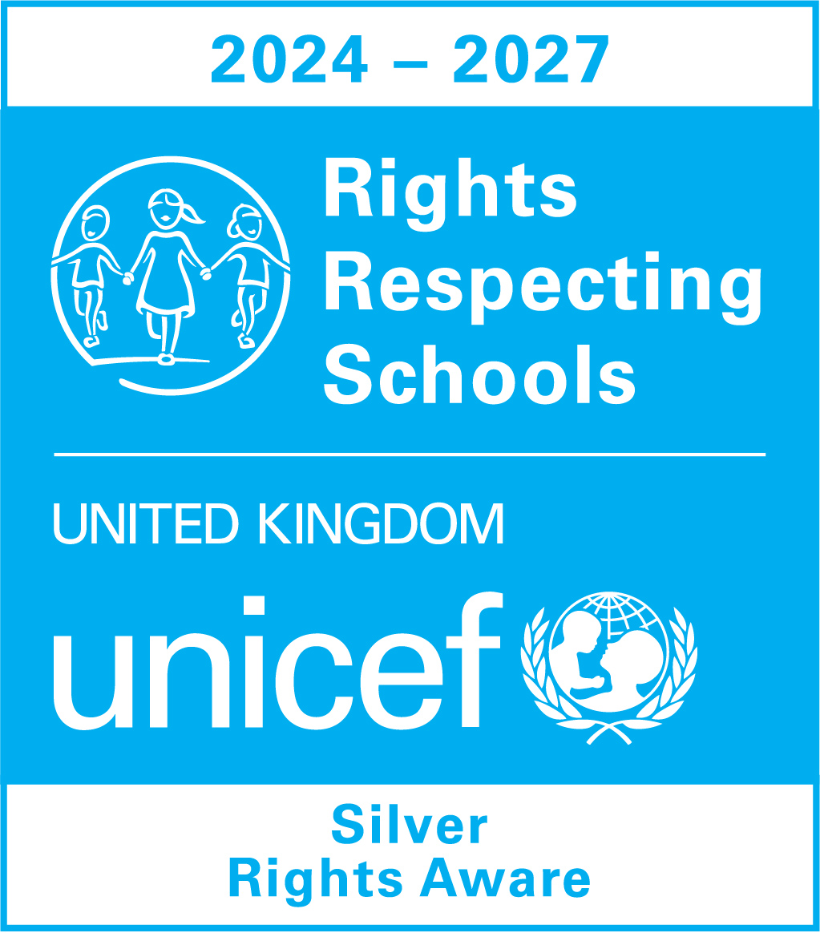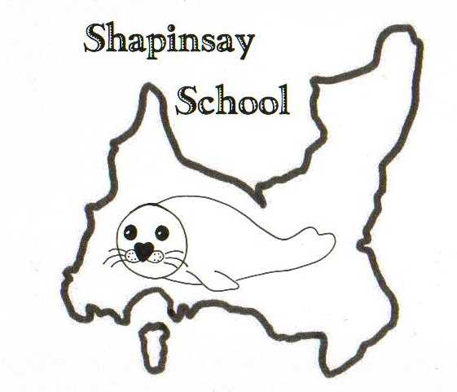

**Orkney Islands Council Department of Education, Communities and Housing**

**Shapinsay Community School** Shapinsay, Orkney, KW17 2DY

Tel: (01856) 711218 Fax: (01856) 711218

Email: [admin.shapinsay@glow.orkneyschools.org.uk](mailto:admin.shapinsay@glow.orkneyschools.org.uk)

Web: <https://blogs.glowscotland.org.uk/or/shapinsayschool>

Head teacher: Emma Clements

Tuesday 16th September 2025

Dear Parents / Carers,

**Primary Learning this week**

This week the children in the Sunshine class are learning about rainbows.

**Swimming**

We will be swimming again this Friday, Please can children meet at the boat by 8:45am (bus children will be dropped off there). They will need with them a bag that they can carry themselves, with swim kit and towel in. They should also have their water bottles and a snack for after swimming. School jumpers should be worn, and they should have a coat. They may wish to bring goggles as well, and a £1 coin for the locker but these are not essential. Children may also want to bring something quiet to do on the boat

**Bookbug**

Bookbug will be in the Community Centre at 10:30am Wednesday 17th September, All under 5’s welcome also.

**Flu vaccine**

Please return any letters not yet returned.

**Staffing**

We are delighted to welcome Chris Moore to the team on a relief basis. He will be supporting in the classrooms on Wednesdays.

**Christmas shoeboxes**

A reminder that any filled shoeboxes or donations towards them should be returned to school by Friday 3rd October.

**Parent Council**

Parent Council meet next Tuesday, all encouraged to attend. Please see emails for further information.

Kind regards,

Emma Clements

Headteacher