   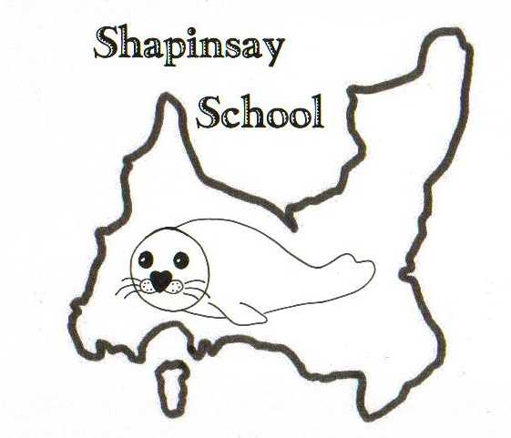

**Orkney Islands Council Department of Education, Housing and Leisure**

**Shapinsay Community School**

Shapinsay, Orkney, KW17 2DYTel: (01856) 711218 Fax: (01856) 711218

Email: [admin.shapinsay@glow.orkneyschools.org.uk](mailto:admin.shapinsay@glow.orkneyschools.org.uk)

Web: <https://blogs.glowscotland.org.uk/or/shapinsayschool>

Head teacher: Emma Clements

Monday 9th December 2024

Dear parents / carers,

**Primary Learning this Week**

This week the children are finalising the Mousetivity performance, recording audio and editing it all together with Jason’s help. In maths we are continuing to work on number and calculations.

**Dates for your Diary**

Tuesday December 17th Peedie schools trip to the Picky

Wednesday 18th December Christmas Assembly 1.30pm

Friday 20th December is the end of this term

Monday 6th January the spring term starts

**Christmas Tree Party**

The Shapinsay Community Association are hosting the Christmas Tree Party on Sunday 15th December 2024. The party will take place in the school hall from 3pm until 5.30pm. Parents/carers must remain with their children. There will be games, tea, and a visit from Santa.

**Christmas Assembly**

Our assembly is on Wednesday 18th December at 1.30pm. Parent Council are doing refreshments and a raffle. Please look out for communication from Parent Council about this, but any raffle and baking donations can come to school next week.

**Trip 17th December**

We will be going to the Pickaquoy Centre on Tuesday 17th December with pupils from some of the other peedie isles schools. Children will be going to soft play and then a special screening Paddington 3. We will be travelling in on the 9am boat and returning on the 2.15. Children should be at the boat by 8:50am, and can be collected either from school at 3, or the boat when it gets in. Bus children will be as normal.

Children will need a packed lunch (please let us know asap if you need a packed lunch from school), water bottle, suitable clothing and school jumpers please.

**Christmas Lunch**

It will be our Christmas Lunch on Wednesday 11th December.

**Choir**

A reminder that for the last 2 choir rehearsals we will be at the kirk.

Kind regards,

Emma Clements

Head teacher