
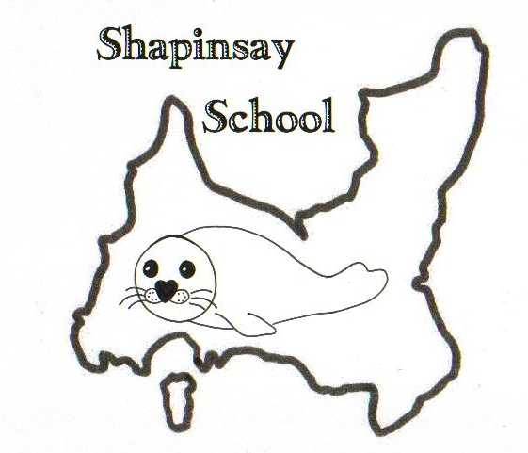
Orkney Islands Council
Department of Education, Housing and Leisure
Shapinsay Community School
Shapinsay, Orkney, KW17 2DY
Tel: (01856) 711218 Fax: (01856) 711218
Email: admin.shapinsay@glow.orkneyschools.org.uk
Web: https://blogs.glowscotland.org.uk/or/shapinsayschool/
Head teacher: Emma Clements.



Monday 18th November 2024
Dear parents / carers,

Primary Learning this Week
This week the children are making presentations on a place in France to research. In Maths we are still working on fractions. In Science the children are learning about shadows.

Poppy Scotland
Thank you to everyone who purchased a poppy from the shop or school. We raised £43.28 for Poppy Scotland.

Children in Need
We raised the amazing total of £323-41 for Children in Need. Thank you to everyone who donated.

Recorder Lesson
This Friday 22nd November Valerie will be starting recorders for those who want to take part.

Christmas Tree Party
The Shapinsay Community Association are hosting the Christmas Tree Party on Sunday 15th December 2024. The party will take place in the school hall from 3pm until 5.30pm. Parents/carers must remain with their children. There will be games, tea, and a visit from Santa.

Trip 17th December
We will be going to the Pickaquoy Centre on Tuesday 17th December with pupils from some of the other peedie isles schools. Children will be going to soft play and then a special screening Paddington 3. Please complete the reply slip, we will let you know further details when we have them.

Christmas Tree Lighting
The primary children have been asked to sing at the tree lighting on Friday 6th December at 7pm. Please can all children take part – please return the reply slip asap.

Choir
The choir will also be performing at the tree lighting and at the Kirk on Christmas Eve afternoon. Please can children in the choir return this reply slip for Christmas Eve. Choir will take place again this Friday.

Kind regards,

Emma Clements
Head teacher

Pickaquoy Centre 17th December 2024

Name of child / children:………………………………………………………………

I give permission for my child / children to go to the Picky Centre on 17th December 2024

Have any details changed on your child’s medical record? YES/NO
Have any of your contact details changed? YES/NO

If YES please specify………………………………………………………

Parents signature…………………………………………………………………………………………..

Christmas Tree lighting Friday 6th December 2024

We will be attending the Tree Lighting on 6th December 2024

Name of child / children:………………………………………………………………

Parents signature………………………………………………………………………………

Christmas Eve afternoon at the Kirk

My child/children are part of the choir, and we will be attending the tree lighting at the kirk on Christmas Eve

Name of child / children:………………………………………………………………

Parents signature………………………………………………………………………………

