
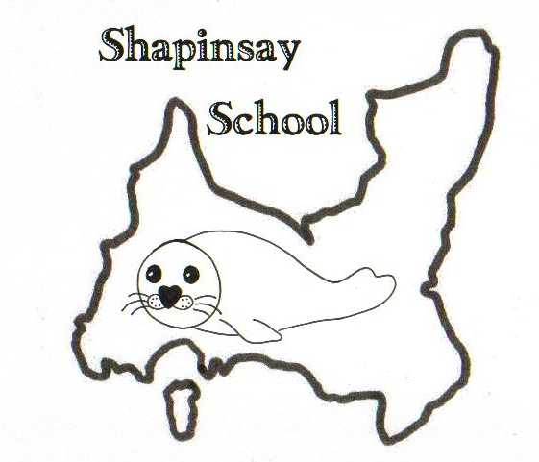
Orkney Islands Council
Department of Education, Housing and Leisure
Shapinsay Community School
Shapinsay, Orkney, KW17 2DY
Tel: (01856) 711218 Fax: (01856) 711218
Email: admin.shapinsay@glow.orkneyschools.org.uk
Web: https://blogs.glowscotland.org.uk/or/shapinsayschool/
Head teacher: Emma Clements.



Wednesday 30th October 2024
Dear parents / carers,

Welcome back, hope you all have had a lovely break.

Dates for your diary
Tree Lighting Friday 6th December, 7pm
Christmas Assembly Wednesday 18th December, 1.30pm
This term finishes on Friday 20th December 2024
The new term begins on Monday 6th January 2025

Menu Change
There will be a change to the school lunch menu on Monday 4th November. It will be soup and sandwich or soup and baked tattie, please indicate your child’s choice on the slip below and return to school before Thursday this week please.

School photos - Monday 4th November
Sarah Mackie will be in school on Monday 4th November to take photos. She will do individual and family ones of children as well as a whole school photo. Children should wear their school jumpers for this please but are welcome to change for the individual and family photos.
She is also able to take family photos where parents and siblings not at school can come in, as discussed on the WhatsApp chat.

Children in Need
It is Children in Need Day on Friday 15th November. The Pupil Council will be organizing some fun activities to raise funds. Watch this space for more details coming next week.

Playgroup Halloween Party
The playgroup Halloween party is on Thursday 31st October from 3.15pm until 4.45pm in the community rooms. Its for all children aged 12 and under. Parents are to stay with their children and the cost is £2 per family.

The Scottish Poppy Appeal
Poppies are now on sale in the shop and we have some for sale in school too.

Rights Respecting Schools
We have our virtual accreditation visit for the Silver Award taking place Tuesday 5th November. If you are able to come in and talk to the assessor as part of a group between 10.45 and 11.15, please let Emma know asap.

Choir Club
In preparation for lots of singing at Christmas, Emma and Caroline will be holding a choir club from 3 – 4pm on Fridays, beginning on 8th November. All primary children are invited to take part, and we would also like to invite any older siblings who are at KGS to come along too. We will be practicing to perform at the Shapinsay tree lighting and at the Kirk during the service on the afternoon of Christmas Eve, so please make sure you are able to come to these events. Children will need to bring a snack for after school each week. Please complete the reply slip and return to school if children would like to come to this.

Dental Letters
Please find the attached letter from Orkney Dental Services about school dental inspections this year.

Parent Council
The Parent Council meeting will take place next Wednesday, 6th November at 9am in the Music Room. Afterwards there is a session for parents with the Youth and Family Engagement team, where they will be discussing how to stay safe online and also looking at how else they can support us here in Shapinsay. Please see the flyer attached to this letter.
Also please see the attached flyer from Parent Council about the Shapinsay Winter Market on Sunday 24th November.

Homework
Now that we have finished swimming, homework should be returned on a Friday morning. As discussed at the last Parent Council meeting, children are being given the chance to do their math’s homework and practice spellings in any time where they have completed their work in school, but will still bring their work home to show you each week. Please can parents also encourage children to either read at home at least twice per week, either independently or with an adult, and that this is recorded in reading records. Children are welcome to read anything of their choice and can change choice books whenever they need to.

Cast Affs
Parent Council are in Cast Affs this week and next week. Donations for the raffle and for baking would be greatly appreciated, as all money from these go to Parent Council. They can be brought into school tomorrow (or next week if it’s baking for next week). Thank you so much to the parents who are doing shifts and to Gemma for organizing this.

Kind regards,

Emma Clements
Head teacher

Menu Change Monday 4th November 2024

Name of child / children:…………………………………………………………

Lentil Soup
Cheese sandwich ……..
Tuna sandwich ……..
Baked tattie ……..

Will bring a packed lunch from home …………….

Signed:………………………………… Date:…………………………………..

Choir Club Starting Friday 8th November 2024

Name of child/children ……………………………………………………………………………

I do give permission for my child/children to attend Choir Club

Signed:………………………………. Date:……………………………………..

