
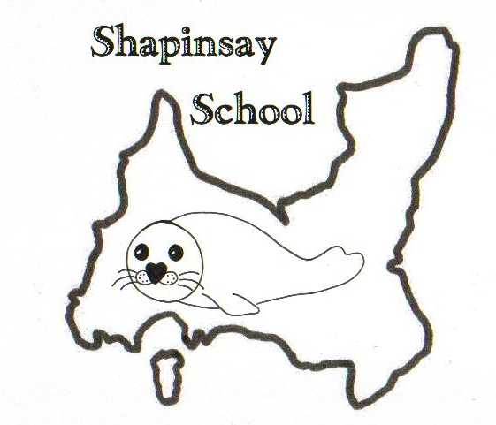
Orkney Islands Council
Department of Education, Housing and Leisure
Shapinsay Community School
Shapinsay, Orkney, KW17 2DY
Tel: (01856) 711218 Fax: (01856) 711218
Email: admin.shapinsay@glow.orkneyschools.org.uk
Web: https://blogs.glowscotland.org.uk/or/shapinsayschool/
Head teacher: Emma Clements.



Monday 30th September 2024

Dear parents / carers,

Parents Consultations Tuesday 8th October
Please find the attached slip with your appointment time. If you haven’t yet requested a time and would like one please get in touch as soon as possible.

Shoebox Appeal
If you are able to either make a complete box or make donations of items towards boxes please bring them to school by Friday 11th October.

Staffing
We have an advert at the moment for Relief Janitor for Shapinsay School, which can be found on My Job Scotland. The closing date for this is 6th October. There are also some other relief posts for things like Education Support Worker (covering things like clerical and auxiliary work), cleaner and kitchen assistant which are always available on My Job Scotland and cover various schools in Orkney, including Shapinsay.
If you think you might be interested in any of these posts please feel free to speak to Emma to find out more.

Trips
As part of our topic on “Our Community”, the primary children have a few visits planned within our local area.
- Wednesday 2nd October 1.15pm visit to the Fire station, Stanley will be taking us in the bus, we will return to school by 2.45pm for pick up from school as usual.
- Thursday 3rd October, 1.30pm – visit to Cast Affs.
- Tuesday 8th October, times to be confirmed, Shop and Post Office

If any parents are able to come with us on any of these visits please let Emma know.

Flu Vaccines
The nurse from the Shapinsay Surgery will be in school on Tuesday afternoon for Flu vaccines. Nursery and Pre school children are to go to the surgery at 1pm after nursery.

Wear Red Day
On Friday 11th October, its Show Racism the Red Card Day. Everyone can wear red to school and make a small donation to the charity if they wish.

Dental Visit
On Wednesday morning the dental team will be visiting the school for fluoride varnishing. Please find the attached letter from the childsmile team about care of your child’s teeth after the varnish application.

Kind regards,

Emma Clements
Head teacher

