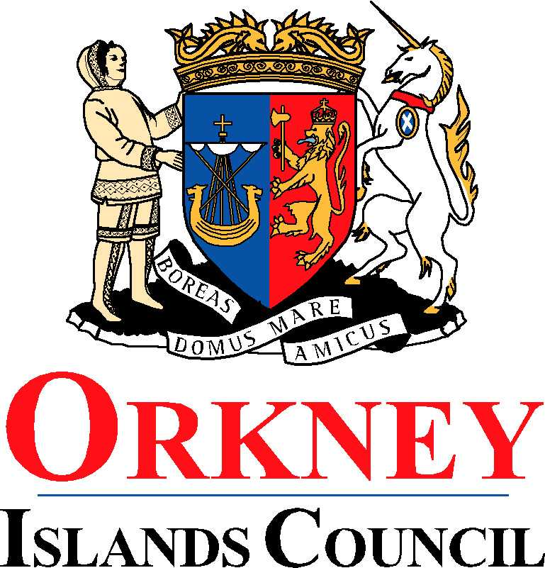
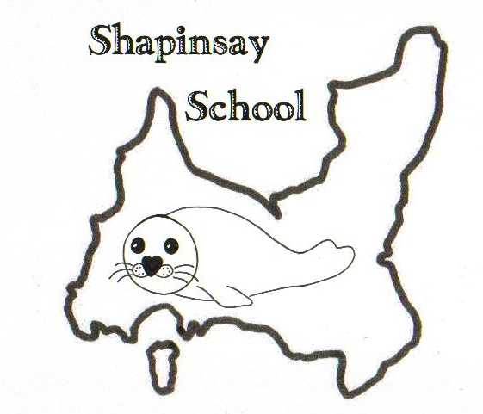
Orkney Islands Council
Department of Education, Housing and Leisure
Shapinsay Community School
Shapinsay, Orkney, KW17 2DY
Tel: (01856) 711218 Fax: (01856) 711218
Email: admin.shapinsay@glow.orkneyschools.org.uk
Web: https://blogs.glowscotland.org.uk/or/shapinsayschool/
Head teacher: Emma Clements.



Monday 23rd September 2024

Dear parents / carers,

Rights
There is a document with this weeks newsletter about the Convention on the Rights of the Child. We are having our accreditation visit on 5th November in the morning. Please can parents look through the document and let Emma know if you are able to take part in the visit.

Parents Consultations
Parent consultations will take place on Tuesday 8th October 2024. Please return the slip below indicating if you would prefer an afternoon or evening appointment.

Shoebox Appeal
If you are able to either make a complete box or make donations of items towards boxes please bring them to school by Friday 11th October.

Trips
As part of our topic on “Our Community”, the primary children have a few visits planned within our local area.
- Thursday 26th September from 9am – visit to the Kirk. We will be travelling there in Stanley’s bus and hope to walk back.
- Wednesday 2nd October 1.15pm – visit to the Shapinsay Fire Station we will travel in the school bus and will be back at 2.45pm in time for usual school pick up.
- Thursday 3rd October, 1.30pm – visit to Cast Affs.
- Tuesday 8th October, times to be confirmed, Shop and Post Office
If any parents are able to come with us on any of these visits please let Emma know.

Sallianne Smales visit
Sallianne Smales, author of the Smoozles books, will be visiting on Friday 27th September in the afternoon. She will be doing some work with the children and there will be an opportunity for the children to buy some of her books and get them signed. You can find out more here https://thesmoozles.co.uk/. Please send in some money with children on the day if they wish to buy books, or parents can come in at 2.45 if they wish to buy the books themselves.

Violin
As we have our visit to the kirk this week, the violin day will change. Please watch out for updates on the whatsapp group as we are waiting for confirmation from Miss Procter as to which day she will be out. It is likely to be Tuesday or Wednesday.

Wear Red Day
On Friday 11th October, its Show Racism the Red Card Day. Everyone can wear red to school and make a small donation to the charity if they wish.

Kind regards,

Emma Clements
Head teacher

Parent Consultations Tuesday 8th October 2024

Name of Child or Children……………………………………………………………………….

I would like an afternoon appointment 3.15pm – 4.30pm…………………………………..

I would like an evening appointment 6.00pm – 7.00pm…………………………………...

Parents signature………………………………………………………………………………….

