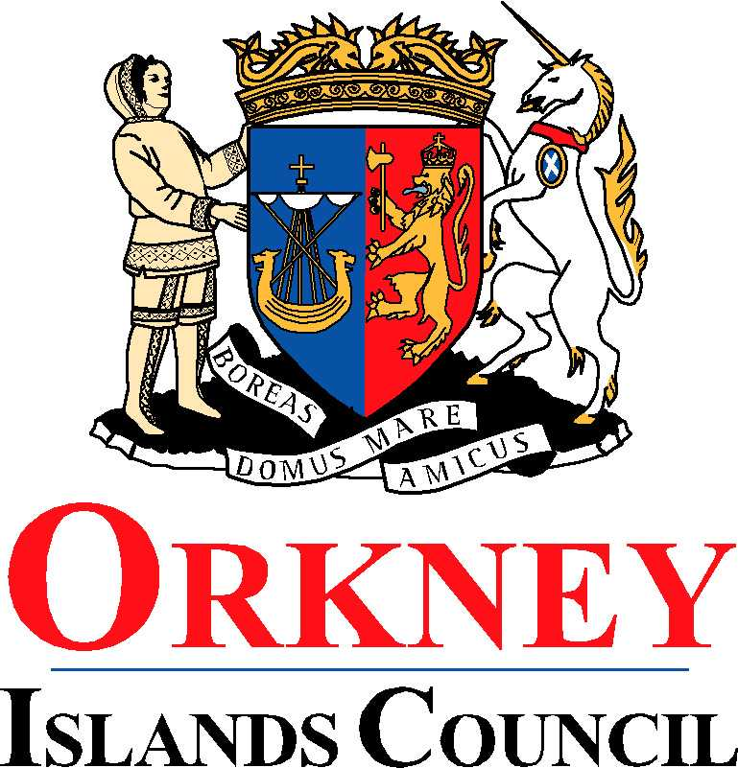
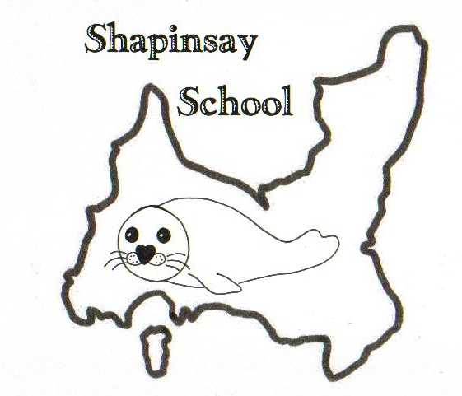
Orkney Islands Council
Department of Education, Housing and Leisure
Shapinsay Community School
Shapinsay, Orkney, KW17 2DY
Tel: (01856) 711218 Fax: (01856) 711218
Email: admin.shapinsay@glow.orkneyschools.org.uk
Web: https://blogs.glowscotland.org.uk/or/shapinsayschool/
Head teacher: Emma Clements.

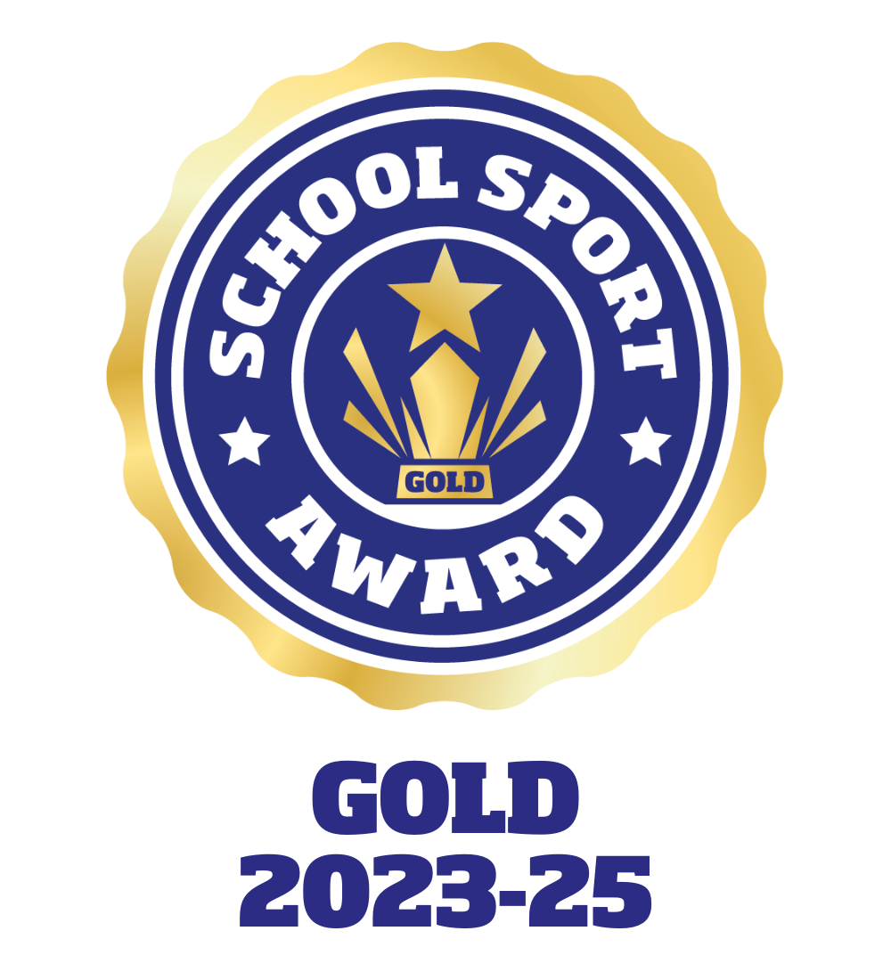

Monday 16th September 2024

Dear parents / carers,

Violin Lessons
There will be no violin lessons this week as Miss Proctor is at the instrumental course.

Bookbug Session
Just a reminder that there will be a Bookbug session on Wednesday 18th September in the Shapinsay club rooms at 10.30am.

Shoebox Appeal
Please find attached a leaflet about the Blythswood shoe box appeal. If you are able to either make a box or make donations towards boxes please bring them to school by Friday 11th October.

Trips
As part of our topic on “Our Community”, the primary children have a few visits planned within our local area.
- Thursday 19th September, 11am – visit to the Smithy
- Thursday 26th September from 9am – visit to the Kirk. We will be travelling there using Stanley’s bus and hope to walk back.
- Thursday 3rd October, 1.30pm – visit to Cast Affs.
If any parents are able to come with us on any of these visits please let Emma know.

Sallianne Smales visit
Sallianne Smales, author of the Smoozles books, will be visiting on Friday 27th September in the afternoon. She will be doing some work with the children and there will be an opportunity for the children to buy some of her books and get them signed. You can find out more here https://thesmoozles.co.uk/

Dental Letters
The dental team will be in school on Wednesday 2nd October 2024. Please find the attached reconsent forms.

Photos for topic
A reminder to get the photos of Shapinsay for the primary topic emailed to Emma by next Monday. If there any issues with this please let us know.

Library Books
Please look at home to see if you have these overdue library books:-
Lily Pad Lake by Rosie Banks
Emily Windsnap and the falls of Forgotten Island
The library van will be here on Thursday this week, please have all library books in school by then.

Kind regards,

Emma Clements
Head teacher

