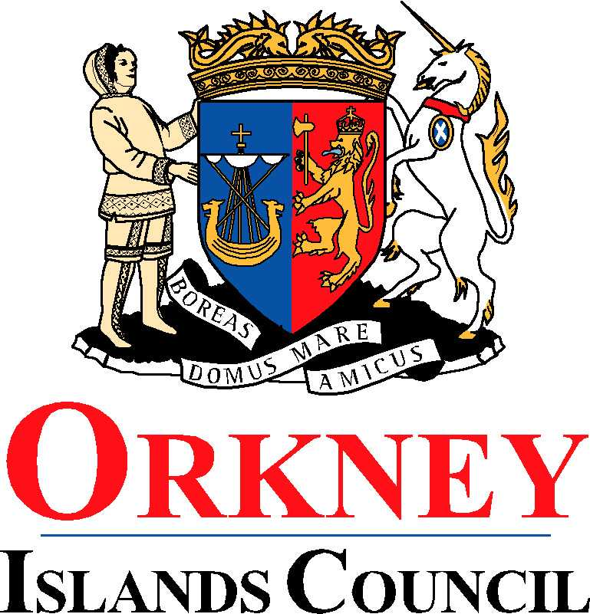
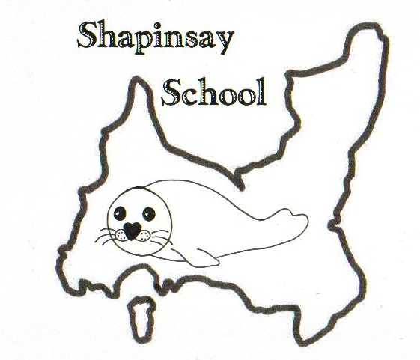
Orkney Islands Council
Department of Education, Housing and Leisure
Shapinsay Community School
Shapinsay, Orkney, KW17 2DY
Tel: (01856) 711218 Fax: (01856) 711218
Email: admin.shapinsay@glow.orkneyschools.org.uk
Web: https://blogs.glowscotland.org.uk/or/shapinsayschool/
Head teacher: Emma Clements.

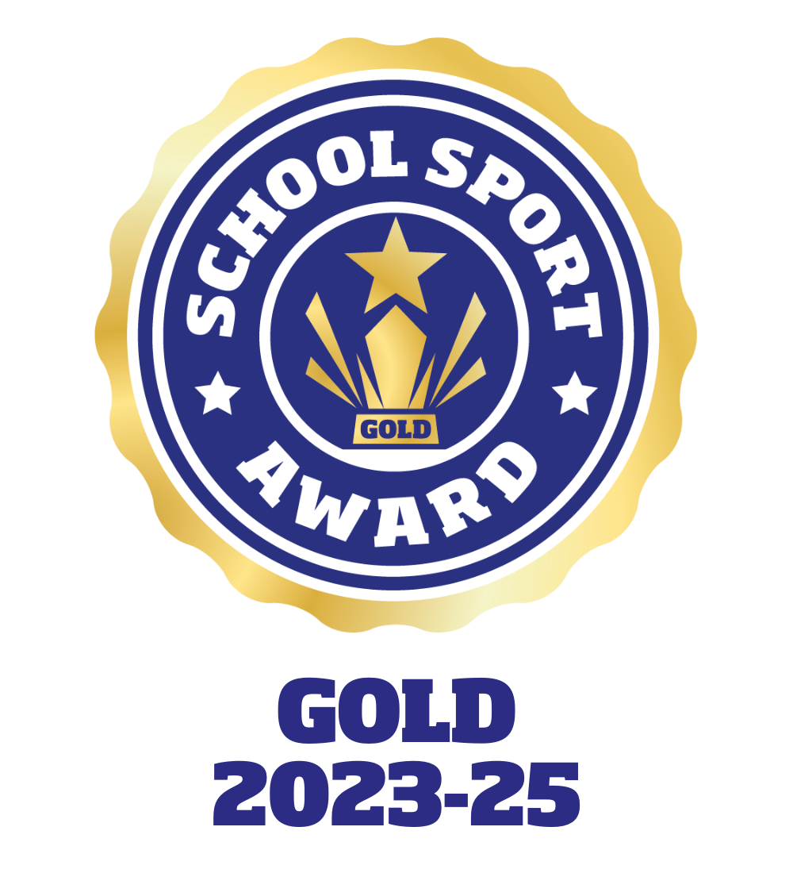

Monday 9th September 2024

Dear parents / carers,

Parent Council
The Shapinsay Parent Council will be meeting tomorrow evening, Tuesday 10th September. Please see your email from Parent Council for further details. All parents are encouraged to attend. Everyone welcome.

Bookbug Session
There will be a Bookbug session on Wednesday 18th September in the Shapinsay club rooms at 10.30am. All are welcome please see the details printed overleaf.

Parenting Smart, On-line Course
Please find attached a leaflet about Parenting Smart, it gives all the details for you to access a free online course to provide you with extra tools to deal with everyday parenting challenges.

Kind regards,

Emma Clements
Head teacher

