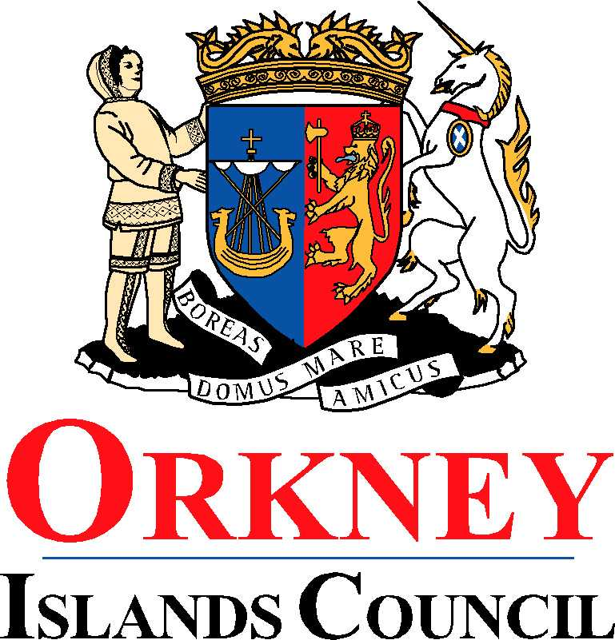
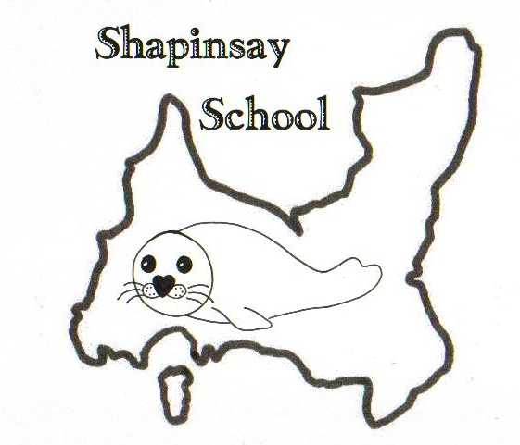
Orkney Islands Council
Department of Education, Housing and Leisure
Shapinsay Community School
Shapinsay, Orkney, KW17 2DY
Tel: (01856) 711218 Fax: (01856) 711218
Email: admin.shapinsay@glow.orkneyschools.org.uk
Web: https://blogs.glowscotland.org.uk/or/shapinsayschool/
Head teacher: Emma Clements.

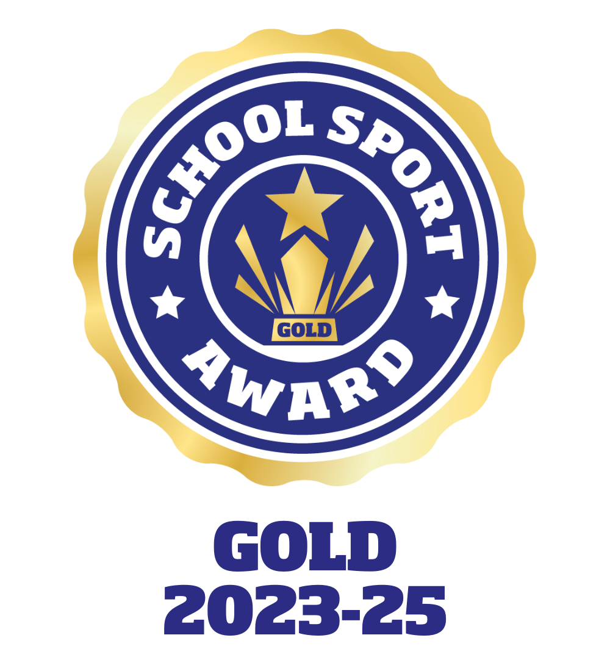

Monday 2nd September 2024

Dear parents / carers,

Missing Library Book
We are missing a library book from last term, called “Goose bumps – Horror land” please can you take a look at home to see if we can find it.

Open Classroom
As we have reorganized the primary classrooms, we would like to invite parents in from 2pm this Wednesday to come and have a look at the new way we are working.

Science Festival
We are having a few visitors as part of the Science Festival.
Tuesday 3rd September – Starplate (primary)
Thursday 5th September – Science of Superheroes (primary)
Friday 6th September – Computing (primary)
Monday 9th September – Edinburgh botanical gardens (nursery and primary)

Kind regards,

Emma Clements
Head teacher

