

EDUCATION, LEISURE AND HOUSING

Shapinsay Community School
Shapinsay, Orkney, KW17 2DY
Tel: (01856) 711218 Fax: (01856) 711218
Email: admin.shapinsay@glow.orkneyschools.org.uk
Web: https://blogs.glowscotland.org.uk/or/shapinsayschool/
Head teacher: Emma Clements.

Monday 17th April 2023
Dear parents / carers,

Welcome
We are delighted to welcome Caroline Bird, who starts with us today as Classroom Auxiliary.

Pupil Committees
Pupil committees will all meet on Wednesday 19th April at 9am.

Fluoride Varnish
The Dental Team will be here tomorrow, Tuesday 18th April, for Fluoride Varnish.

Bag the Bruck
A reminder that we are taking part in Bag the Bruck again this year, collecting rubbish at Sandgarth Beach. This takes place tomorrow, Tuesday 18th April leaving school at about 1.15pm and staying until the end of the school day. Thank you to all the parents who have offered to come along and help. Please can you be at school by 1.10pm. All children will have their things with them for the end of the day, with children going on the school bus leaving their things on the school bus or in a teacher’s car. Children whose parents are coming to help will be going in their parents’ car.
If there are any changes with parents now able to help, or unable to help please let us know as soon as possible.
Children may wish to bring their own wellies from home tomorrow, rather than wearing the wellies from school. If so, please bring them when you collect your child or send them in in the morning.

Parent Council
The Parent Council meet next Monday at 7pm. All parents are invited, please look out for an email regarding the meeting.

Overdue Library Books
We are looking for some library books which are now overdue. The list is printed overleaf. Can you check at home and if any are found please send them into school?

North Isles Landscape Partnership Scheme

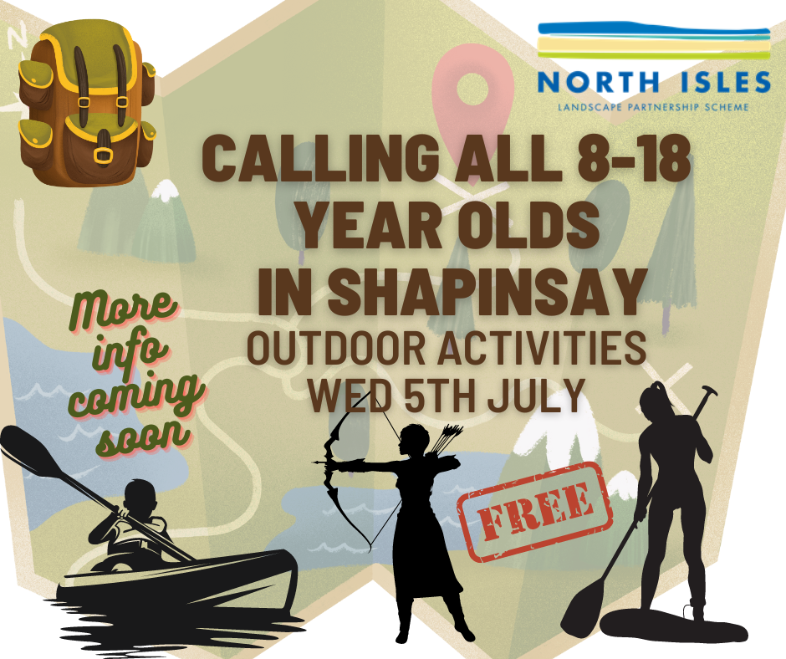
Katy Firth (Education and Learning Programme Coordinator) has asked us to let you all know about an Outdoor Activities Day in the Summer holidays. The event is for children aged 8-18 in Shapinsay.
Activities on offer are: kayaking; stand up paddle boarding; raft building; archery; bushcraft. These are weather dependent and they might not get to do them all.
The aim is to provide an opportunity to enjoy the wonderful landscape in Shapinsay, and learn a little about its heritage whilst having fun. These will be delivered by the same instructors who are doing the OIC schools Hoy residential
It is funded by NILPS and is FREE (although lunch is not included).

Kind regards,

Emma Clements
Head teacher

Barcode | Title | Author | Due Date
2320117 | Poppy the posh kitten / by Jenny Dale ; illustrated by Susan Hellard | Dale, Jenny | 23/03/2023
2364914 | Monster blood for breakfast! / R.L. Stine | Stine, R. L | 23/03/2023
2471826 | The world's fastest cars / by Sean McCollum | McCollum, Sean, author | 23/03/2023
2476841 | The Force oversleeps / Jarrett J. Krosoczka | Krosoczka, Jarrett, author, illustrator | 23/03/2023
2475466 | Bumpfizzle : the best on planet Earth / Patricia Forde ; illustrated by Elina Braslina | Forde, Patricia, author | 23/03/2023
2475987 | Amazing / Steve Antony | Antony, Steve, author, artist | 23/03/2023

2473257 | The Halloween book / Annalees Lim | Lim, Annalees, author | 23/03/2023
2233458 | Princess Emily and the wishing star / Vivian French, Sarah Gibb | French, Vivian | 23/03/2023

