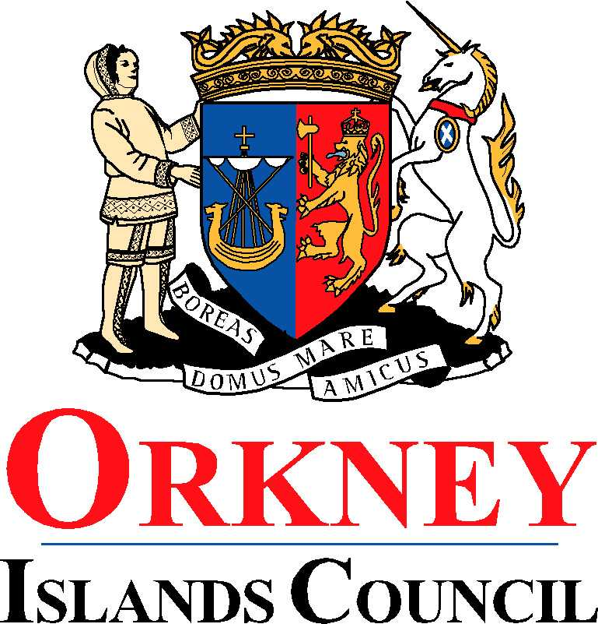
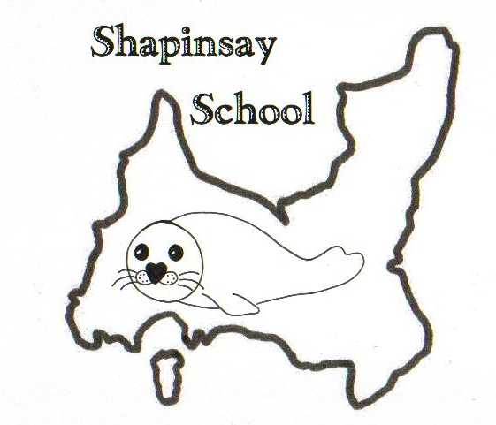
EDUCATION, LEISURE AND HOUSING

Shapinsay Community School
Shapinsay, Orkney, KW17 2DY
Tel: (01856) 711218 Fax: (01856) 711218
Email: admin.shapinsay@glow.orkneyschools.org.uk
Web: https://blogs.glowscotland.org.uk/or/shapinsayschool/
Head teacher: Emma Clements.

Monday 4th October 2021

Dear parents / carers,

Homework this Week
There will be no spelling homework this week. Maths homework will be set to be back at school on Wednesday 6th October if possible.

Junior Road Safety Officers
The JRSO’s will be reminding everyone about car safety this week. Please find a booklet with this letter all about child car seat safety.

Show Racism the Red Card
Just a reminder about wearing RED to school on Wednesday for Show Racism the Red Card. Donations to the charity are also welcome.

Blythewood Christmas Shoebox Appeal
Thank you if you have donated a shoebox already. The deadline for bringing any other boxes is 6th October, 2021.

Rugby
John Cairns from Orkney rugby club has offered to come in and do some after school rugby sessions with the primary children next term. The dates are 28th October, 11th November and 2nd December. The sessions will run from after school until 4.15, and children will need to bring a snack. Please return the reply slip by this Wednesday.

Pupil Committees
The Pupil committees (JRSO’s, Sports and Library) will be meeting tomorrow afternoon at 1.20pm until about 2pm.

Kind regards,

Emma Clements
Head teacher

