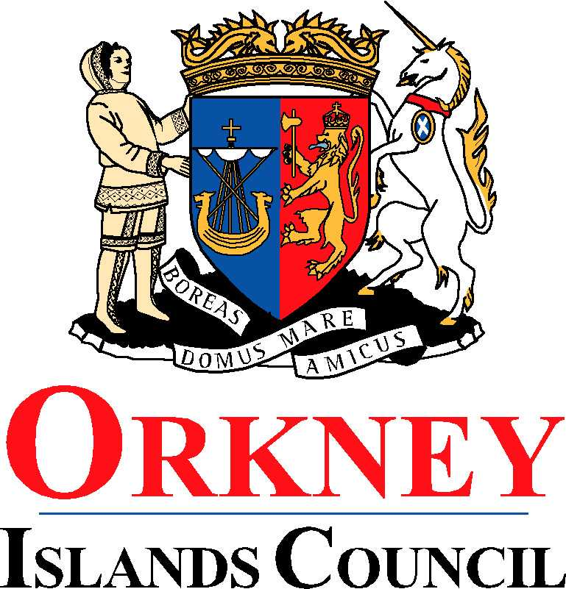
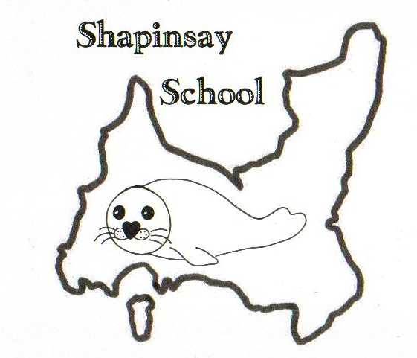
EDUCATION, LEISURE AND HOUSING

Shapinsay Community School
Shapinsay, Orkney, KW17 2DY
Tel: (01856) 711218 Fax: (01856) 711218
Email: admin.shapinsay@glow.orkneyschools.org.uk
Web: https://blogs.glowscotland.org.uk/or/shapinsayschool/
Head teacher: Emma Clements.

Monday 20th September 2021

Dear parents / carers,

Show Racism the Red Card
We will be supporting Show Racism the Red Card again this year. The actual date is 22nd October but, as the school will be closed, we will be having our wear something red to school day on Wednesday 6th October. All pupils need to do is wear something red to come to school and make a small donation to the charity.

Parent Council Meeting
There will be a Parent Council Meeting tonight at 7pm in the clubrooms.

Pupil Committees
Our Pupil Committees are now formed and involve all children from P2 – P7.
All groups have now started working together and will feed back in due course.

Crisp Tasting
As part of this terms topic the nursery to P4 children will be using their senses during a blind crisp tasting session to guess the flavours of the crisps. They will be doing this in class later this week. We will check that any crisps we use are suitable for any allergy or dietary requirements of the children. If you have any concerns, please get in touch with the school before Thursday.

Childsmile
There is a letter attached, for nursery and P1 children, with information about the Childsmile toothbrushing programme.

Kind regards,

Emma Clements
Head teacher

