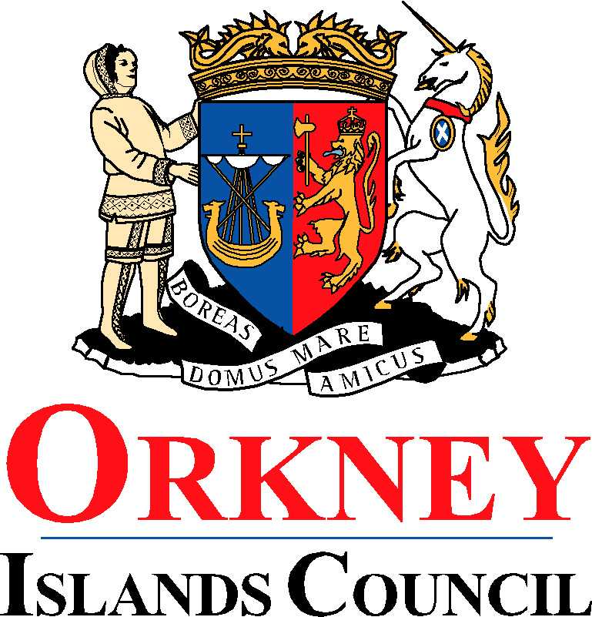
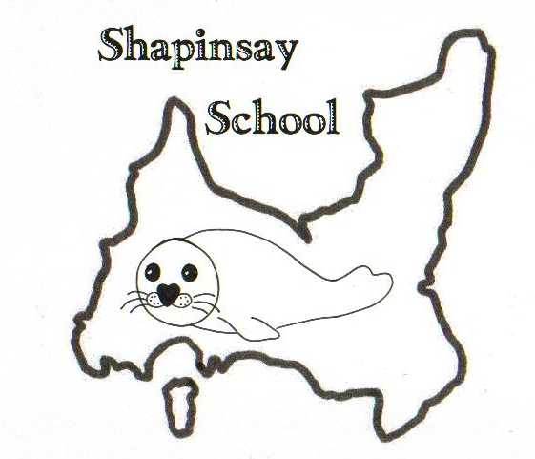
EDUCATION, LEISURE AND HOUSING

Shapinsay Community School
Shapinsay, Orkney, KW17 2DY
Tel: (01856) 711218 Fax: (01856) 711218
Email: admin.shapinsay@glow.orkneyschools.org.
Web: https://blogs.glowscotland.org.uk/or/shapinsayschool/
Head teacher: Emma Clements

Monday 24th May 2021

Dear parents / carers,

School Website
Please note our school website is now https://blogs.glowscotland.org.uk/or/shapinsayschool/

Junior Road Safety Officers
The Junior Road Safety Officers are running a competition to design a badge that the JRSO’s can wear. All pupils can enter, nursery to P7. The winning design will be worn by the JRSO’s and they are offering a small prize too. The closing date for the competition is Friday 28th May. Please find a small piece of paper attached to this letter, this is the correct size for the badges.

P7 Transition to KGS
Parents of P7 pupils please find the attached letter from KGS. There has also been a video sent out to your email, if you have not received it please get in touch with us and we will forward it to you.

Kind regards,

Emma Clements
Head teacher

