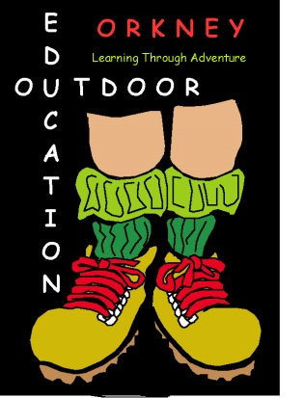
P6 OUTDOOR EDUCATION PROGRAMME

PUPIL KIT LIST / EQUIPMENT

The suggested list of items below are a checklist & guide to what each pupil WILL NEED TO BRING EACH DAY for a typical Outdoor Programme based in & around the school and at nearby outdoor Locations.

Please note that there will likely be both LAND & WATER based activities each day, therefore any items that are used or wet should be removed and new items refreshed each day.

PERSONAL CLOTHING (For Land Based Activity):

Outdoor Trainers Wellies
Thick, Long Warm Socks 1 T Shirts / Warm Thin Tops
Fleece Jacket / Warm Jumper Hat & Gloves
Outdoor Warm / Windproof Jacket Trousers, (NO Denim or Jeans)
Waterproof Jacket & Trousers Rucksack

PERSONAL CLOTHING (For Water Based Activity):

Old Lace-Up Trainers (Water Use, NO Crocs) Swimwear or Spare Underwear
Warm Fleece Top / Sweatshirt Large Towel
Spare socks Black Bin Bag

OTHER PERSONAL ITEMS:

Packed Lunch & Snack Water Bottle (filled)
Sun Cream / Midge/Insect Repellent Personal Medication / Inhaler / Glasses

All specialist Land & water-based activity equipment will be provided and issued when appropriate.

Please do not wear or bring any expensive, breakable, or unnecessary items.

No liability will be taken by the school or Orkney Islands Council for damage or loss to personal possessions whilst taking part in outdoor activities.

