**Strawberry, Raspberry and Banana Smoothie**

|  |  |  |  |  |
| --- | --- | --- | --- | --- |
| Stock foto af 'Fem jordbær på hvid baggrund' | Bananas: Health Benefits, Risks & Nutrition Facts | Related image | Image result for ice cubes | Image result for milk |
| 4  Strawberries | 1  Banana | 8  Raspberries | 4 Ice cubes or 50 ml cold water | 150ml  Milk |

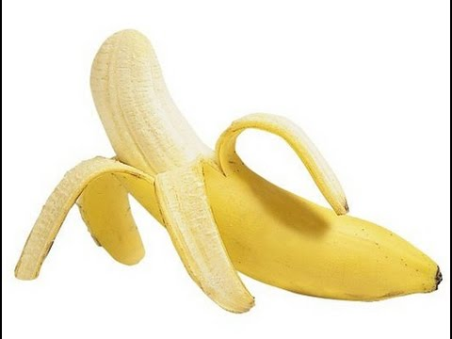

1. Peel and cut a banana.

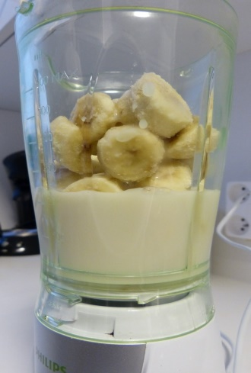

1. Add 150ml of milk and the chopped banana to the blender

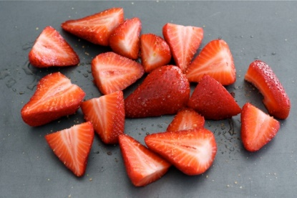

3. Cut the strawberries and raspberries and put in the blender.

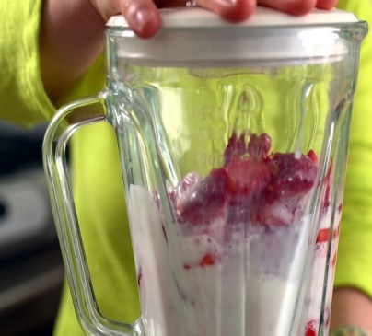

4. Add the ice cubes, put the lid on the blender and whizz until smooth